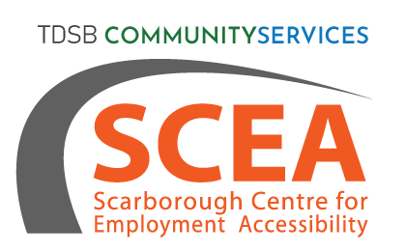
NHI Recruitment Event
NHI IS HIRING!

- Level I and II Dental Assistant
- Registered Dental Hygienist
- Dental Reception/Dental Office Manager – with Diploma and or must have experience
- Personal Support Worker – new grads welcome
- Registered Nurse – 1 year current or recent experience
- Registered Practical Nurse – 1 year current or recent experience
- RN student (completed 2 years)
- RPN student (completed 1 year)
TUESDAY, NOVEMBER 2ND, 2021
11AM – 12PM

JOIN US ONLINE VIA ZOOM
REGISTER:
Call 416-396-8100
Visit https://bit.ly/3i6Brkf
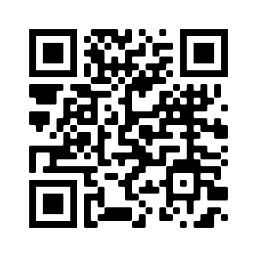
*Free images from Unsplash

