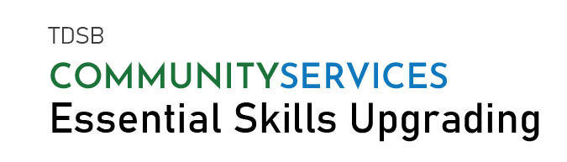
COMPUTER WORKSHOPS STARTING IN OCTOBER 2021
Topic | Start Date | End Date |  | Time | Location
Microsoft PowerPoint | October 5, 2021  (Tue & Thurs) | October 28, 2021 |  | 6:30PM - 9:00 PM | Online
Microsoft Excel | October 12, 2021  (Tue & Thurs) | December 2, 2021 |  | 9:30AM -12:00PM | Online
Microsoft PowerPoint | October 12, 2021  (Tue & Thurs) | November 4, 2021 |  | 12:00 PM - 2:30PM | Online
Microsoft Word | October 14, 2021  (Thurs & Fri) | November 5, 2021 |  | 9:30 AM -12:00PM | Online
Microsoft Excel | October 19, 2021  (Tue & Thurs) | December 9, 2021 |  | 6:30 PM -9:00PM | Online
Microsoft PowerPoint | October 19, 2021  (Tue & Thurs) | November 11,2021 |  | 6:30 PM – 9:00PM | Online
Microsoft Word | October 25, 2021  (Mon only) | December 13,2021 |  | 6:30 PM – 9:00PM | Online
To attend workshop:

- Attendees need laptop/computer with software installed.
- Learners MUST be registered to attend workshop.
- Valid SIN required
- CLB level 5/6
WORKSHOPS ARE FREE.  REGISTRATION REQUIRED.  Essential Skills for Employment  Facebook @TDSBCommunityServices  Twitter @TDSB_CS |  |  | TO REGISTER,  CALL 416-396-6368 OR  EMAIL MAHNAZ.CHINOY@TDSB.ON.CA

