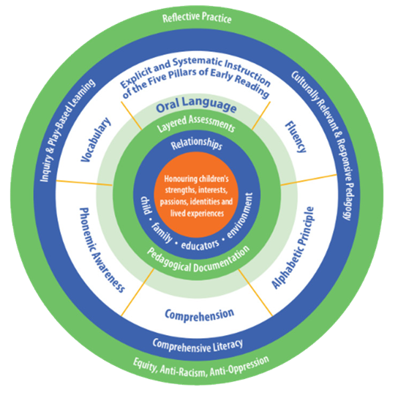

This image is a circular representation of the multiple components that are necessary for early reading instruction. The centre, an orange circle, represents the child. Educators honour children’s strengths, interests, passions, identities and lived experiences.
A blue ring follows and this represents relationships with children, families, educators and the environment. The following green ring represents layered assessments and pedagogical documentation which is how educators develop a deep understanding of the learner.
This is followed by two more rings that are interconnected. The first ring is light green and represents oral language which is the foundation of reading instruction. This is then followed by a thicker white ring which represents explicit and systematic instruction of the five pillars of Early Reading which include vocabulary, phonemic awareness, comprehension, alphabetic principle and fluency. The following dark blue ring represents the instructional approaches that educator use to teach reading and they include comprehensive literacy, culturally relevant and responsive pedagogy and inquiry and play-based learning. The final, outermost ring is dark green and represents reflective practice through an equity, anti-racism and anti-oppression lens.

