Math Tasks: Primary (Grades 1-3)

Monday, October 19
Learning Goal: I am learning to give and follow multi step instructions involving movement from one location to another, including distances and half- and quarter-turns.
Materials: Game board, 2 whiteboard dry erase markers (different colors).  Game Objective: The game is won by making two straight lines of 4 in a row. The two lines may share 1 common marker. The first person or team to do this wins the game.  Skill Objective: Allow students to practice the concept of graphing coordinate points in a fun, engaging, and meaningful fashion.  How to Play:  - Print off the game board  - Decide who will go first by using the "rock, paper, scissor" method.  - Player 1 selects a point by giving the coordinates and placing his/her marker on that point. Player 2 must be sure to watch carefully to be sure that Player 1 properly places their piece on the board (remembering that X comes before Y).  - At this point it becomes Player 2's turn. Player 2 repeats step 3.  - Players alternate turns until someone has successfully made two straight lines of four in any direction. The two winning lines can share one marker or be completely separate.  Source: http://www.pepnonprofit.org/uploads/3/4/0/7/34070191/coordinate_fours.pdf |  | 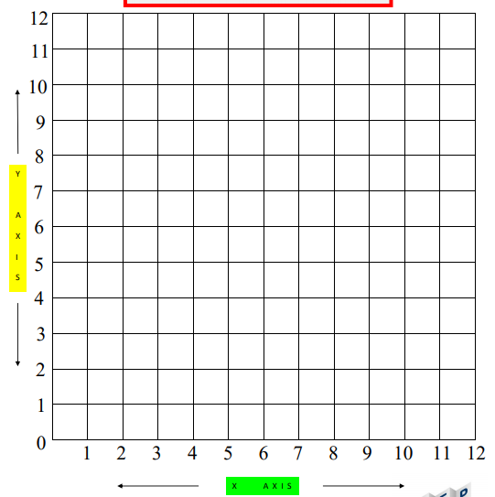

Tuesday, October 20
Learning Goal: I am learning to sort, construct, and identify cubes, prisms, pyramids, cylinders, and cones by comparing their faces, edges, vertices, and angles
Task: Shapes in Boxes  - Find an empty box, such as a cereal box or facial tissue box.  - Unfold the box carefully by detaching the tabs that hold the box together.  - Then flatten the box.  - Your box might look something like this.  - Examine the flattened box; identify the different shapes.  - Label the different shapes.  - Try this activity with a variety of boxes.  Thinking Questions:  - How were the boxes similar? How were they different?  - Which shape was more difficult to identify? Why?  Source: https://www.mathies.ca/files/Patterning%20and%20Algebra%20Grade%201.pdf |  | 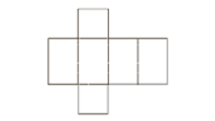

Wednesday, October 21
Learning Goal: I am learning to use mathematical language, including the terms “impossible”, “possible”, and “certain”, to describe the likelihood of complementary events happening, and use that likelihood to make predictions and informed decisions.
Task: Impossible, Possible or Certain  - Talk about possible events in your life.  - Discuss whether these events are impossible, possible or certain to happen in your life.  - Talk about events that are impossible to happen right now in your life.  Thinking Questions:  - Are there events that are unlikely to happen now but are more than likely to happen when you are older? What do you think that is?  - Are there events that do happen right now that will unlikely happen when you are older ?Why do you think that is?  Source: https://www.mathies.ca/files/Data%20Management%20and%20Probability%20Grade%201.pdf |  | Events:  - Certain: You will go to sleep.  - Possible: You will go outside this week.  - Impossible: We will fly around the park.

Thursday, October 22
Learning Goal: I am learning to create and translate patterns using various representations, including shapes and numbers.
Tasks: Growing Patterns  Materials:  - small objects (e.g. buttons, pebbles, coins)  Rules:  - Create a growing pattern and explain how the pattern grows. For example, explain, “I add 2 more pennies each time” or “The pattern is adding 1 each time.”  - Try creating some other patterns.  - Create the first four terms of a growing pattern and extend the pattern by constructing the next three terms. Explain how you can extend (grow) the pattern.  Thinking Questions:  - What did you do to get points?  - Was it difficult to think of addition and subtraction at the same time? Why or why not?  Source: https://www.mathies.ca/files/Patterning%20and%20Algebra%20Grade%202.pdf |  | 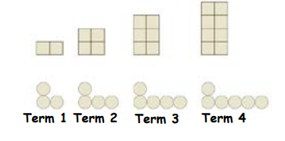

Friday, October 23
Learning Goal: I am learning to compose and decompose various structures, and identify the two-dimensional shapes that these structures contain.
Task: Toothpick Shapes Game

Materials:
- Die, Toothpicks

Rules:
- Players take turns rolling a die. The number rolled is the number of toothpicks each player takes to make a shape.
- If players use three toothpicks, the shape of the triangle is as shown. The shape must be closed; no gaps in between toothpicks.
- If the die shows a 1 or 2, the player does not take any toothpicks and the turn passes to the other player
- The first player to make all four shapes (triangle-3 toothpicks, quadrilateral-4 toothpicks, pentagon-5 toothpicks, hexagon-6 toothpicks) wins the game.

Thinking Questions:

- What strategy did you use to make your shapes?
- How would you describe the shapes you made?

Source: https://www.mathies.ca/files/Geometry%20and%20Spatial%20Sense%20Grade%203.pdf

