Math Tasks: Junior (Grades 4-6)

Monday, October 19th
Learning Goal: I will add and subtract fractions with like and unlike denominators, using appropriate tools, in various contexts
Task: Fractions Talk!  - Write a mathematical statement that, to you, describes the whole Fraction Talks image. Your statement can be an expression, an equation, a ratio, or anything else it makes sense to use.  - In the image, what fraction of the whole is yellow? How do you know?  - If you subtract yellow from orange, what fraction of the whole remains? Verify your answer using operations with fractions.  - What percent of the whole is orange or blue? What process did you use to find your answer?  - Create your own fraction or percent question based on the image, and figure out what the answer should be. Either use the image shown, or create and colour your own fraction talk!  Share your question with someone in your home, and discuss the answer. |  | 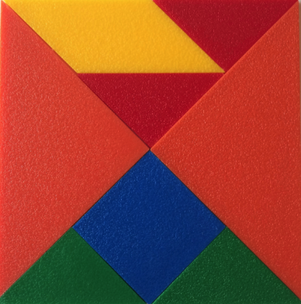  Fraction Talks

Tuesday, October 20th
Learning Goals: I will solve problems and create computational representations of mathematical situations by writing and executing code, including code that involves sequential and repeating events
Task: The Turtle Returns  - Play with the Turtle Pond simulation until you can move the turtle to the pond. What is the fewest number of moves in which you can do this?  - Imagine the turtle has already had a swim, and just wants to go for a stroll. Can you program the turtle to walk the shape of a square? What do you need to remember about squares to make this work?  - If you wanted a friend to walk the shape of a square, how could you give more efficient directions than the ones you gave to the turtle?  - Add more angle choices for your turtle by changing by clicking on to get  - Program the turtle to walk the shape of a parallelogram, and then a trapezoid.  - What challenges did you encounter when creating these new shapes? Is there anything that is important to remember? Discuss your process with someone in your home. |  | 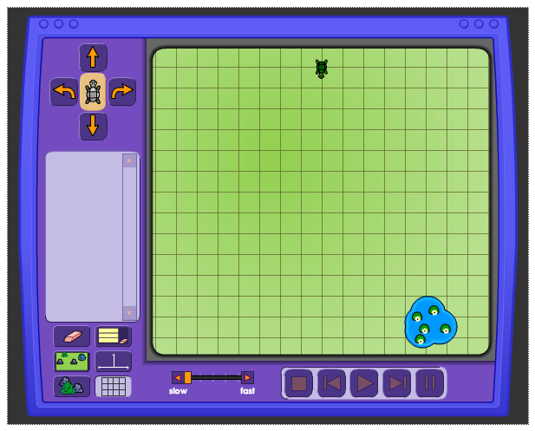  Turtle Pond

Wednesday, October 21st
Learning Goal: I am learning to plot and read coordinates in all four quadrants of a Cartesian plane, and describe the translations that move a point from one coordinate to another
Task: Coordinate Fours  Materials: Game board, 2 whiteboard dry erase markers (different colors).  Game Objective: The game is won by making THREE straight lines of 4 in a row. The lines may each share 1 common mark. The first person or team to do this wins the game.  Skill Objective: Allow students to practice the concept of graphing positive and negative coordinate points in a fun, engaging, and meaningful fashion.  How to Play:  - Display the game board on an overhead projector (or give to each group playing the game).  - Decide who will go first by using the "rock, paper, scissor" method.  - Player 1 selects a point by giving the coordinates and placing his/her mark on that point.  - Player 2 must be sure to watch carefully to be sure that Player 1 properly places their mark on the board (remembering that X comes before Y). At this point it becomes Player 2's turn. Player 2 repeats step 3.  - Players alternate turns until someone has successfully made THREE straight lines of four in  - any direction in a minimum of two different quadrants. The winning lines can share one mark  - with another line and a minimum of two quadrants must be used.  IMPORTANT NOTE: ALL THREE LINES CANNOT BE IN THE SAME QUADRANT. AT LEAST ONE OF THE LINES MUST BE IN A QUADRANT SEPARATE FROM THE OTHER LINES. HOWEVER, EACH OF THE THREE LINES CAN BE IN DIFFERENT QUADRANTS.  IMPORTANT NOTE: IF A LINE CROSSES AN AXIS, THUS IT IS SHARED BY TWO DIFFERENT  QUADRANTS, THE QUADRANT WITH TWO OF THE POINTS IS CONSIDERED THE LOCATION OF THAT LINE. THIS IS IMPORTANT WHEN DETERMINING WHICH QUADRANT A LINE IS IN TO ENSURE A MINIMUM OF TWO DIFFERENT QUADRANTS ARE USED TO WIN THE GAME.  Source: http://www.pepnonprofit.org/uploads/3/4/0/7/34070191/coordinate_fours.pdf |  | 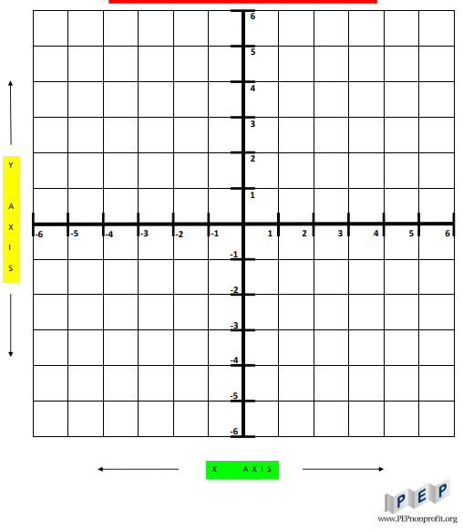

Thursday, October 22nd
Learning Goal: I will create and translate repeating, growing, and shrinking patterns including whole numbers, fractions, and decimals, using various representations; I will create computational representations of mathematical situations
Task: A Trick of the Eye  - Optical art contains geometric shapes and patterns. Sometimes these patterns trick the eye with an “optical illusion”.  - Look at the three examples. Do you see anything in the patterns that tricks the eye?  - Using a 100-square area on grid paper (10x10), create your own interesting pattern. Can you create an optical illusion within your artwork?  - Can you see any patterns, fractions or decimals in your artwork? Where are they?  - Think of a mathematical question you could ask about your artwork.  - If someone wanted to recreate your artwork, what directions would you give them? Share your directions with someone in your household, and see if they can draw your pattern.  Task adapted from youcubed |  | 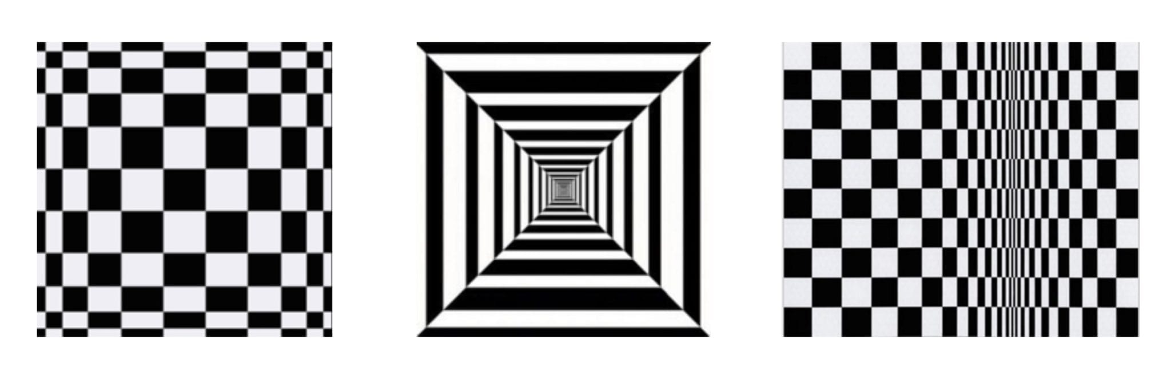  A larger image of the illusions is here  For printing, a grid clipart is here

Friday, October 23rd
Learning Goal: I am learning to use the row and column structure of an array to measure the areas of rectangles and to show that the area of any rectangle can be found by multiplying its side lengths.
Area of Rectangles  Number of Players: 2  Materials - Colour Tiles learning tool or you can print off a grid on a piece of paper  - Create a large rectangle using the annotation tool.  - Shuffle four sets of number cards 1 to 7 and place them face down in a pile.  How to Play the Game:  - Decide who goes first.  - Players take turns:  - picking two cards from the pile  - creating a rectangle using colour tiles with the dimensions noted on the two cards  - placing these tiles in the empty space in the large drawn rectangle  - writing a multiplication equation for the area of their rectangle created by the tiles  - When the pile of cards is finished, or there are no more moves possible, the players find the sum of their products. The player with the greatest sum wins the game.  Thinking questions:  - Does it matter which order we multiply the numbers together? Why or why not?  - What strategies did you use to determine the area of your rectangles?  https://www.mathies.ca/files/WINS/5_SituationsInvolvingProductsTo50.pdf |  | 