Math Tasks: Intermediate (Grades 7-8)

Tuesday, October 13th
Learning Goal: Identify the transformations that occur in tessellations
Task: Tessellation Transformation  Using the Shape Tool, create a tessellated shape with the following criteria:  - Your shape must contain three or more polygon types.  - To create your shape, you may translate polygons to any position. You must also show at least one example of each of the following transformations: vertical reflection, horizontal reflection, and rotation.  - Dilation may be used, if the re-sized polygon fits into the tessellation.  Predict what a mirror image of your entire tessellated shape will look like. If you like, try sketching the mirror image with pencil and paper.  Use the tool to view the mirror image of your shape. How close did you come with your prediction?  Using the tool, create a rotation of your entire tessellated shape. Did you meet any challenges in this process? What were they? Discuss your process with someone in your home. |  | Shape Tool

Wednesday, October 14th
Learning Goal: Describe and perform reflections and translations on a Cartesian plane
Task: Reflecting on Reflections  - Using the Graphing Calculator, plot the vertices (points) of a polygon of your choice in the cartesian plane. Your polygon can be regular or irregular.  Coordinate pairs are entered as in this example, making points visible on the graph:  Challenge: can you figure out how to join the points?  - On a new line, write coordinates for a reflection of your polygon in the vertical (y) axis.  This means the y-axis is used as a mirror. You may adjust values as needed until your reflection is accurate.  - What do you notice about these new vertex coordinates? What is different from the coordinates for your original polygon? What stays the same?  - Based on your observations, predict which coordinates will reflect your original polygon in the horizontal (x) axis.  - Use the graphing calculator to test your prediction. Were you correct? If not, adjust, and try again.  - What advice would you give to someone for translating/shifting the vertices of any polygon 5 units up, down, left, or right? Does your advice work for your original polygon? Discuss your results with someone in your home. |  | 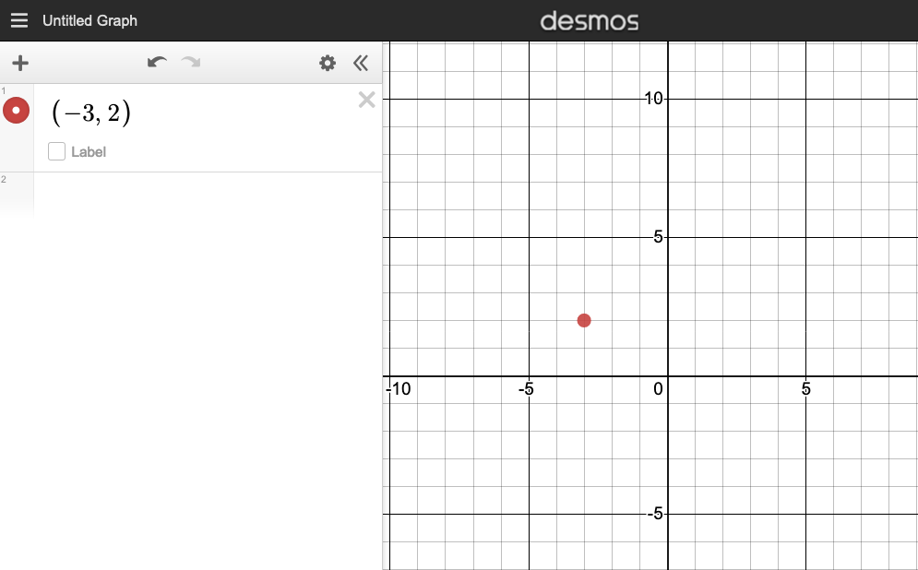  Graphing Calculator

Thursday, October 15th
Learning Goal: Identify and compare a variety of repeating, growing, and shrinking patterns, including patterns found in real-life contexts, and compare linear growing patterns on the basis of their constant rates and initial values; Create an infographic about a data set, representing the data in appropriate ways, including in tables and scatter plots.
Task: Growing Greens  - In late spring, two students hear their family talking about a new community - based farming project.  The students decide to try planting okra and spinach plants in a container garden at home. They are wondering: Are vegetables actually easy to grow?  - For a school project, they record the growth of their plants over several weeks.  They start measuring an okra plant when it is 5 cm tall, and find that its height increases by around 1.4 cm every day.  They start measuring a spinach plant when it is 3 cm tall, and find that its height increases by around 1.6 cm every day.  - They want to harvest some spinach leaves when the plant is 30 cm tall. Around how many days will they need to wait, starting from the day of their first measurement? Explain how you found your answer. Can you confirm your answer using algebra?  - Is there a day on which the two plants will be the same height? Which day is it, and how can you tell?  To help, use either the Data Grapher tool or pencil, ruler, and grid paper.  Data Grapher Tech Tips:  The “+” buttons add rows and columns.  Adding a “Column 3” allows you to include y-values for a second relationship. Make sure the drop-down at the top is set to “y”.  Choose “Line”, and when you are ready to see your graph, click “Preview”  (table is an example only)  - Imagine a plant that starts out taller than the okra, but then grows at a slower rate. What could its growth look like on a graph?  - Add values for this third plant to your graph. Is the graph’s appearance what you expected? Explain what you observe to someone in your home. |  | 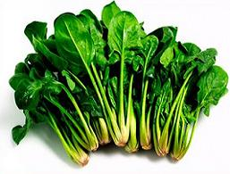  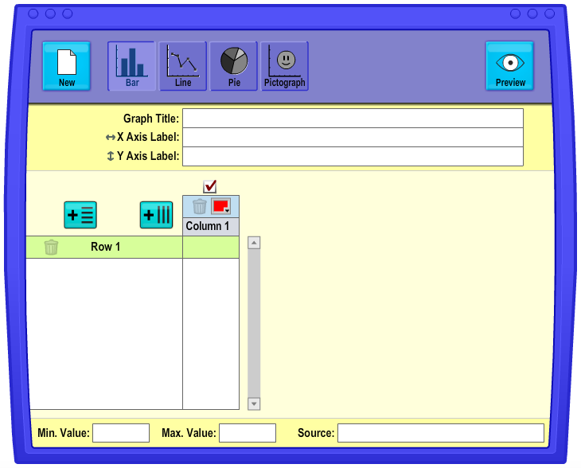  Data Grapher

Friday, October 16th
Learning Goal: Collect qualitative data to answer questions of interest, and organize the sets of data as appropriate. Select from among a variety of graphs, including circle graphs, the type of graph best suited to represent various sets of data
Task: Category Query  - In your home, identify a type of object that you can sort into categories, e.g. colours of cars that pass by; groups of food; types of clothing  - Create a question you can answer about an object category, e.g. I wonder if silver is the most common car colour; I wonder what percent of food in my home is grains  - Gather the qualitative data that will help you to answer your question, and represent the data in an appropriate graph of your choice.  You can use the Data Grapher tool, or pencil and paper.  Data Grapher Tech Tips:  The “+” buttons add rows and columns.  Choose the type of graph you want, label the categories, and enter your data.  When you are ready to see your graph, click “Preview” (table is an example only)  - From the information in your graph, can you draw a conclusion to answer your question? Why or why not?  - Determine the percent of the overall data in each category. What strategy did you use to calculate percent?  - Does knowing the percent in each category make it easier for you to draw a conclusion? Explain. |  | Data Grapher

