Math Tasks: Intermediate (Grades 7-8)

Monday, October 5th
Learning Goal: I will read, represent, compare, and order rational numbers
Task: Which One Doesn’t Belong - Fractions  - Which fractions do you think belong together, and why? Is there more than one way to make a group of fractions that belong together?  - Which fraction doesn’t belong with the other three? For each fraction, can you find a mathematical reason why it doesn’t belong?  - It’s your turn! Create a “Which One Doesn’t Belong” with four different fractions of your choice. Make sure there are at least two different ways to choose a fraction as not belonging to the group. |  | 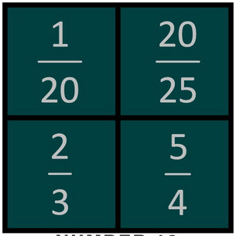  By Helene Matte in Numbers

Tuesday, October 6th
Learning Goal: I will use the properties and order of operations, and the relationships between operations, to solve problems involving rational numbers, ratios, rates, and percents, including those requiring multiple steps or multiple operations
Task: Krypto Challenge  - Try the interactive Krypto game. Use the numbers provided, along with the four arithmetic operations, to make the target number. Each operation is only used once.  - Complete at least three rounds of interactive Krypto.  - Now, it’s your turn to create a different kind of Krypto!  - Choose five numbers between 0 and 4. At least three numbers must be fractions.  - Use each of the four arithmetic operations between your five numbers  - Determine the target number. It must be a whole number between 1 and 5.  - Arrange your five numbers at random, state the target, and ask a friend or family member to play! |  | 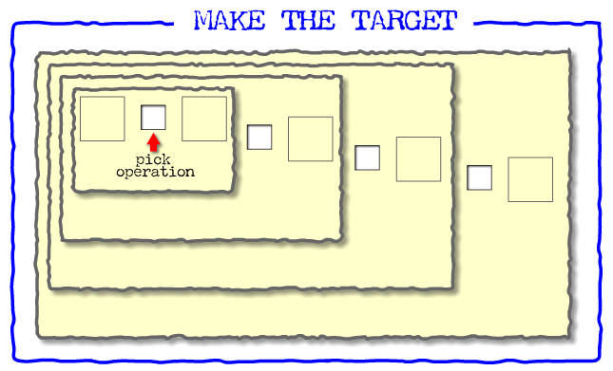  Primary Krypto

Wednesday, October 7th
Learning Goal: I will determine the experimental probabilities of multiple independent events happening, and reason about the theoretical probabilities
Task: Plinko Probability  - In the game of Plinko, each ball can move diagonally right or left, downward only. At any point, it is equally likely that the ball will fall right or left.  - In the Plinko Probability Intro, let one ball fall. Notice the path of the ball. Let another two balls fall. What do you notice about where all three balls end up?  - How many possible paths can a ball take to get to the bin on the furthest left? Is there another bin with the same number of paths? Explain.  - Let 100 balls fall. What do you notice about the result? Describe any pattern you see. Why do you think this pattern occurs?  - For the experiment you just did, write the probability (out of 100) of a ball falling in the middle bin.  Run the experiment two more times. Is the probability for the middle bin the same each time? Explain why or why not.  - Switch to the Lab section of the tool. Ask someone in your home to predict where the greatest number of balls will fall. Run the lab with balls falling continuously, and discuss what you see! |  | 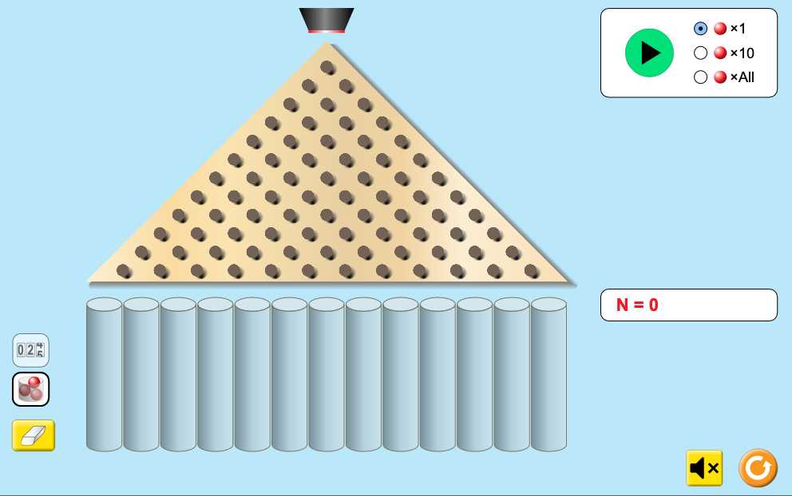  Plinko Probability Intro

Thursday, October 8th
Learning Goal: I will represent and compare very large and very small numbers, including through the use of scientific notation, and describe various ways they are used in everyday life
Task: Do the Wave  - Visible light (light we can see) comes in waves, and the length of the wave determines the colour. Cone cells at the back of the eye detect the waves, and send nerve signals to the brain.  - Visible light waves are the only type of electromagnetic radiation we can see.  - From the top image, identify three other ways we use electromagnetic radiation in our daily lives  - From the bottom image, choose a very long wave and write its length as a decimal number. How many zeros does it have to the left of the decimal place?  Then, choose a very short wave, and write its length as a decimal number. How many zeros does it have to the right of the decimal place? Is this what you expected?  - Compare your long wave to your short wave. How many times longer is it? Explain your reasoning.  - Can you find a shortcut for your comparison just by looking at the numbers in exponent form?  Test out your idea on two other wavelengths and see if you are correct! |  | 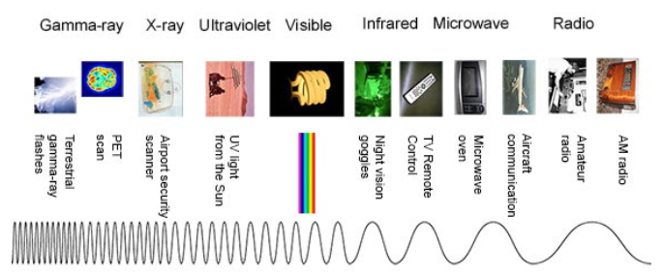  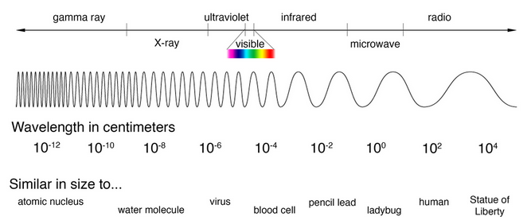  Larger images are here  From powers of 10 to decimals examples here

Friday, October 9th
Learning Goal: I will create computational representations of situations by writing code that includes conditional statements, sub-programs, and other control structures.
Task: Program your Day!  - Think about a typical school day for you, in-person or remote.  - Make a list of all decisions you make that depend on some fact about your situation. Each of these is a conditional. It needs an “if-then” statement, and an “else” if there is an alternative.  Examples: If it is raining, then I put on a raincoat.  If there is milk, then I have cereal; else (otherwise), I have bread.  - Make a list of any tasks you repeat back-to-back, and when you stop doing the task. Each of these repetitions is a loop.  Examples: I keep pushing the button for the elevator until it arrives  I check my virtual classroom until I see today’s assignment  - Make a list of any tasks you group together for one purpose. Each of these groups is a subroutine.  Examples: To get ready, I brush my teeth, wash my face, and do my hair  To pack my bag, I put in my lunch, binder, pencil case, masks, and sanitizer.  - Finally, you will write a set of directions for your school day. List in order your conditional, loop, and subroutine tasks, along with any other tasks you do (e.g. walk to the bus).  - Share this program with someone in your house, and see if there is anything else you need to include! |  | 