**SEPTEMBER HIGHLIGHTS**

* Check it Out, Contacts, Important Dates, Parent/Guardian/Caregiver Resources
* Mental Health Action Plan
* Special Education Advisory Committee (SEAC)
* Parent Concern Protocol
* International Day of Sign Language
* International Week of Deaf People
* International FASD Awareness Month
* Updates to UDL Guidelines

**CHECK IT OUT!**

* [**All Are Welcome – Read aloud kids book in full screen and with music!**](https://www.youtube.com/watch?v=O5gia39y5uo)
* [**What is UDL? Universal Design for Learning Explained (3 minutes)**](https://www.youtube.com/watch?v=eYN-qrKIIYI)
* [**Inclusive education video series: Positive behaviour approach**](https://www.youtube.com/watch?v=BU4EqfXr970&t=53s)
* [**The 5-4-3-2-1 Method: A Grounding Exercise to Manage Anxiety**](https://www.youtube.com/watch?v=30VMIEmA114)
* [**Introduction to 5-4-3-2-1 and Skill Practice**](https://www.youtube.com/watch?v=BsKpumL-ohQ)
* [**Circle Of Control Activity For Kids - Good Mental Health And Stress Management**](https://www.youtube.com/watch?v=L9zwduYp9G0)

**The Ontario Autism Program (OAP)** is a government-funded service that provides support to families of children and youth with Autism. Any child or youth under 18 with a written diagnosis of Autism Spectrum Disorder (ASD) can register. Families can choose from different service options, including the Entry to School (ETS) program.

More details are available on the [**ACCESS OAP**](https://accessoap.ca/) website.

**IMPORTANT DATES;**

**KEY DATES 2024-2025**

**ELEMENTARY PD DAYS:**

September 27, 2024: Professional Development

October 11, 2024: Professional Development November 15, 2024: Parent-Teacher Conferences

November 29, 2024: Professional Development January 17, 2025: Professional Development

February 14, 2025: Parent-Teacher Conferences

June 6, 2025: Professional Development

SECONDARY PD DAYS:

October 11, 2024 – Professional Development November 15, 2024 - Professional Development

November 29, 2024 - Professional Development

January 30, 2025 - Professional Development February 14, 2025 - Professional Development June 26, 2025 - Professional Development

June 27, 2025 - Professional Development

SCHOOL YEAR HOLIDAYS (as per Ministry of Education)

Labour Day: September 2, 2024

Thanksgiving: October 14, 2024

Winter Break: December 23, 2024 – January 3, 2025

Family Day: February 17, 2025

Mid-Winter Break: March 10-14, 2025

Good Friday: April 18, 2025

Easter Monday: April 21, 2025

Victoria Day: May 19, 2025

**Parent/Guardian/Caregiver Resources:**

[**Special Education Parent Guides**](https://www.tdsb.on.ca/Learning-Equity-and-Well-Being/Special-Education-and-Inclusion/Parent-Guides-to-Special-Education-and-Inclusion)

**Resources**

* [**Mental Health at School**](http://www.mentalhealthatschool.ca) **-** A mental health directory of local agencies:
* [**The Access Point**](http://theaccesspoint.ca) **-** TO Mental Health & Addictions Access Point (16+) A resource hub of caseworkers to connect you to one of their 54+ (free) agencies.
* [**MentalHealth**](http://www.ementalhealth.ca) **-** Mental Health Directory for counselling, crisis centres, and mental health facilities by area.
* [**Geneva Centre for Autism**](http://www.dsto.com) **-** Information on Programs and Services
* [**Community Networks of Specialized Care**](http://www.community-networks.ca) **-** Community Networks of Specialized Care is a Cross-sectoral specialized service system that supports people with a developmental disability and mental health and/or behavioural needs
* [**Ontario Autism Program**](https://www.ontario.ca/page/ontario-autism-program) **-** Ministry of Health information on creating AccessOAP account, Entry to school programs, Urgent response services, Foundational family services & Caregiver-mediated early years programs
* [**Mental Health Services for Children and Youth**](https://www.ontario.ca/page/mental-health-services-children-and-youth) **-** Ministry of Health call a helpline, Tele-Mental Health Service, Secure treatment
* [**Indigenous children and youth programs**](https://www.ontario.ca/page/indigenous-children-and-youth-programs) **-** Ministry of Health Indigenous Healing and Wellness Strategy programs, Family Well-Being program, Ontario Indigenous Children and Youth Strategy
* [**TDSB Urban Indigenous Education Centre**](https://www.tdsb.on.ca/indigenouseducation/)- Information for families (programs, community engagement, resources, events and news)
* [**CAMH**](https://www.camh.ca/) **-** The Centre for Addiction and Mental Health
* [**TDSB Innovation: Gender and Sexual Diversity**](https://www.tdsb.on.ca/About-Us/Innovation/Gender-Based-Violence-Prevention) **-** Social work support for families and students
* [**CEBSA Centre of Excellence for Black Student Achievement**](https://www.tdsb.on.ca/CEBSA)

[**Pathways to Care for Mental Health Virtual Office Hours**](https://www.tdsb.on.ca/Elementary-School/Supporting-You/Mental-Health-and-Well-Being-Professional-Support-Staff-PSS/Virtual-Office-Hours)

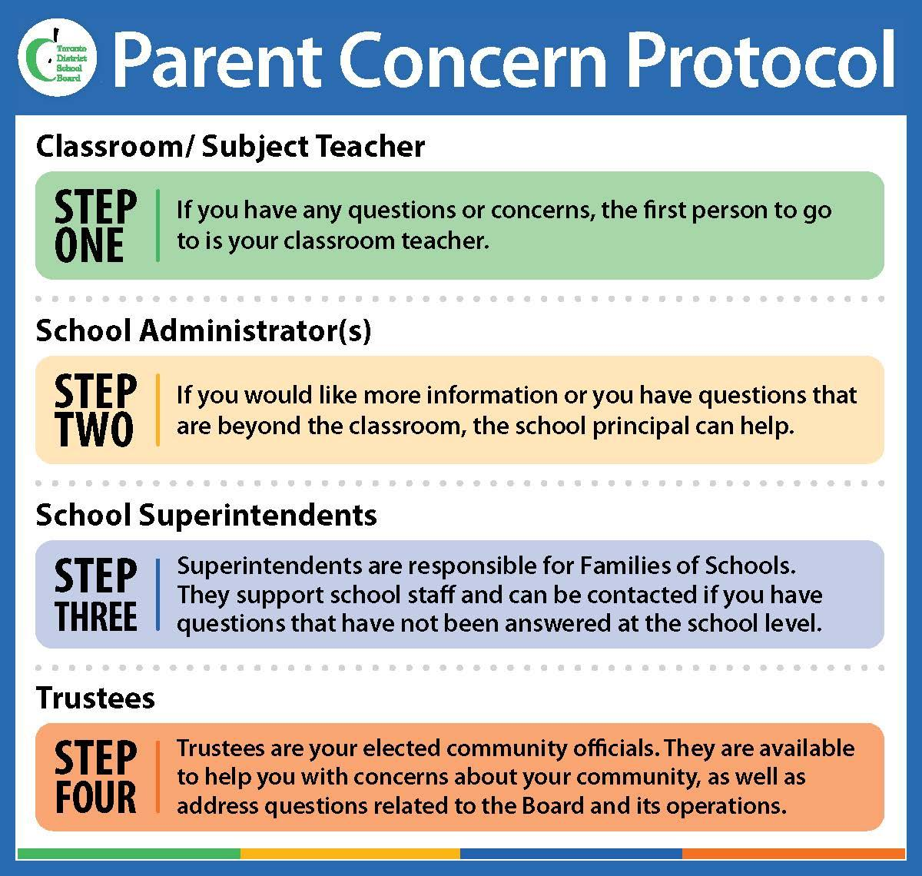

**Special Education Advisory Committee (SEAC)**

The [Ontario Education Act Regulation 464/97](https://www.ontario.ca/laws/regulation/970464) outlines the role of SEAC (Special Education Advisory Committee). SEAC advises the TDSB on special education matters and makes recommendations on how to improve special education programs and services for exceptional students. The TDSB values SEAC's input and considers its recommendations to better support students with disabilities and special needs.

For more information, visit the [TDSB SEAC page](https://www.tdsb.on.ca/Community/How-to-Get-Involved/Advisory-Committees/Statutory-Advisory-Committees/Special-Education-Advisory-Committee).

**September is F**[**ASD Awareness**](https://mytdsb01.tdsb.on.ca/+CSCO+0h756767633A2F2F6A6A6A2E736E66717A626167752E706E++/) **Month**

The Government of Canada [officially recognized September as Fetal Alcohol Spectrum Disorder (FASD) Awareness Month](https://mytdsb01.tdsb.on.ca/+CSCO+0h75676763663A2F2F6A6A6A2E706E616E716E2E706E++/en/health-canada/services/calendar-health-promotion-days.html). This month is devoted to raising awareness of FASD to improve prevention, diagnosis and support for individuals with FASD. Historically, research and discussion about FASD has focused on challenges. While this discussion is necessary, it is also important to recognize people’s unique talents,

abilities and interests. When we don’t explore the success of people with FASD, and celebrate their contributions, we fail to recognize their immense potential.

The theme for this year’s FASD awareness month is **Everyone Plays a Part**. For more information on how you can get involved, please visit: [**CanFASD 2024**](https://canfasd.ca/fasd-awareness-month/everyone-plays-a-part/)

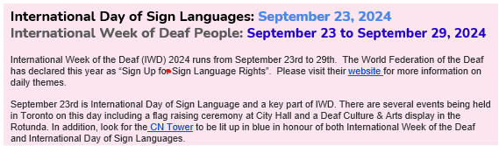

[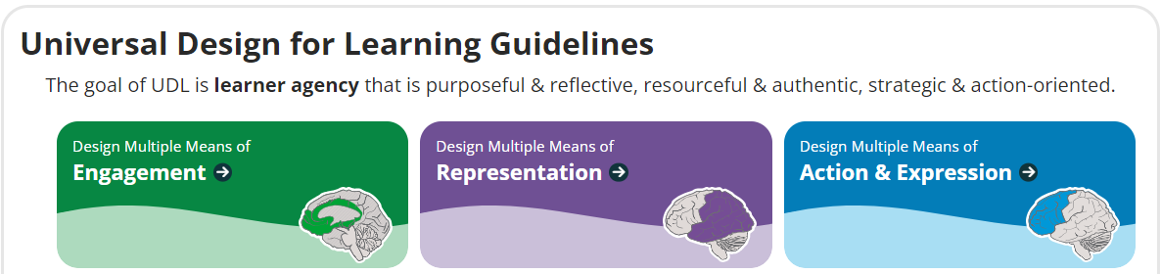](https://udlguidelines.cast.org/)

This new update to the [**Universal Design for Learning Guidelines**](https://udlguidelines.cast.org/), released in July 2024, builds upon previous iterations and emphasizes addressing barriers rooted in biases and systems of exclusion. This expanded version intentionally includes those practitioners and scholars whose experiences and perspective may not have been recognized in previous versions. This update aims to fulfill the promise of the Guidelines as a resource to guide the design of learning environments and experiences that reduce barriers and more fully honor and value every learner.

For a side-by-side comparison of what changed from Guidelines version 2.2 to Guidelines version 3.0, please explore: "[**Changes from Guidelines 2.2 to Guidelines 3.0**](https://docs.google.com/document/d/1v7aaJ74XMGaIUb4G1sgfe4ffEo9PXLodc8338GMxPUU/edit?usp=sharing)"