Tuesday, September 22
Learning Goal:  - I can use scientific and research skills to investigate local water issues. | Task  - Observe: These videos highlight some of the challenges and possible solutions to maintaining clean and accessible drinking water.  - Think: What are some of the ways that you can conserve water in your home? School?  - Design & Build: Using found materials or 3D modeling software like Tinkercad or SketchUp for Schools design and build a model that reduces the use of water in a community (e.g school)  - Reflect: Share your work with a peer/adult and try to convince them why it is important to adopt your method. What feedback did you receive from them? | Video 1: The Story of Water  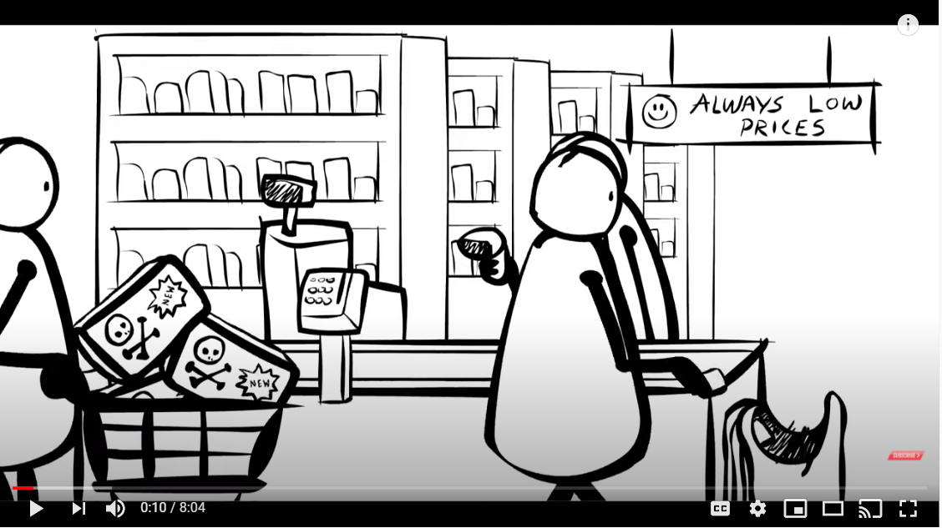  https://www.youtube.com/watch?v=Se12y9hSOM0&feature=youtu.be  Video 2: Build a Water Collection System  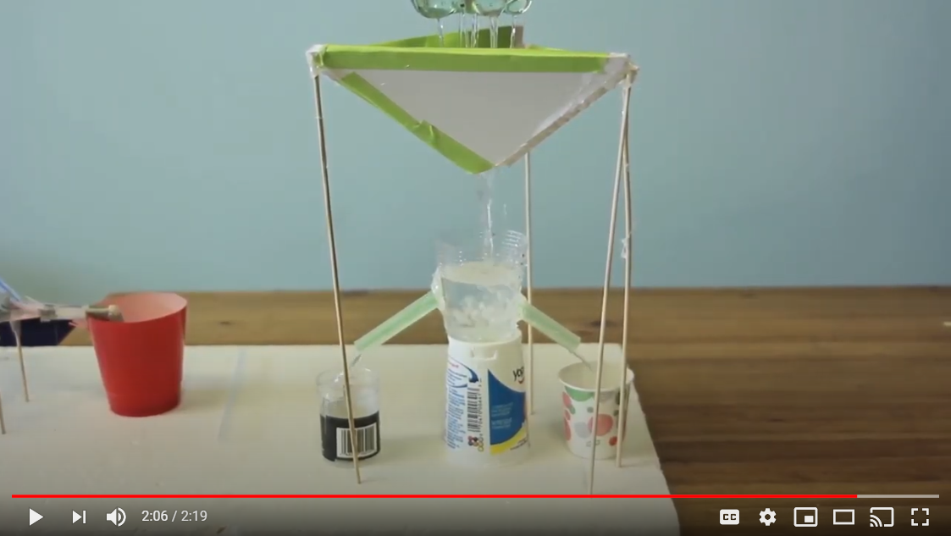  https://www.youtube.com/watch?v=iFUsi3wIr4k
Thursday, September 24
Learning Goal:  - I can use a variety of media (images, text, sound, video) to communicate what I know about ecosystems. | Task  - Research: Using the City of Toronto e-book, Mammals of Toronto find out everything you can about a local animal (e.g. racoon).  - Design: Use Google Slides, PowerPoint or pencil and paper to create an infographic or poster that communicates the role healthy ecosystems play in the survival of your animal.  - Reflect: What information about the animal do you think is most important for people to know. Using social media platforms like Twitter or Instagram, create awareness by writing 1-2 sentences that clearly communicate your thoughts | Mammals of Toronto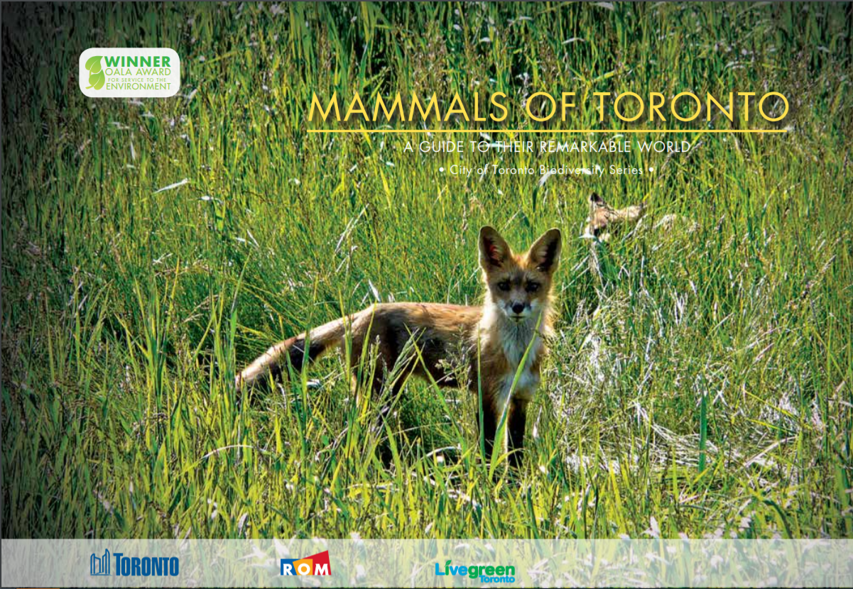  Video: https://www.toronto.ca/wp-content/uploads/2017/08/9718-Biodiversity-MammalsBook-Division-Planning-And-Development-part1.pdf

