Science, Technology & STEM Grade 1-3

Tuesday, September 22
Learning Goal:  - I can predict, observe and explain some of the different ways that plants grow and change. | Task  - The video shows a kidney bean growing in soil for 25 days  - Predict: how do you think the bean will change at the end of the video?  - Observe: how does the bean move as it grows?  - Explain: Draw, write or tell an adult what you noticed. Did the bean do what you thought it would do?  Video:https://www.youtube.com/watch?v=w77zPAtVTuI | 25 Day Bean Time Lapse Video  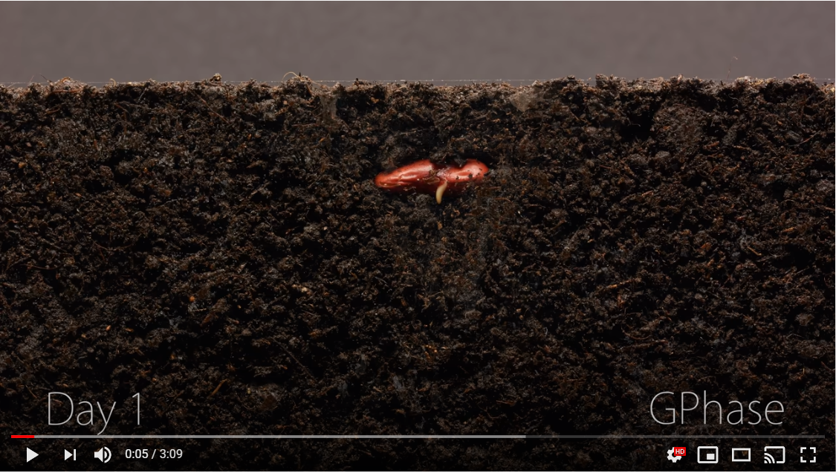

Wednesday, September 23
Learning Goal:  - I can predict, observe and explain why leaves change colour and fall from trees during autumn. | Task  - The video shows a close up of different leaves changing in Autumn  - Predict: What do you think the leaves will look like at the end of the video?  - Observe: How do the leaves shapes and colours change as time passes?  - Explain: Draw, write or tell an adult what you noticed. Did the leaves do what you thought they would do?  Video: https://www.youtube.com/watch?v=-dfmha1SJck | Leaves Changing Colour Time Lapse Video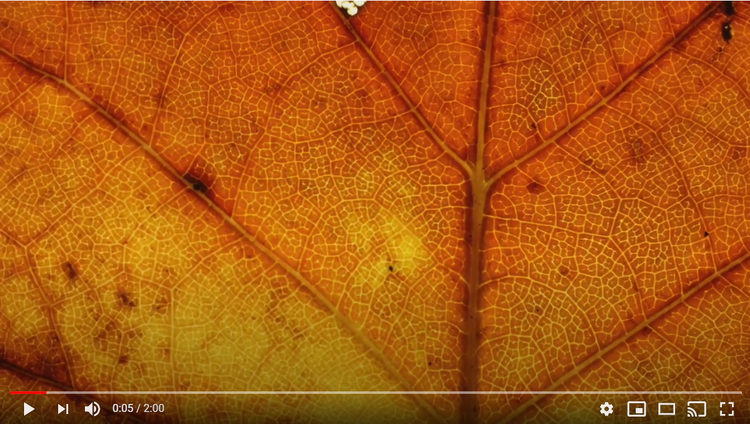

Thursday, September 24
Learning Goal:  - I can predict, observe and explain how a hummingbird uses its tongue to eat. | Task:  - The video shows a close up of a hummingbird using its tongue to get food.  - Predict: Why do you think the hummingbird eats in this way?  - Observe: Draw, write or tell an adult how the hummingbird gets food  - Explain: How is this way of eating similar or different from how other animals and insects eat?  Video: https://www.youtube.com/watch?v=QYoYQAbPXbU | Hummingbirds Tongues in Slow Motion  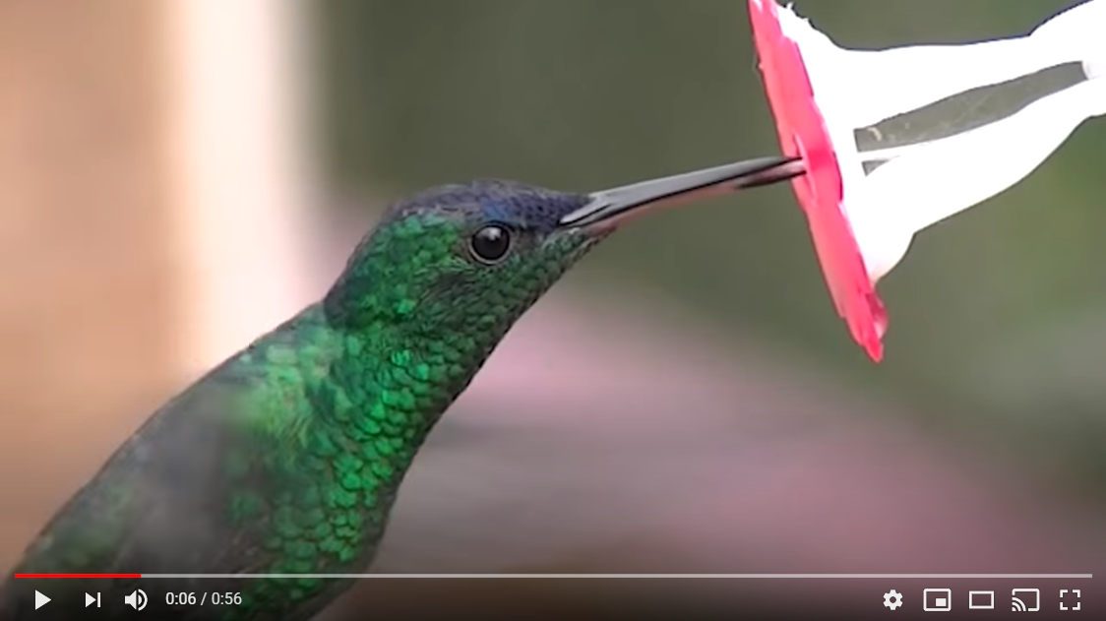

Friday, September 25
Learning Goal:  - I can predict, observe and explain how a glass of water will change over time. | Task:  - The video explains how water changes depending on its environment.  - Predict: place a glass of water on a table in your home and predict how it will change over the next 3 days.  - Observe: Draw, write or tell an adult any changes you see. For example, has the water level increased or decreased? Are there any bubbles forming on the glass? Is there the same amount as there was on day 1?  - Explain: Use ideas from the video to help explain your observations to a friend. | Crash Course Science: The Great Aqua Adventure  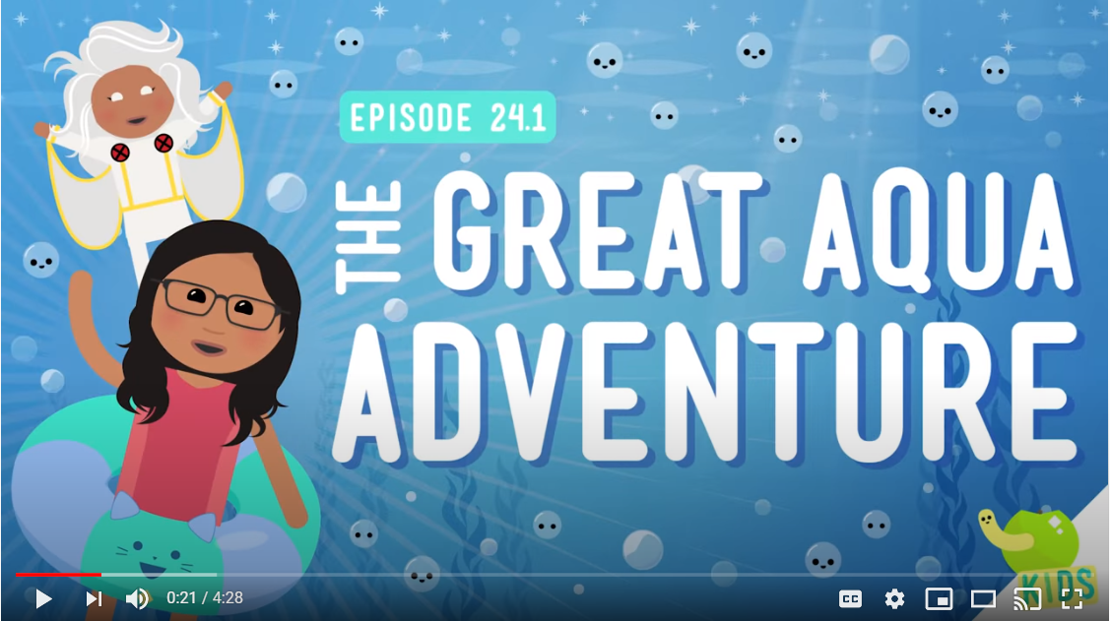  Video: https://www.youtube.com/watch?v=z5G4NCwWUxY

