In order to access some resources, it will be useful to have an account with Idello. | - offers free French-language educational videos, digital books, apps and games to engage K-12 children in their second language learning  - subtitles available (use of French subtitles is suggested)  - How to create an Idello account (parents and students).pdf  - IDÉLLO : Video Tutorial for Parents & Students on how to create an account
Chantons Ensemble  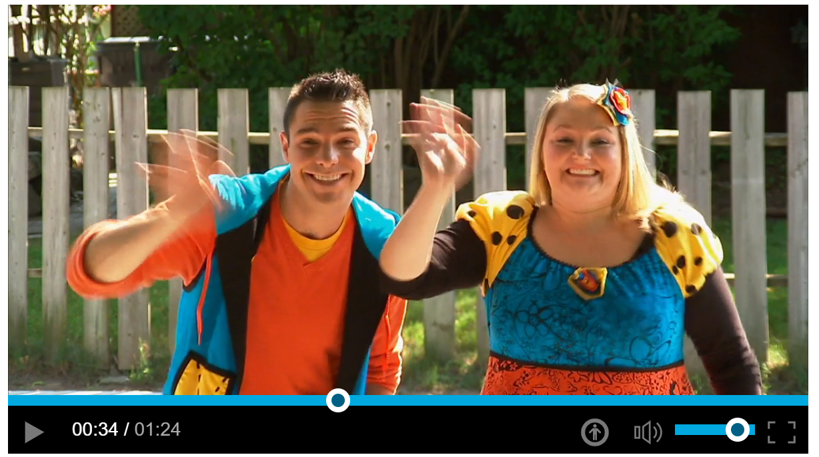 | - Listen to the song from yesterday again. Sing along with Josée and Louis! Chanson : Bonjour - Video - Écoute (FLS),
Les maths  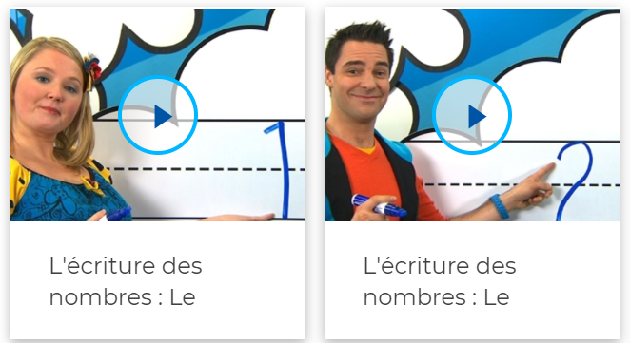 | - Watch these videos on how to write numbers.  - Write the numbers in the air. Draw them on a rough surface with your finger.  - Can you make these numbers with found objects?  - Write the numbers down on paper. Can you draw that number of objects?  https://www.idello.org/en/resource/4550-Lecriture-Des-Nombres-Le-Nombre-1?navcontext=13663  - Practice up to number 5 today.
Écouter une histoire  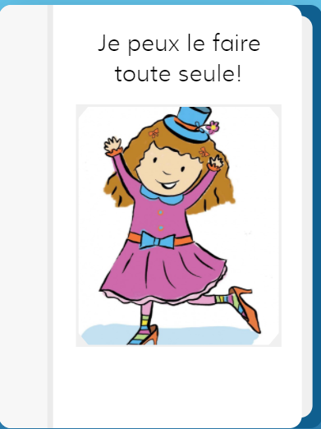 | - This is a story about Miss Topé. She can do many things by herself.  - Listen to this story https://app.boukili.ca/livre/18 . Choose “mode narration’.  - Look at the pictures to see what Miss Topé can do. “Elle fait toute seule”. Try to match the pictures with what you hear.  - Read the story a second time. Give a thumbs up when Miss Topé does something you can do.  - Try to repeat one page after Miss Topé.
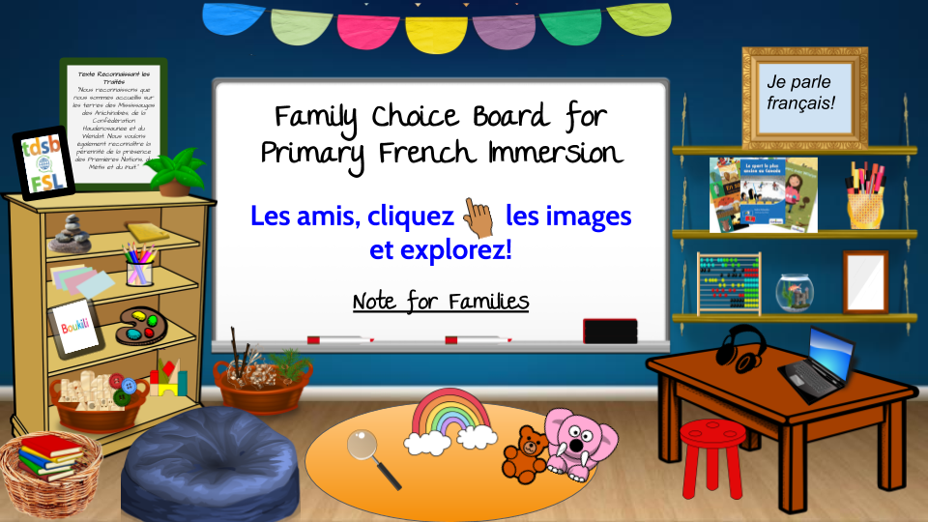 | Choose an activity from the Choice Board

