Asynchronous Learning for
SK-Grade 1 French Immersion

Week of November 16, 2020

Note: For this task, students must have an Idéllo account in order to access the video.
If you already have a student account (username and password) from previous years, you may continue to use it.
If you don’t have a student account, please create your free student account using code 03n7pv3718mp6.
For information and tutorials that show how to create an account, please visit TDSB FSL Resources for Families.
Please keep track of your username and password carefully.

Les émotions

Learning Goal: I can watch a video and show what I understand. I can make personal connections.
Instructions: Each day of the week, watch one video from the video series “Charlie et les ballons” on the Idéllo site. (Be sure to log in to your account.) Turn on the subtitles in French. Complete the activities suggested below for each of the videos.
Quelle émotion a le ballon?  How might you represent each emotion with movement or actions? Share an action or move around in a way that represents the balloons’ emotions. How might you put your movements together to make a little dance that shows each emotion?  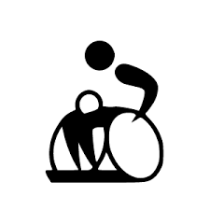 | Charlie makes some sounds to represent the emotions. Listen to him carefully. Can you detect what those sounds are?  Match the sounds to the emotion and draw an emoji that represents the emotion. Sometimes the emotion has no sound. How might you create one? (Use the subtitles to follow along for clues.)  Sound Emotion Emoji  ah triste  ha ha ha  rrrr  aaaah  zzzz  beurk  ah!
Quelle émotion a le ballon? How might you represent the emotions that Charlie is showing?  Use loose parts (found objects around you) or create a visual representation (ex. drawing, collage, modeling clay, etc) to express each emotion.  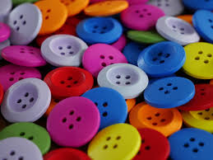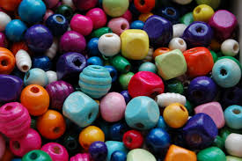 | How might we represent emotions with sounds? Share a sound that you think represents each of the emotions.  How might you put sounds together to make a song to represent the emotions? Make a song and share it with someone you live with.  Talk with someone in your home about when you might feel each emotion.

Image Sources

https://thenounproject.com/term/people-talking/2257688/
https://commons.wikimedia.org/wiki/File:Wheelchair_rugby_pictogram_(Paralympics).svg
https://www.pxfuel.com/en/search?q=crayon
https://www.pxfuel.com/en/free-photo-xsvhw
https://commons.wikimedia.org/wiki/File:Plastic_buttons_20190306.jpg
https://commons.wikimedia.org/wiki/File:Wooden_beads.JPG
https://pixabay.com/images/search/pebble/
https://thenounproject.com/term/sing-song/2311509/

