In order to access some resources, it will be useful to have an account with Idello. | - offers free French-language educational videos, digital books, apps and games to engage K-12 children in their second language learning  - subtitles available (use of French subtitles is suggested)  - How to create an Idello account (parents and students).pdf  - IDÉLLO : Video Tutorial for Parents & Students on how to create an account
Chantons ensemble  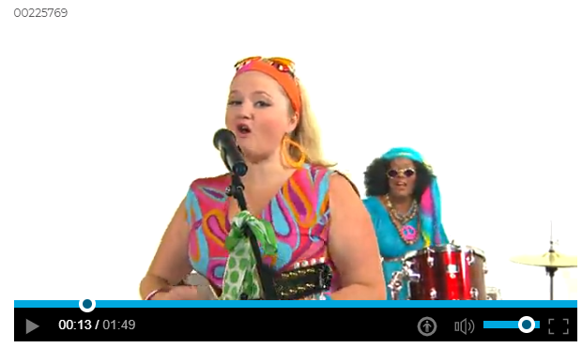 | - Listen to J’aime Papa again. Can you sing along? Follow the words with your finger if you can.  - Try a new song. Remember the story we read yesterday about Les jours de la semaine? This song is about the days of the week too. https://www.idello.org/en/resource/6843-Les-Jours-De-La-Semaine  - Click here for the words to the song.  - First viewing - watch and listen  - Second viewing - watch and listen, and follow along by reading the words.  - Third viewing- watch and try to sing along. Follow the words with your finger.  - Can you read the words of the days of the week?  - What is your favourite day and why? Tell someone in your house.
Les maths  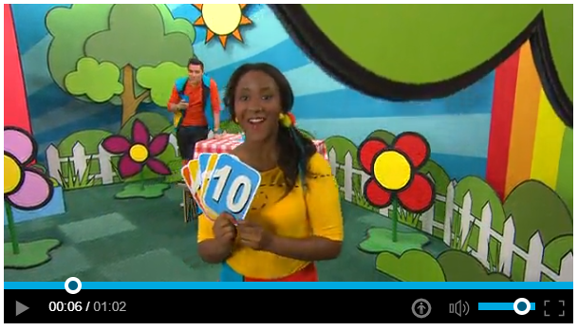 | - Try le défi de 10!  - Try the first action. Count along with the video in French.  - Make room so you can do the action safely!  - Try 3 other défis de 10 on the same page.  - Can you invent your own “défi de 10”? Challenge someone in your house to do your action 10 times. Count aloud in French.
Écouter une histoire | - In this story Lili la souris helps her friend Rose la rose.  - While the storyteller is telling the story, watch what objects she shows us to help us understand.  - Lili la souris et Rose la rose  - Point at the screen to show someone in your house who Rose is and who Lilli is.  - Can you tell someone in your house what problem Rose has? Can you tell them what Lilli does to help solve the problem?
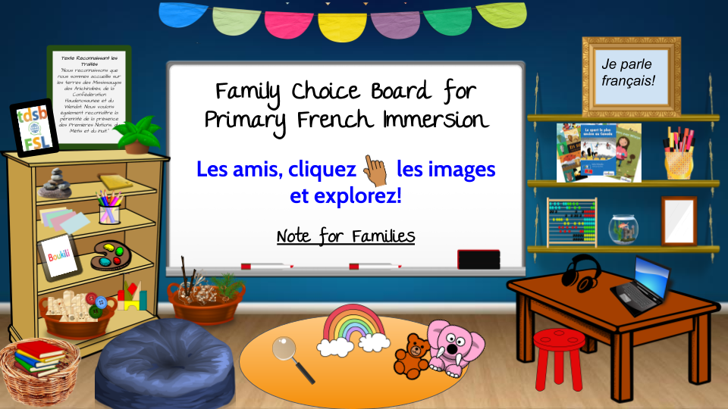 | Choose an activity from the Choice Board

