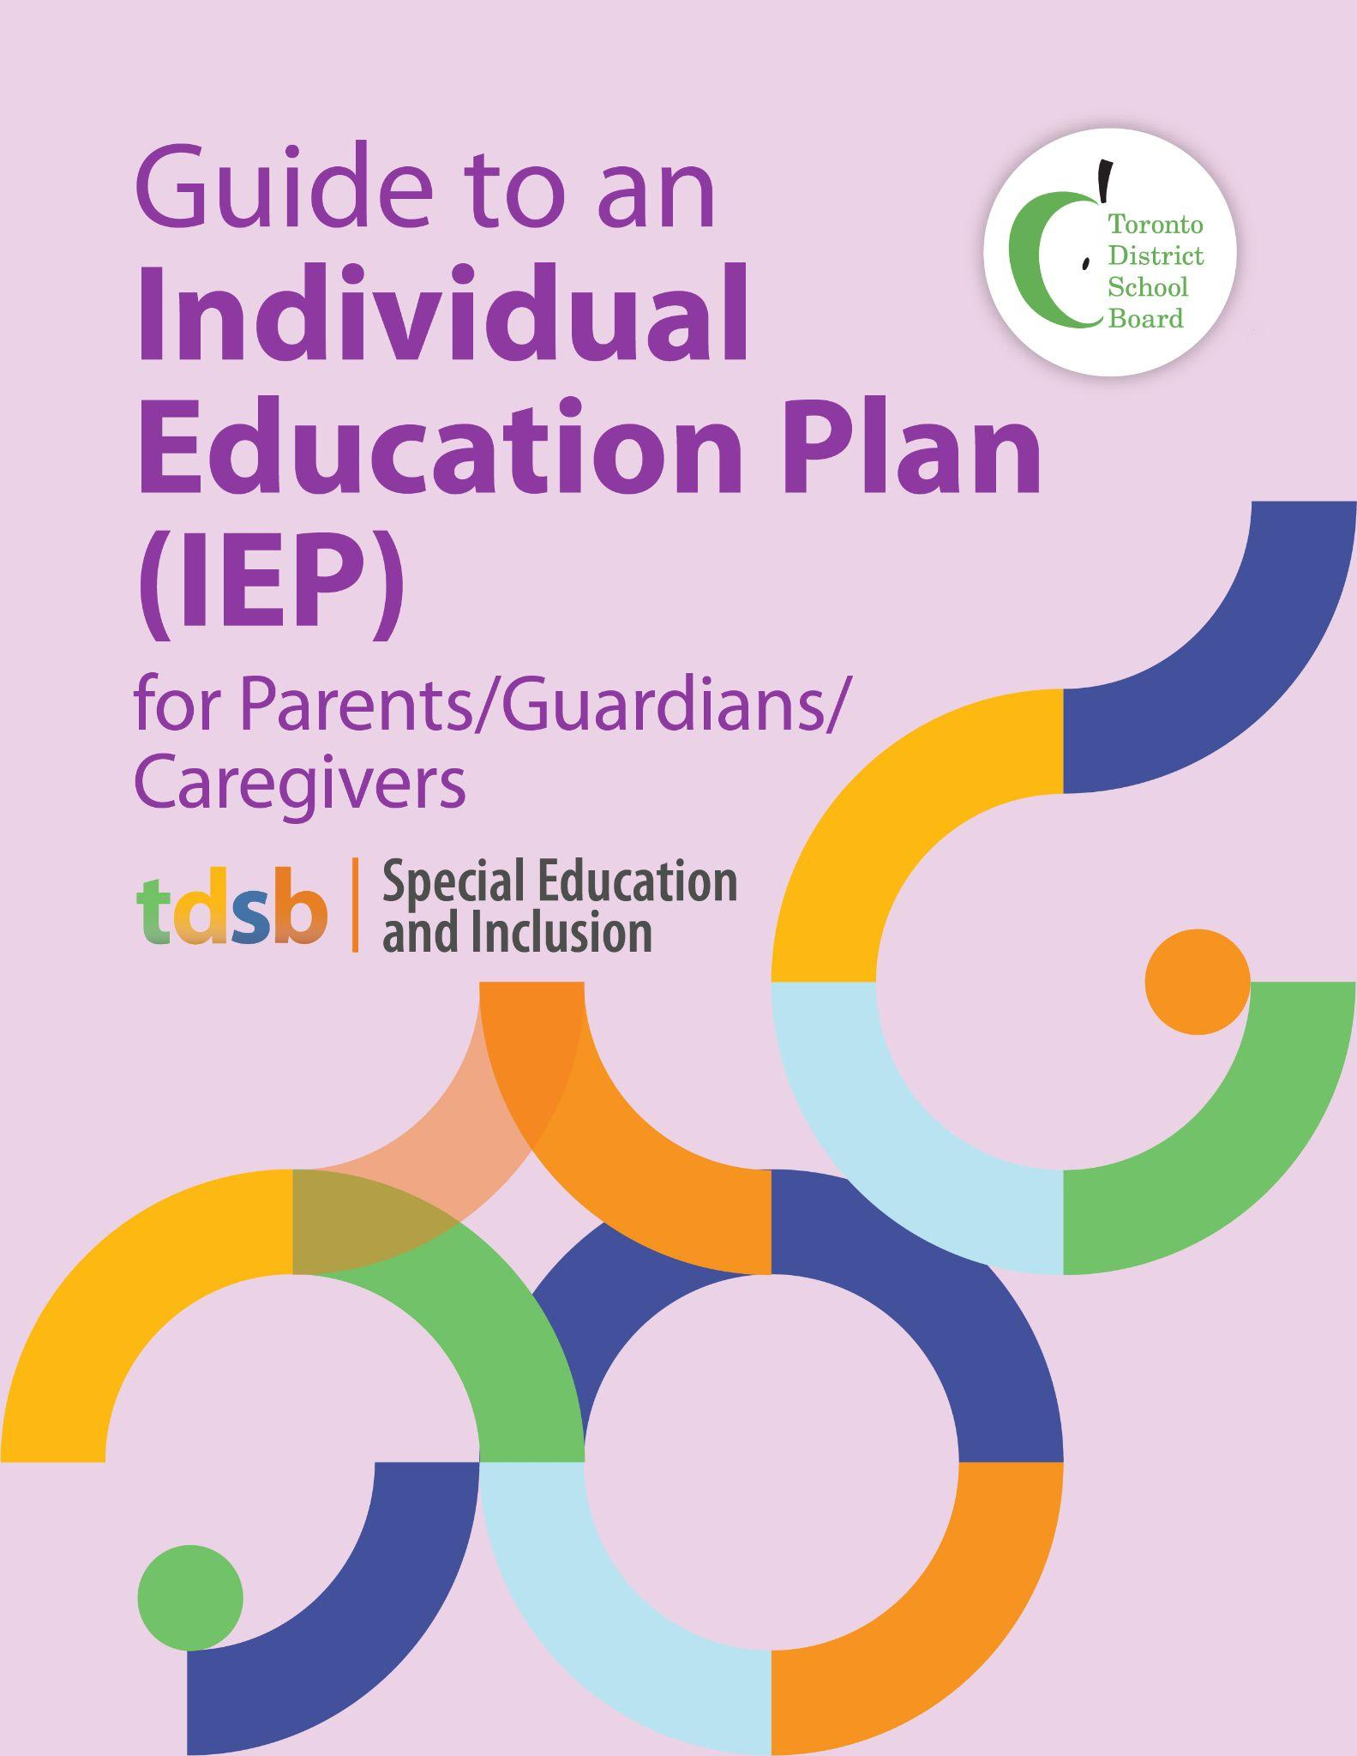
October 2022
Purpose of this Guide
This guide for parents/guardians/caregivers explains what an Individual Education Plan (IEP) is, outlines your rights as a parent and describes how your partnership is key to ensuring the appropriate programming (assessment and instruction) decisions are made for your child.

Guiding Principles
The Toronto District School Board (TDSB) is committed to student achievement and well being. We recognize that students develop and learn in different ways, and that some students require special education programs and services to meet their needs. TDSB staff are committed to working collaboratively with parents/guardians/caregivers and students in a respectful and transparent way, and value your partnership. We encourage you to approach your child’s teachers and principal to engage in discussions about your child in an ongoing manner. The sharing of information between yourself and school staff is critical to ensuring the success of your child.

The Special Education and Inclusion Department, in collaboration with all staff, are committed to providing equitable access to learning opportunities for all students. This includes our ongoing commitment to human rights, anti-oppression, equity, anti-ableism, and anti-racism. This commitment is aligned with the foundation of the TDSB Equity Policy and underpins all programming across all grade levels.

Parents as Partners
As parents/guardians/caregivers, you know your child best. You know your child’s strengths, abilities, needs, and areas for improvement. It is critical that you provide information about your child and participate in decisions that affect your child’s education. We hope that this guide will help you better understand the Individual Education Plan (IEP). Should you require additional information about IEPs, please contact your child’s teacher or principal.

What is an Individual Education Plan (IEP)?
An Individual Education Plan (IEP) is a plan that describes special education programs, services, or additional support a student receives. This written plan is a working document which describes a student’s strengths and areas for improvement, and the special education program, supports and services accessed or provided to meet the student’s individual needs.
The IEP helps with monitoring and assessing a student’s progress, and is adjusted as the student’s areas for improvement change. It is reviewed and updated at every reporting period.

An IEP is…
- a written plan describing the special education program and/or services, based on a thorough assessment of the strengths and needs;
- a working document that contains a transition plan;
- a record of any accommodations needed to help the student achieve the learning expectations identified in the IEP;
- a working document that identifies learning expectations that are modified from the expectations for the regular grade level, if modifications are required;
- a working document that identifies alternative expectations, if required, in areas not represented in the Ontario curriculum;
- a record of the teaching strategies specific to modified and alternative expectations and of assessment methods to be used to determine the student’s progress towards achieving these expectations;
- a working document that is developed at the beginning of a school year or semester or at the start of a placement and that is reviewed and adjusted throughout the reporting period;
- an accountability tool for the student, the student’s parents, and everyone who has responsibilities under the plan for helping the student meet the stated goals and learning expectations as the student progresses through the Ontario curriculum.

An IEP is not…
- a description of everything that will be taught to the student;
- a list of all the teaching strategies used in regular classroom instruction;
- a document that records all of the student’s learning expectations, including those that are not modified from the regular grade level curriculum expectations;
- a daily lesson plan.

Why is an IEP developed?
An IEP is developed for a student for one of the following reasons:
- An IEP must be developed for every student who has been identified as an “exceptional pupil” by an Identification, Placement, and Review Committee (IPRC) to plan special education programs and/or services in order to achieve curriculum expectations and to demonstrate learning.
- An IEP may be developed for a student who has not been identified by an IPRC as exceptional, but who requires a special education program and/or services in order to achieve curriculum expectations and/or to demonstrate learning.

Meeting a Student’s Needs
Special education needs can be met through:
Accommodations: specialized teaching and assessment strategies that may include individualized equipment, technology and environmental adjustments as required for the student to access the curriculum and demonstrate learning. Accommodations allow a student to participate in learning without any changes to the knowledge and skills the student is expected to demonstrate. Students are expected to demonstrate all the overall expectations of the curriculum.

There are three types of accommodations:
- Instructional – adjustment in teaching and assessment strategies (differentiated instruction);
- Environmental – change, or support, to the physical environment of the classroom and/or school; and/or
- Assessment – adjustment in assessment activities/methods/timing to enable the student to demonstrate learning.

Modifications: changes made in the age-appropriate, grade-level expectations for a subject or course to meet a student’s learning needs.
Modifications can be made by:
- selecting expectations from a different grade level;
- altering the number of the grade level expectations; and/or
- altering the complexity of the grade level expectations.

Students may still require accommodations to help them achieve the learning expectations in subjects or courses with modified expectations.
Some decisions about modifications can impact a student's educational pathway. It is important that parents/guardians/caregivers and school staff have conversations about the use and impact of modifications. For example, modifications in secondary grades can affect credit attainment. It is important that parents/guardians/ caregivers understand the nature of the accommodations and/or modifications as they may impact a student’s future program.

Alternative Curriculum Expectations: learning expectations that are not represented in the Ontario curriculum. Examples include Functional Literacy, facilitating transitions and organizational skills. Secondary school courses identified as non-credit courses are considered alternative curriculum. These courses are written based on student baseline assessment and evaluation from the previous grade/course.
For further information regarding secondary diplomas and certifications, please see the Ontario Schools K to 12 Policy and Program Requirements.

How is an IEP Developed?
The IEP is developed by a collaborative team that includes you, your child, your child's educators, the principal, support staff and community agencies (if applicable). The In-School Team (IST) and/or School Support Team (SST) meets to review the assessment information available about the child, and designs an educational program to address the child's educational needs to achieve their learning expectation. Both the IST and SST help develop action plans and strategies based on the student’s learning needs. The IEP must be completed within 30 school days after a child has been placed in a special education program and the principal must ensure that parents receive a copy of it.

What are the components of an IEP?
An IEP must include:
- Accommodations – strategies and supports that differ from what is normally provided during instruction
- Specific and measurable educational expectations
- An outline of the special education program and services that the child will receive
- A statement about the methods for reviewing your child’s progress
- A personalized transition plan with specific goals and actions that build on student strengths, needs and required supports. If a student does not need a transition plan, the plan will state that no action is required.

Transition Plans
IEPs include plans for helping a child cope with transitions. A transition plan is a written plan which outlines the daily, short term and long term changes to programs/pathways. Within the transition plan there are individual goals, actions required to meet those goals, identified individuals to support, and timelines.
Not all students require the same degree of support, which may be different from year to year. While some students require help moving within a classroom or locations within the school, others may benefit from different teaching strategies. Larger transitions can involve changes in locations or programs and require support from adults.
Transitions may include:
- entry to school
- activity to activity
- class to class
- between grades
- school to school
- elementary school to secondary school
- secondary school to education, career, community, and life pathway
A Transition Plan is developed in collaboration with students and their families, the school, community agencies and post-secondary partners, as appropriate, and is reviewed and updated as part of the IEP review process.

How Can Parents/Guardians/Caregivers be Involved?
Parents/Guardians/Caregivers play a powerful supporting role in the IEP process and transition planning and will be asked to provide information on the development of the IEP through conversations and/or the IEP Parent Consultation Form. Parents are encouraged to share information with the teacher to support their child’s learning strengths, needs and interests such as:
- talents and abilities;
- likes, dislikes and interests;
- hopes and dreams for the future including any short and/or long term goals;
- how your child learns best (e.g., by doing, through demonstration, etc.);
- family relationships (including extended family and pets);
- peer relationships;
- family routines and schedules; and/or
- interest in extracurricular activities.
Parents/Guardians/Caregivers will be provided a copy of their child’s IEP, within 30 school days, so they may support the planned activities at home. This plan is reviewed and updated at least once every reporting period. However, parents/guardians/caregivers are always encouraged to connect with their child’s teacher at any time during the school year.

There are many things you can do at home to help your child to reach their goals:

Talk to the teacher about your child’s IEP goals.

Do what you can at home to support your child’s goals.

Take every opportunity to communicate with your child’s teacher.

Provide additional insights and resources to the school.

Share significant personal/family events as is relevant.

Resolving IEP Concerns
If parents/guardians/caregivers disagree with TDSB staff over aspects of their child’s IEP, they can ask the principal to help resolve the problem. This could involve a discussion with the teacher to identify areas of concern and to find solutions. It might also involve meeting with the School Support Team and student,or the Learning Network Superintendent. Special Education and Inclusion staff will work with school-based staff to support students and families as needed.

Additional Information:
- The Ministry of Education’s Individual Education Plan (IEP) A Resource Guide
- TDSB Parent Guide to Special Education
- TDSB Special Education Plan

This document contains important information. Please take it to someone who can read English or to your School Office so that they can arrange for an interpreter or translation (Link to translation statement in alternative languages).

