**OCTOBER HIGHLIGHTS**

* What’s New, Reminders, Check it Out, Contacts
* IEP Parent Consultation Form
* CCAT Universal Screening
* Learning Disabilities Month, Dyslexia Awareness Month, ADHD Awareness Month
* Entry to School Program for Students with Autism Spectrum Disorder (ASD)

[**PARENTS & CAREGIVERS AS PARTNERS**](https://parentsaspartners.ca/)

Journey to Joy, Wellness, and Wholeness

November 16, 2024 10:00 AM - 1:15 PM

**REMINDERS**

* IEP completion date: **October 15, 2024**
* Students with special needs are eligible to attend school until June of the calendar year in which they turn 21 years of age (Birth Year 2004)([**Education Act, Section 33**](https://www.ontario.ca/laws/statute/90e02))**.**

**CHECK IT OUT!**

* [**Introduction to Self-Regulation**](https://www.youtube.com/watch?v=r3-5HvIn0lo)
* [**Lazy 8 Breathing**](https://www.youtube.com/watch?v=4NY0nuwo8co)
* [**Well Being for Children: Confidence and Self Esteem**](https://www.youtube.com/watch?v=pdjaxS4ME2A)
* [**OTPT Public Website Sensory Processing**](https://sites.google.com/tdsb.on.ca/ot-pt/resources/sensory-processing)

**IMPORTANT DATES;**

**KEY DATES**

**2024-2025**

**ELEMENTARY PD DAYS:**

1. September 27, 2024 – Professional Development

2. October 11, 2024 – Professional Development

3. November 15, 2024 – Parent-Teacher Conferences

4. November 29, 2024 – Professional Development

5. January 17, 2025 – Professional Development

6. February 14, 2025 – Parent-Teacher Conferences

7. June 6, 2025 – Professional Development

**SECONDARY PD DAYS:**

1. October 11, 2024 – Professional Development

2. November 15, 2024 - Professional Development

3. November 29, 2024 - Professional Development

4. January 30, 2025 - Professional Development

5. February 14, 2025 - Professional Development

6. June 26, 2025 - Professional Development

7. June 27, 2025 - Professional Development

SCHOOL YEAR HOLIDAYS (as per Ministry of Education)

Labour Day: September 2, 2024

Thanksgiving: October 14, 2024

Winter Break: December 23, 2024 – January 3, 2025

Family Day: February 17, 2025

Mid-Winter Break: March 10-14, 2025

Good Friday: April 18, 2025

Easter Monday: April 21, 2025

Victoria Day: May 19, 2025

**Parent/Guardian/Caregiver Resources:**

[**Special Education Parent Guides**](https://www.tdsb.on.ca/Learning-Equity-and-Well-Being/Special-Education-and-Inclusion/Parent-Guides-to-Special-Education-and-Inclusion)

**Individual Education Plan (IEP):**

**IEP Parent Consultation Form**

The IEP Parent Consultation Form ensures that the voices of parents/guardians/caregivers and students are acknowledged.

Regulation 181/98 mandates that the Principal consults with parents, guardians, caregivers and students (16 or older) during IEP development and/or review and provides them with a copy upon completion.

**Grade 3 Universal Screening (CCAT-7)**

The Canadian Cognitive Abilities Test, 7th version (CCAT-7) is an online platform for all Grade 3 students.

The CCAT-7 test provides valuable information to schools, as well as parents, guardians and caregivers, about the strengths and areas of growth for each student in their class.

**Testing administered: October 16 - 30, 2024**

**Learning Disabilities Awareness Month**

October is Learning Disabilities Awareness Month. The focus this month

is to stop the stigma and realize students have ABILITIES!

For more information, please visit the [**LD@School website**](https://www.ldatschool.ca/ld-awareness-month-posters/)**.**

**DON’T DIS MY ABILITIES** (#LDmonth)

[Dyslexia Awareness Month](https://www.dyslexiacanada.org/en/mark-it-read)

**Mark it Read** **for Dyslexia Awareness Month 2024**

The theme for Mark it Read 2024 is **Breaking the Silence. Mark it**

**Read** is the official Canadian celebration for Dyslexia Awareness Month. October 1, 2024 marks the start of the 7th annual national awareness-raising campaign. Each year across Canada, monuments and buildings are lit up red, schools and workplaces wear red, and cities and towns sign proclamations to officially declare the month of October as Dyslexia Awareness Month.

[**ADHD Awareness Month**](https://caddac.ca/is-your-adhd-hiding/)

October is ADHD (Attention-Deficit/Hyperactivity Disorder) Awareness Month. This October, the Center for ADHD Awareness, Canada (CADDAC) is raising awareness about the additional mental health conditions that often come with an ADHD diagnosis. Did you know:

* 80% of adults and 44% of children with ADHD have at least one additional mental health condition
* 46% of women are misdiagnosed with another mental health condition disorder before being diagnosed with ADHD
* Up to 40% of children and 50% of adults with ADHD also have an anxiety disorder
* 40% of individuals with ADHD also have a mood disorder
* As many as 50% of individuals with substance use disorder also have ADHD
* Early intervention is shown to prevent further mental health disorders such as anxiety, depression, and substance use disorders

Please find information on ADHD in this [**ADHD Fact Sheet**](https://docs.google.com/document/d/1lpUSvh2PAMaYMboJ3ZaQ3wOtKk93UBgGoUh66QwBzgM/edit) created by members of TDSB SEAC and staff. For more information, visit the [**CADDAC website**](https://caddac.ca/is-your-adhd-hiding/).

**Entry to School for Students with ASD**

**[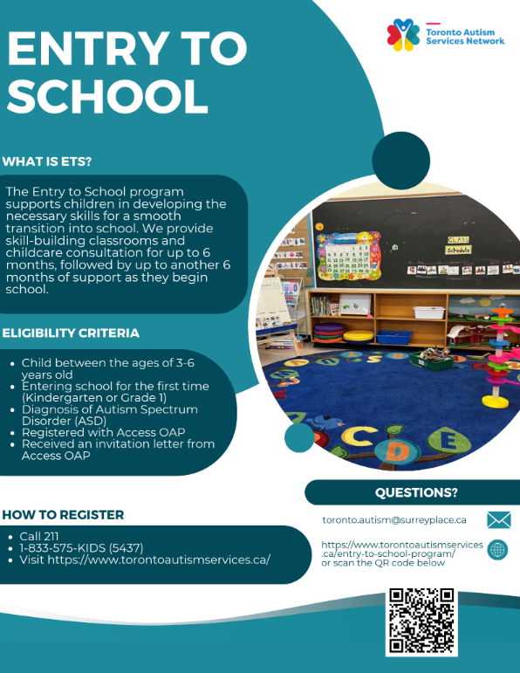](https://drive.google.com/file/d/1KETzBNQH5vwSp3RppoLDc8szd4n_92YE/view?usp=sharing)**

The Ontario Autism Program (OAP) recently introduced Entry to School (ETS), a new program for young students with Autism Spectrum Disorder (ASD). In Toronto, ETS is delivered by the Toronto Autism Network (TAN), which consists of six agencies (Geneva Centre, Surrey Place, Lumenus, Strides, SAAAC and Kerry’s Place). This is a six-month, group-based, skill-building program, focused on preparing young children with ASD who have never attended school to transition to kindergarten or grade 1.

The ETS program has two options:

1. Childcare Consultation: Transition Facilitators consult with Childcare Centre staff bi-weekly

2. ETS Skill Building Classrooms: Children attend a small group program in a classroom environment that is modeled after an Ontario Kindergarten classroom for 3-hours/day, 5-days/week.

Programs are 6 months in duration. Across both options, the following components are provided:

* Goals are set around building school readiness skills to support children in getting ready for Kindergarten or Grade 1
* At the end of the program, children enter school with a portfolio prepared by the ETS Transition Facilitators. This portfolio outlines the strategies that were used to support the child in their skill-building classroom or childcare.
* The ETS Transition Facilitator is available to consult with the classroom teacher around that portfolio for the first 6 months following the child’s transition to school

This fall, they announced a new French Entry to School Pilot Program. The aim of this program is to immerse students in the French language and culture, equipping them with essential skills and confidence as they prepare to enter French Immersion Kindergarten. Click here to access the[**French Entry to School Flyer**](https://drive.google.com/file/d/1up2LrR7dSQc5wlptm9mHzhf3AoqdNlUe/view?usp=sharing)**.**

* The goal of the ETS transition phase is to set students and their teachers/teaching teams up for success during their first educational milestone. Although Transition Facilitators who could be connecting with our schools belong to six different agencies, they all operate under Toronto Autism Network (TAN).