**Thank you for your interest in the Middle French Immersion program!**

This form is for students currently in Grade 3 who wish to attend the Middle French Immersion program beginning in September of Grade 4.

Applications to the Middle French Immersion program may be submitted, on behalf of students in the English program, the year the child is in Grade 3 for entry in September of Grade 4. It is an entirely online process. All communication will be sent via the email address you provide. Please check your email regularly, including junk mail folders.

Please Note: While admission to the Middle French Immersion (Grade 4 entry) program is guaranteed at the entry point to all eligible on-time applicants, admission to a specific school is NOT guaranteed. Applications to begin these programs are open to all students not already enrolled in a French program.

Below, you will find step-by-step instructions to help complete this form. If you require assistance completing the application form, please contact your local school.

**Parent/Guardian/Caregiver - Create an Account or Sign In**

1. Access the Application Link from the [Middle French Immersion](https://www.tdsb.on.ca/Elementary-School/School-Choices/French-Programs/Application-Middle-French-Immersion) page.

Under Application click on Proceed to Apply.   
  
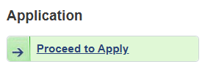

1. Create an account or sign into an existing account.  
   1. If you have never completed a PowerSchool Enrollment form before, click “Create Account”.  
      1. If you do not have an email address, you may create an account using your cell phone number.
   2. If you have previously completed a PowerSchool Enrollment form, click “Sign In”.  
      1. If you are having trouble logging in, select “Forgot password”.
      2. If you aren’t sure if you have an account, click “Create Account” to try creating a new account. If your email address is on file with us, you will be prevented from creating a new account. You can then click “Forgot password” to recover your account credentials.
      3. If you need to sign in using a phone number, select “Sign into your account using your cell phone number”.
2. Once signed in, add the student that you would like to complete the application for. If this student has already been added to your account, you may select them.  
     
   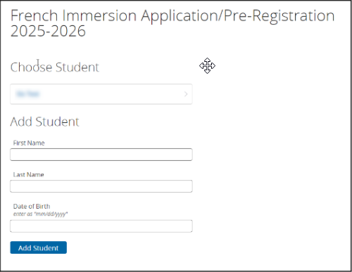

**Complete the Form**

Before you begin, be sure that you know your child’s TDSB student number (if they are a current TDSB student). It is recommended that you only work on one form at a time if you have more than one child applying for the Middle French Program.

1. Read through the Introduction page carefully, then click “Next” to navigate to the subsequent page.

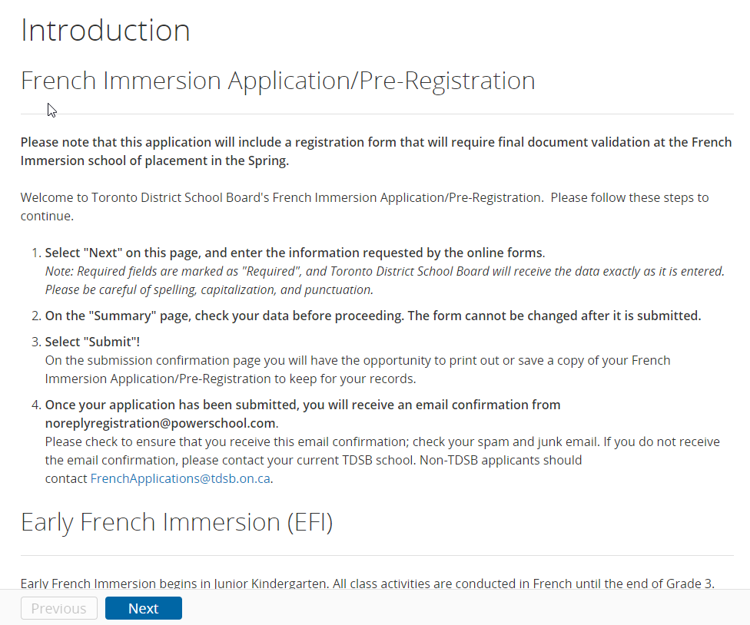

1. Please ensure your Middle French Immersion form is for the 2025/2026 school year. On the verification screen.

**Please note:** If the student’s date of birth is different than 2016 you will receive the error message: “The student is not eligible to apply to a French Immersion Program for the 2025-26 year - YOU WILL NOT BE ABLE TO SUBMIT THIS FORM.”

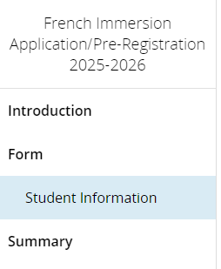

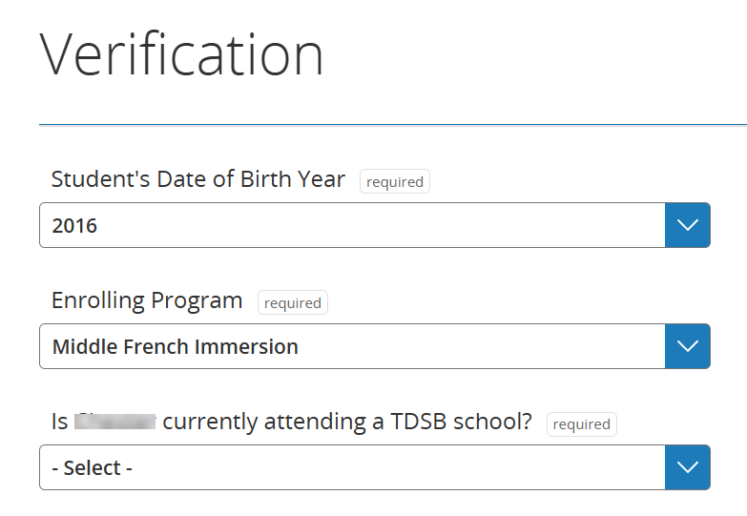

1. Identify if the student currently attends a TDSB school (and have the student number with you) or if they are a new student.

Your child's TDSB student number is a 9-digit number starting with a '3'. Please contact your current TDSB school to get the correct student number, if needed.

Fill out the fields on the form, ensuring that all “Required” fields have been filled out. When you have completed all fields on a page, you may click “Next” to continue to the subsequent page.

**Scenario 1: If the student is currently attending a TDSB school**

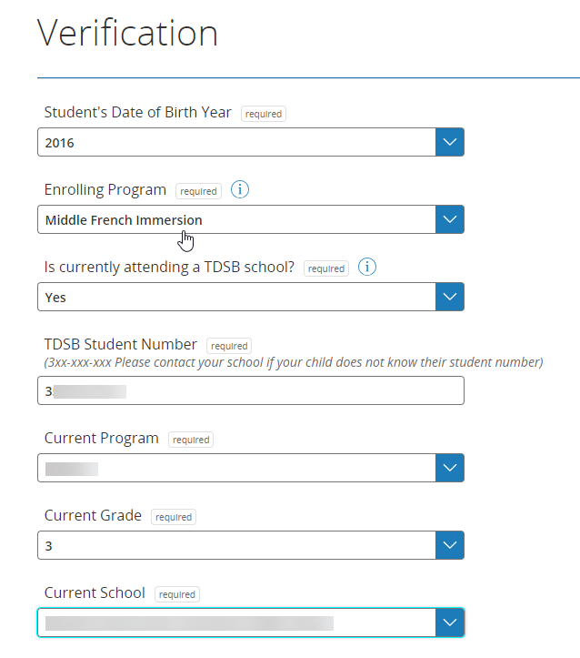

1, The following information must be entered:

1. **Sibling Information:**

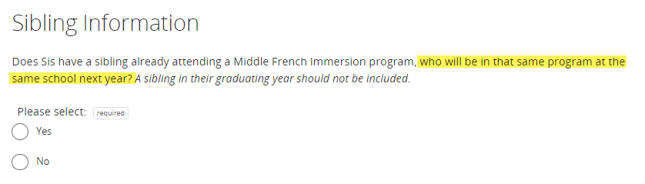

**Please note:** Both siblings must be in the same program, at the same school, at the same time. If you select Yes, you will need to provide the sibling’s TDSB student number, legal last and first name, date of birth and sibling current grade.

## Student's Primary Home Address:

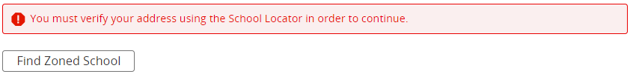

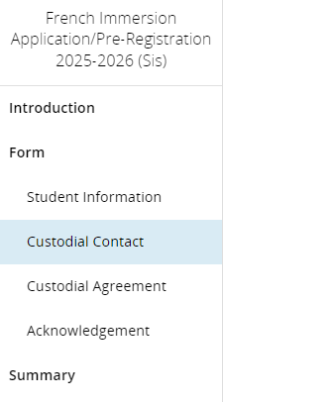

**Note:** By finding the address, the web page will identify the English Home School.

**Note:** Every English school catchment is associated with a Middle French Immersion program school. While every effort is made to place students in the school identified as their area school, this is not always possible. Students may be redirected to another school with available program space.

The panel on the left of the screen will allow you to navigate between the different sections of the form. Make sure you complete all the sections correctly.

2. On the Acknowledgement page, make sure to read all information and provide consent that you are acknowledging that all information provided above is correct and true. In the Parent/Guardian/Caregiver signature section, you need to complete the required fields, ensuring that the date you are submitting the application is entered from the calendar.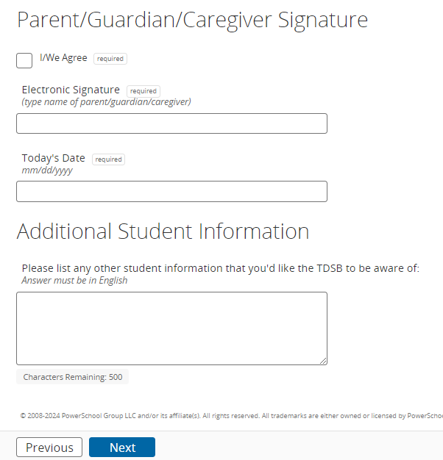

3. If there is anything missing, you will be able to identify it in the Summary tab. By clicking on the error, the page will redirect you to the section where you must correct or add information.

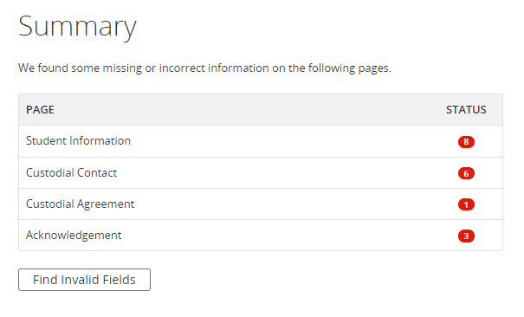

4. If a green check mark appears for all sections, it means that all required fields were completed. You now have access to the Submit button.

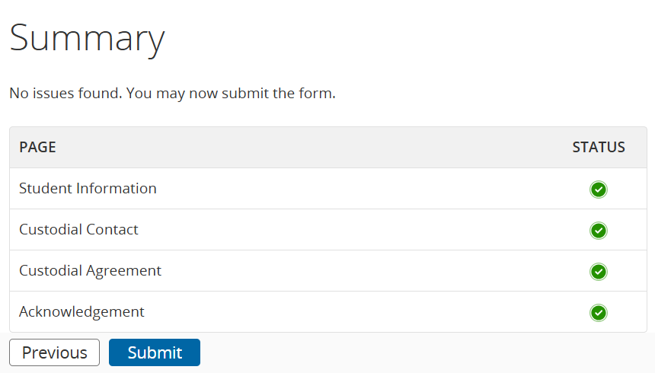

5. To submit this application, click Submit.

6. The next step page tells you that if you would like to print or save a copy of the registration record for your own records, you can click on the Completed Form link.

**Scenario 2: If the student is new to TDSB**

1. If the student is new to TDSB, you must continue filling out the form to complete all their personal information. On the Contact Information page, Parents and Emergency Contact Information must be entered. Priority Information, Custodial Contact and Custodial Agreement are required to continue.

Continue to fill in the information on the pages as you go through the form, clicking Next as you move from page to page.

1. A page for the Priority Information for the contacts will appear. Update by clicking on the dropdown option. One contact must have a priority of 1.

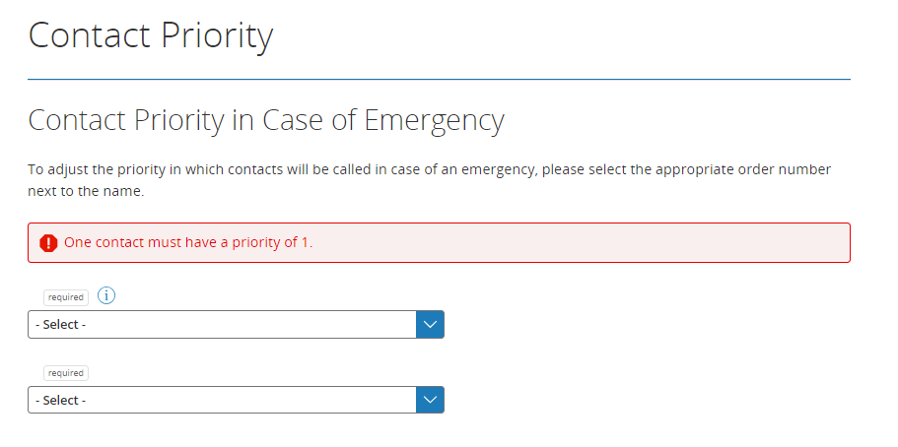

1. On the Medical Information page, enter the health card number for the child if you have it available. For the Student Medical Condition section, you can choose a medical condition if your child has one. Enter a remark or explanation in the comment field to describe the condition. Answer the required questions for this particular medical condition and indicate if this condition requires an EPIPEN or an Allerject.

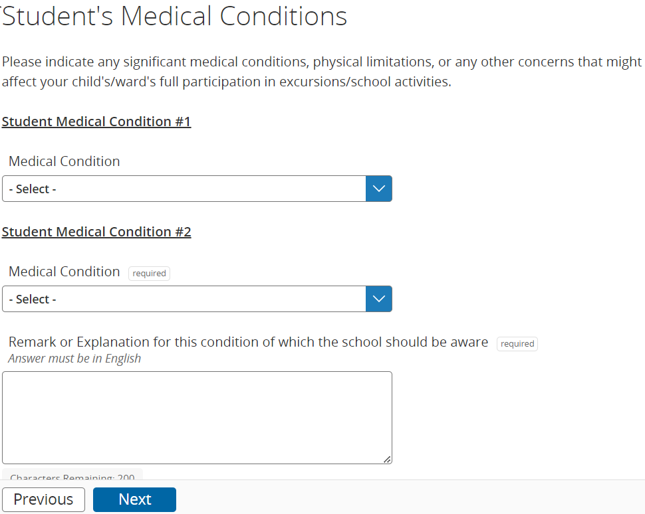

To enter an additional medical condition, check on the box, and you can enter the next medical condition for your child. Answer the three required questions. If you need to enter an additional medical condition, you can check the box or check Next.

Note: If your child has no medical conditions you need to share with the school, you do not need to make selections on this page. Select No for the required sections.

1. In the New Student details section, the language, citizenship, educational background and Indigenous student self-identification must be completed.  
   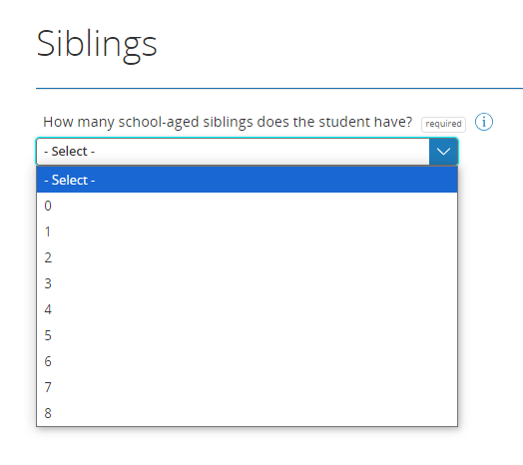
2. In the next section, Siblings, indicate how many school-aged siblings the student has, if any. The Last Name, First Name, Date of Birth will be required. Also, you must indicate if the sibling is currently enrolled in a TDSB school.
3. On the Acknowledgement page, make sure to read all information and provide consent that you are acknowledging that all information provided above is correct and true. In the Parent/Guardian/Caregiver signature section, you need to complete the required fields, ensuring that the date you are submitting the application is entered from the calendar.  
   
4. Click Next. On the Summary page, you can see that the pages listed from the left-hand navigation bar are displayed here.
5. If there is anything missing, you will be able to identify it in the Summary tab. By clicking on the error, the page will redirect you to the section where you must correct or add information. Add the required information and click Summary. It should now show a green checkmark.

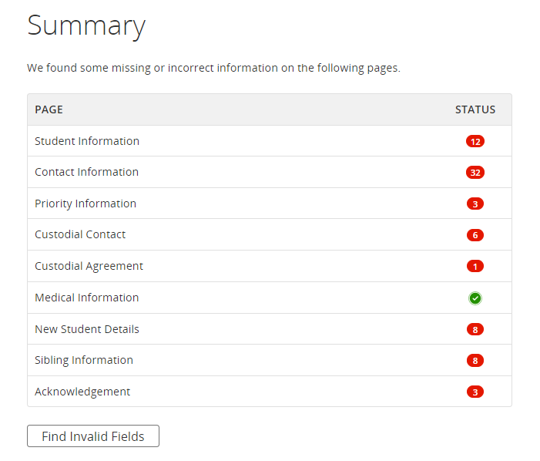

1. If a green check mark appears for all sections, it means that all required fields were completed. You now have access to the Submit button. To submit this application, click Submit.
2. The next step page tells you that if you would like to print or save a copy of the registration record for your own records, you can click on the Completed Form link.

**Notes:**

* If a field has a specific validation requirement, you must resolve any potential errors.  
  + Formatting Error
  + Validating Address
  + Error Messages
* If you are unable to complete the form in one sitting, you may click your initials to Save & Sign Out.  
    
  When you are ready to continue your work, click the 2025-2026 Middle Immersion Program Application link, sign into your account and then select the in progress form that you’d like to continue.
* On the Summary page, you will be able to review your progress. If there are any outstanding issues (missing or incorrect information), you will not be able to submit the form. To resolve these issues, click “Find Invalid Fields”. From here, complete any missing required fields or resolve validation errors. Once you have resolved all issues, you may submit the form.
* Once the application has been submitted, you may print or save a copy of the completed form.   
    
  ***Once you submit an application, you will not be able to make any changes. If you do need to make changes, please contact your current TDSB school. If you are not a current TDSB student, please contact the TDSB French Department at*** [***FrenchApplications@tdsb.on.ca***](mailto:FrenchApplications@tdsb.on.ca)

**Complete an Application for an Additional Student**

1. Once you have completed a form for one student, you may complete a form for an **additional student.**
   1. **Please note:** an application must be submitted for ALL students who would like to apply. For example, if you have two children in Grade 3 who would like to apply then you must submit two applications.
   2. **Please note:** you will not be able to submit duplicate applications (i.e. two forms submitted for the same student). **Duplicate student submissions will be discarded.**
2. You will have the opportunity to either “Import” family-specific data (ex. Parent/Guardian/Caregiver information, address information, etc.) between students, or start the form from scratch. If you choose to import data, it will pre-populate your form with any family-specific data that was already submitted in the previous student's application.
3. Follow the same steps (“Complete the Form” section, above) to submit the form.

**Offers of Placement**

1. Offers of placement will begin via email after the close of the application period and will continue during the weeks and months following. Please check the email used to submit the application, including junk mail frequently.
2. The offer of placement will include the name of the school at which your child has been offered placement and the deadline to accept the offer.
3. Placements in French Immersion are made via the central application process based on the child’s current primary home residence at the time of application, not location or enrolment in childcare.
4. Late applicants will be held on a local school waitlist subject to available space.

**End of Process**