Math Tasks: Primary (Grades 1-3)

Monday, September 28
Learning Goal: I will give and follow multi step instructions involving movement from one location to another, including distances and half- and quarter-turns (3)
Task: Turtle Splash 1  - Spend some time playing with the Turtle Pond interactive tool!  - Can you move the turtle to the pond for a swim? Which route is shortest? Challenge yourself by adding some rocks and trees!  - With a friend or family member, pretend one of you is the “turtle”. Give this person forward, back or turn directions to reach a “pond” in your home or outside - it can be a chair, a tree, or anything you like!  - Make sure to have a safe set-up; avoid tripping hazards and sharp corners! |  | 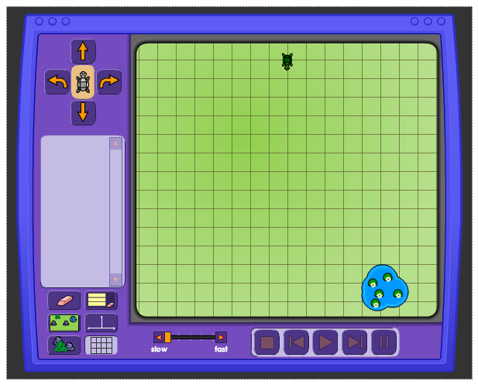  Turtle Pond

Tuesday, September 29
Learning Goal: I will develop and apply reasoning skills (e.g., classification, recognition of relationships, use of counter-examples) to justify my thinking.
Task: Autumn Leaves  - Look at the images and compare them:  - What is the same about the leaves?  - What is different about the leaves?  - Which leaves do you think belong together, and why? Is there more than one way to make a group of leaves that belong together?  - Which leaf doesn’t belong? Ask this question to someone in your home. Do your answers agree?  - Imagine four friends who each choose a different leaf as not belonging. What reasons do you think each friend would give?  Adapted with permission from District School Board of Niagara Virtual School |  | 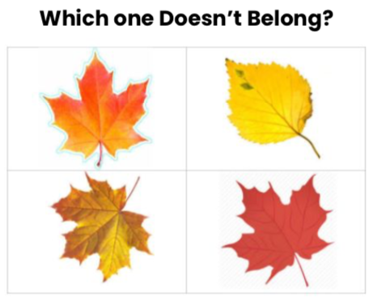

Wednesday, September 30
Learning Goal:
- I will subitize numbers up to and including 10
- I will demonstrate addition facts for numbers up to 10, and related subtraction facts

Task: Super Subitizing!  - Subitizing is determining the number of objects you see at a glance, without counting them individually. For example, you may be able to identify “a five” on a dice without actually counting the dots.  - Try out some of the subitizing games in the Ten Frame tool. Remember to look briefly at each group of objects or spaces, instead of counting how many there are.  - If you tried the games more than once, did you get faster at identifying the numbers? What helped you to improve?  - You can practice subitizing to 10 by rolling two dice, or by printing out these subitizing flash cards to practice with someone in your home. |  | 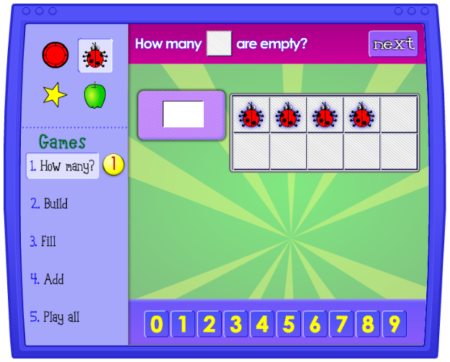  Ten Frame

Thursday, October 1
Learning Goal: I will determine pattern rules and use them to extend patterns, make and justify predictions, and identify missing elements in patterns represented with shapes and numbers
Task: Pattern Parade  - Look at the growing pattern:  - What do you notice?  - How many?  - How can we count?  - Can we count in a different way?  - Explain how you would create the next three terms of this pattern, and describe the appearance of these terms  - Choose another shape and draw or make at least five terms of your own pattern.  Adapted with permission from: SCDSB First 20 days |  | 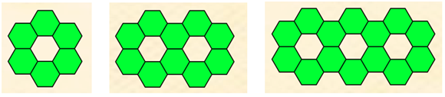

Friday, October 2
Learning Goal: I will select from and create a variety of representations of mathematical ideas, and apply them to solve problems
Task: Figure out the Fashion  - My favourite clothes include four t-shirts, three pairs of jeans, and two pairs of sandals.  - How many days in a row could I wear a different outfit using my favourite clothes?  - Show your mathematical thinking by drawing out each fashion wearing event.  What do you notice about how you tracked each unique outfit?  - What is another method you could use to track each outfit?  - Which of the two methods do you prefer, and why?  Source: Alicia Burdess (Sept 2020) via SCDSB First 20 Days |  | 