Math Tasks: Intermediate (Grades 7-8)

Monday, September 28
Learning Goal: I will make connections among mathematical concepts, procedures, and representations, and relate mathematical ideas to other contexts
Task: Math all Around  - Where is the Math in this subway station? Identify any connections you can think of...Math is all around us!  - Go for a Math Walk in your neighbourhood with an adult, or do a walk in your home.  Look for the Math on your walk, paying attention to things in nature, architecture, and what’s in the sky and on the ground!  What you see might include…  - A pattern  - An example of symmetry/reflection  - A large collection of things - estimate how many  - A pattern  - A structure that is 2x or 5x your height  - A rate  - After your Math walk, revisit the subway picture. Can you find more Math?  Math Walk description adapted with permission from District School Board of Niagara Virtual School |  | 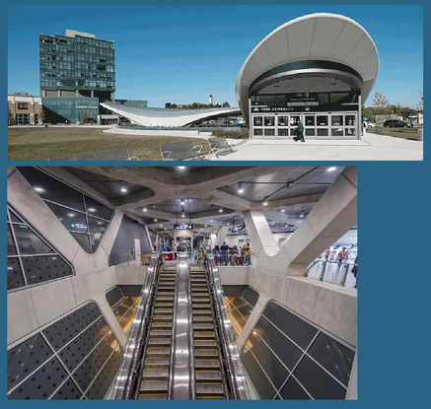  A larger image is here:  Where is the Math YorkU Station

Tuesday, September 29
Learning Goal: I will determine pattern rules and use them to extend patterns, make and justify predictions, and identify missing elements in repeating, growing, and shrinking patterns involving whole numbers and decimal numbers, and use algebraic representations of the pattern rules to solve for unknown values in linear growing patterns
Task: The Painted Cube  - Build three cubes using blocks at home or blocks in the Isometric Drawing tool.  The cube dimensions are:  2x2x2 3x3x3 4x4x4  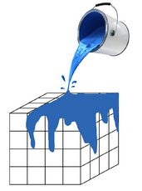  - Imagine painting only the outside of each cube  - How many blocks on each cube would have three faces painted (i.e. facing the outside)? You can rotate your cube in the drawing tool!  - How many blocks on each cube would have 2 faces painted? 1 face painted? No faces painted?  - How many different ways can you use to record or represent your data?  - Use your data to predict values for a 7x7x7 cube. Explain to a friend or family member your reasoning.  Adapted from: Painted Cube |  | 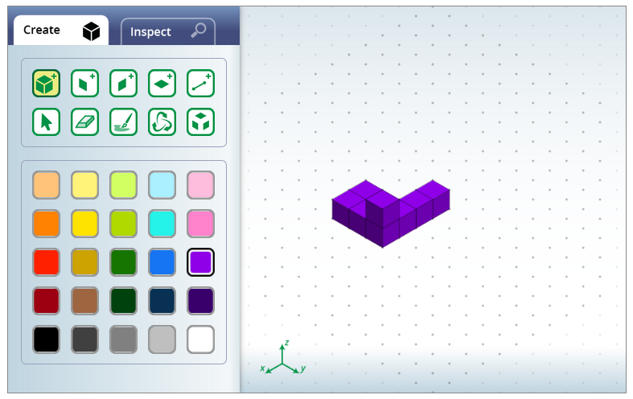  Isometric Drawing Tool

Wednesday, September 30
Learning Goal: I will draw top, front, and side views, as well as perspective views, of objects and physical spaces, using appropriate scales
Task: Outdoor Classroom Planning  - Some schools are setting up learning spaces outdoors. What would you like to see in an outdoor classroom? Discuss your ideas with someone in your home.  - Create a simple block model of your ideal outdoor classroom using the isometric drawing tool. Include seats, structures, tables...anything you like!  - When plans for a new structure are made, architects produce drawings from different views.  Imagine you are submitting your plans to the school principal for approval!  - Produce a scale drawing, paper cut-out, or any other representation of each of the top, front, side, and perspective views of your outdoor classroom.  You can rotate your model in the drawing tool to help you! |  | Isometric Drawing Tool

Thursday, October 1
Learning Goal:
- I will solve problems involving angle properties, including the properties of polygons
- I will determine pattern rules and use them to extend patterns, make and justify predictions, and identify missing elements in repeating, growing, and shrinking patterns involving whole numbers and decimal numbers, and use algebraic representations of the pattern rules to solve for unknown values in linear growing patterns
Task: Dancing with the Triangles  - Imagine learning a new set of dance moves, each of which must return you to your original position.  To do “the triangle”: step, turn, step, turn, then step back to the start!  - Try “the triangle” at home, using a marker such as a piece of tape for your starting position.  - Do your steps need to be the same length? Do your turns need to have the same angle?  - Use the Angle Sums tool to investigate different ways you can do “the triangle”, “the square”, and “the pentagon” moves.  - What do you notice about the sum of the angles for each type of dance? As you investigate different shapes, do you notice a pattern?  - Describe to someone in your home how to use your pattern to predict the sum of angles in a 20-sided shape (icosagon). |  | 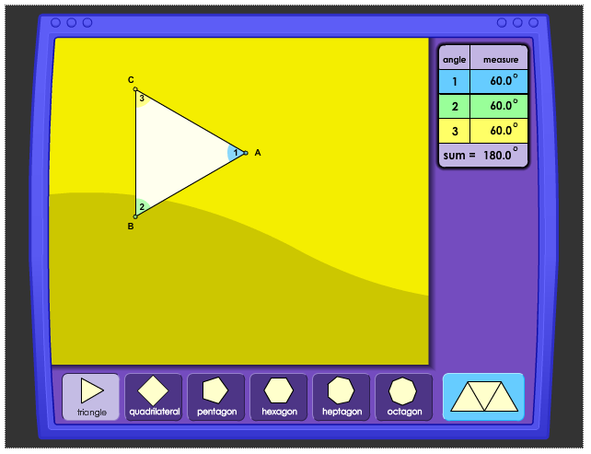  Angle Sums

Friday, October 2
Learning Goal: I will add and subtract integers, using appropriate strategies, in various contexts
Task:  - Take some time to explore the Number Line: Integers tool  Use the number lines for Balance and Elevation to help you with the following tasks:  - Imagine you have saved $17.00 in a piggy bank. You take out $9.00 to go for a distance lunch with a friend. A few weeks later, you try to take out $15.00 to see a movie.  Use the balance number line to determine how much more money you will need for the movie. Describe how you would slide the piggy bank to find your answer. In which direction? How many units?  - Imagine a sea bird dives below the surface to catch a fish swimming through the seaweed. The bird then swims to the surface and flies up to land on a grassy cliff ledge.  Use the elevation number line to determine the distance the bird travelled from catching the fish to landing on a ledge. What strategy did you use?  - Create your own number line problem to solve, and share it with someone in your home. Ask them what strategy they used, and discuss any similarities or differences. |  | 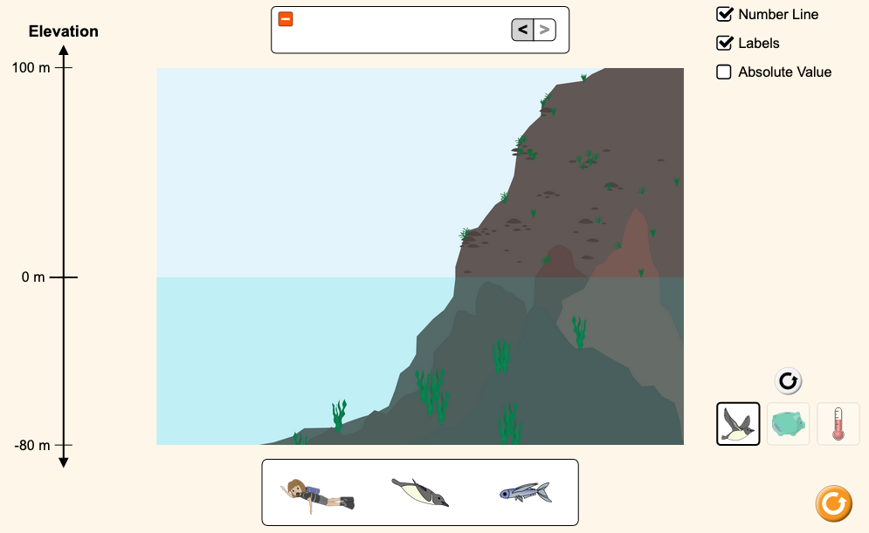  Number Line: Integers  You can switch between number lines by clicking on:

