Math Tasks: Junior (Grades 4-6)

Monday, September 28
Learning Goal: I will make connections among mathematical concepts, procedures, and representations, and relate mathematical ideas to other contexts
Task: Math all Around  - Where is the Math in this subway station? Identify any connections you can think of...Math is all around us!  - Go for a Math Walk in your neighbourhood with an adult, or do a walk in your home.  Look for the Math on your walk, paying attention to things in nature, architecture, and what’s in the sky and on the ground!  What you see might include…  - A pattern  - An example of symmetry/reflection  - A large collection of things - estimate how many  - A pattern  - A structure that is 2x or 5x your height  - A rate  - After your Math walk, revisit the subway picture. Can you find more Math?  Math Walk description adapted with permission from District School Board of Niagara Virtual School |  | 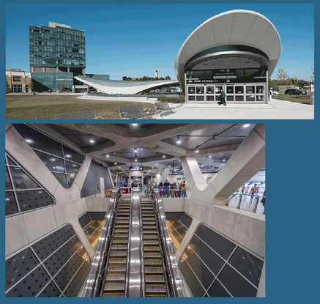  A larger image is here:  Where is the Math YorkU Station

Tuesday, September 29
Learning Goals:
- I will analyse different sets of data presented in various ways, including in stacked-bar graphs and in misleading graphs, by asking and answering questions about the data, challenging preconceived notions, and drawing conclusions, then make convincing arguments and informed decisions.
- I will solve problems involving ratios, including percents and rates, using appropriate tools and strategies.
Task: What’s Going on in the Graph?  - What do you notice about the graphs? What do you think is happening in each?  - What do you wonder about each graph? Is there anything more you think it is important to know?  - Canada is a top global producer of dry peas, beans, and lentils.  What could be the importance of this fact, based on your understanding of the graphs? Explain your thinking to someone in your home.  - Based on the nutrient breakdown for red lentils, a serving contains 3 mg of iron, which equals 15% of a person’s iron Daily Value.  Based on this information, what amount would be 100% of a person’s iron Daily Value?  Which strategy did you use?  Graph from the New York Times; graph choice also used in District School Board of Niagara Virtual School |  | 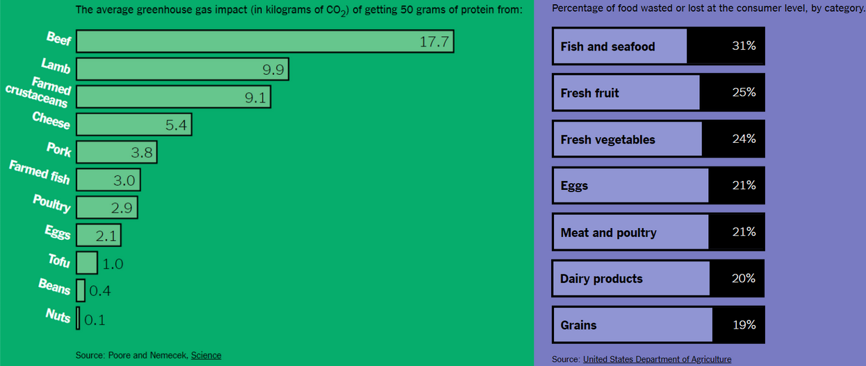  A larger version of the graphs is here  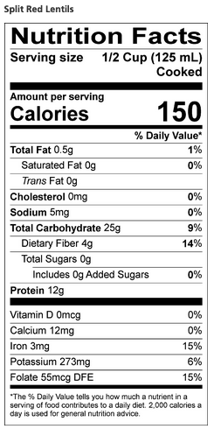

Wednesday, September 30
Learning Goal: I will determine pattern rules and use them to extend patterns, make and justify predictions, and identify missing elements in repeating, growing, and shrinking patterns.
Task: Growing and Shrinking  - Describe what you see in the Lego pattern:  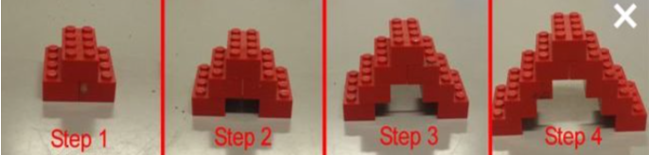  - What might the next term look like? (try building it if you have lego)  - Which term would reach up to the ceiling? Explain your thinking:  - Using objects around the house (coins, toothpicks, lego, etc.), create three terms of a growing pattern.  - Use different objects to create three terms of a shrinking pattern.  - What could be a far term of your shrinking pattern? Could you make it with objects? Share your reasoning with a friend or family member.  Adapted with permission from District School Board of Niagara Virtual School |  | To create a pattern online, here is a tool to explore:  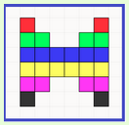  mathies SWF Opener

Thursday, October 1
Learning Goal: I can solve problems and create computational representations of mathematical situation by writing and executing efficient code
Task: Turtle Splash 2  - Spend some time playing with the Turtle Pond interactive tool!  - Can you move the turtle to the pond for a swim? Which route is shortest? Challenge yourself by adding some rocks and trees!  - Add more angle choices for your turtle by changing by clicking  on to get  - Again, try moving the turtle to the pond by the shortest route. Which angle button do you prefer for finding the shortest route, and why?  - With a friend or family member, pretend one of you is the “turtle”. Give this person forward, back or turn directions to reach a “pond” in your home or outside - it can be a chair, a tree, or anything you like!  - Make sure to have a safe set-up; avoid tripping hazards and sharp corners! |  | 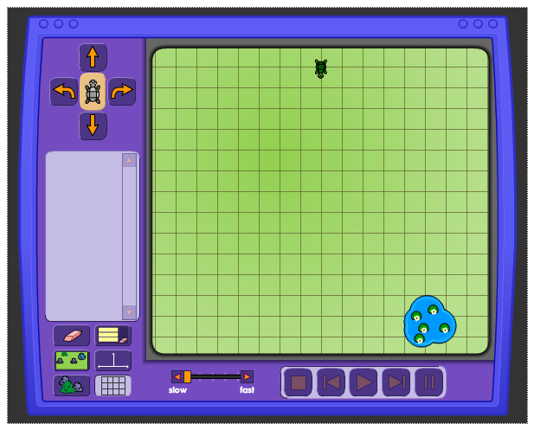  Turtle Pond

Friday, October 2
Learning Goal: I will solve equations that involve whole numbers up to 100 in various contexts, and verify solutions
Task: A Balancing Mystery  - Take some time to explore the Balancing Act Intro.  - Try to balance the fire extinguishers with the garbage can - what do you notice? Why do you think this happens? Can you find a way to make both sides balance?  - Spend some time playing with the Balance Lab. Create at least two different scenarios where people and/or objects are balanced.  - Explain how this activity connects to the mathematics you know, and how it is different.  - Use the weights of any two people in the balance lab to help you determine, as accurately as possible, the weight of a mystery object. You may use more than one copy of your mystery object to solve this problem!  - Once you are confident in the weight of your mystery object, show your process to a friend or family member and explain your reasoning. Let them try to determine the weight - do your results agree? |  | 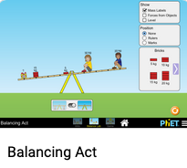  Balancing Act 1.1.24

