Asynchronous Learning for
SK-Grade 1 French Immersion

Week of November 9, 2020

Note: For this task, students must have an Idéllo account in order to access the video.
If you already have a student account (username and password) from previous years, you may continue to use it.
If you don’t have a student account, please create your free student account using code 03n7pv3718mp6.
For information and tutorials that show how to create an account, please visit TDSB FSL Resources for Families.
Please keep track of your username and password carefully.

La lettre “a”

Learning Goal: I can watch a video and show what I understand. I can make personal connections.
Instructions: Watch the videos “L’alphabet avec Charlie - Avion”, “L’alphabet avec Charlie - Abeille” and “La calligraphie animée (a)” on the Idéllo site. (Be sure to log in to your account.) Complete the activities suggested below.
What words do you know that start with the sound “a” like avion and abeille? Look around where you live and try to find some examples of objects that start with the sound “a” in French or your home language. Draw a picture of some of these objects and try to write the word. Do you know any other words in French that have the “a” sound in them? | Let’s practice making the letter “a”.  - Use your finger to trace the letter in the air.  - Use some loose parts around you to practice making the letter. (examples: twigs, pebbles, modeling clay, ribbon, buttons, etc)  - Practice writing the letter in a notebook.
Watch the video “Alouette” on Idéllo. Each time you hear a word with the “a” sound, give a thumbs up or another action of your choice (ex. do a jumping jack, clap). What is the song about? Share your thinking with someone you live with.  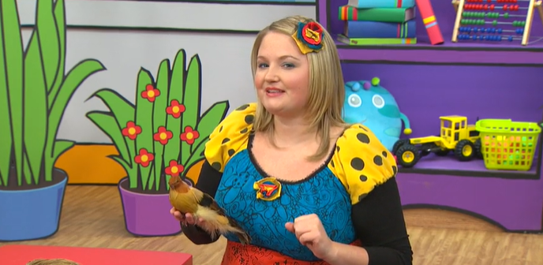 | Do you have a letter “a” in your name? What letters are in your name? Practice writing your name. Ask a family member about your name, and if there is a special story or meaning behind it.

