**January HIGHLIGHTS**

* Important Dates, Link to Parent Guides, Check It Out Videos, Drop-in Sessions
* Occupational Therapy/Physiotherapy Resources
* World Braille Day
* Entry To School for students with ASD
* OAP Ontario Autism Program
* Speech and Language Resources
* Developing and Supporting Language Skills
* Social Work Virtual Session, Developmental Disabilities Connects
* Supporting Transitions

**IMPORTANT DATES:**

**KEY DATES 2024-2025**

**ELEMENTARY PD DAYS:**

September 27, 2024: Professional Development

October 11, 2024: Professional Development

November 15, 2024: Parent-Teacher Conferences

November 29, 2024: Professional Development

January 17, 2025: Professional Development

February 14, 2025: Parent-Teacher Conferences

June 6, 2025: Professional Development

**SECONDARY PD DAYS:**

October 11, 2024 - Professional Development

November 15, 2024 - Professional Development

November 29, 2024 - Professional Development

January 30, 2025 - Professional Development

February 14, 2025 - Professional Development June

26, 2025 - Professional Development

June 27, 2025 - Professional Development

**SCHOOL YEAR HOLIDAYS** (as per Ministry of

Education)

Labour Day: September 2, 2024

Thanksgiving: October 14, 2024

Winter Break: December 23, 2024 – January 3,

2025

Family Day: February 17, 2025

Mid-Winter Break: March 10-14, 2025

Good Friday: April 18, 2025

Easter Monday: April 21, 2025

Victoria Day: May 19, 2025

**CHECK IT OUT!!**

* [**What is UDL?**](https://www.youtube.com/watch?v=eYN-qrKIIYI)
* [**Dr. Dan Siegel: What it means to "flip your lid".**](https://www.youtube.com/watch?v=qFTljLo1bK8)
* [**Truth, Love, & Racial Literacy | Yolanda Sealey-Ruiz | TEDxPenn**](https://www.youtube.com/watch?v=-V_GdpVR6NI)
* [**Why Do We Lose Control of Our Emotions?**](https://www.youtube.com/watch?v=3bKuoH8CkFc)

[**Special Education and Parent Guides**](https://www.tdsb.on.ca/Learning-Equity-and-Well-Being/Special-Education-and-Inclusion/Parent-Guides-to-Special-Education-and-Inclusion)

**Special Education and Inclusion Drop-in Sessions for Parents/Guardians/Caregivers**

Learn more about navigating special education services, resources and supports, ask questions, and connect with other families. [**Calendar of Drop-In Sessions for the 2024-2025 School Year**](https://docs.google.com/presentation/d/1ikPieHXCM7jMFjSvfw1L6JOypowiQ--C/edit)

**Occupational Therapy/Physiotherapy (OT/PT) Services**

**Outdoor Play Time** is good for usall year long!

We all know and recognise the importance of outdoor play time and the benefits to taking learning outdoors. Fresh air and sunshine can help to promote better health and a stronger immune system.

Click on our [**Outdoor Play Newsletter**](https://drive.google.com/file/d/1zMkBdIHIwwyvMCeMiBqSvYfn62dQv2sV/view)to learn more about the benefits of the great outdoors. Can’t get out?  **Bring the outdoors in**! Let in as much natural sunlight as possible, open windows, [**play nature sounds**](https://www.youtube.com/watch?v=u5Drn5VkOM4), and try planting seeds and watching them grow!

[Click **here** for great ways to make WINTER FUN and for ACCESSIBLE ideas](https://drive.google.com/file/d/1lROd8jwd0IN3IuqM_ER6LZhgk3I9VEom/view?usp=sharing)**.**

**Accessible Outdoor Options**

Looking for ways to encourage your families to have fun in the winter? Toronto has many **accessible recreational programs and venues** such as Illuminarium, ROM, Cineplex movie cinemas and more venues. The [**Access 2 Card**](https://access2card.ca/) offers free caregiver accompaniment for individuals with disabilities!

**Outdoor places** such as Evergreen Brickworks offer short walking trails that are maintained over the winter. In the heart of downtown, Nathan Phillips Square is decorated with lights and has skate/ sledges/ skate aides available for rent (good idea to call for availability ahead of time). Both are easily accessible by TTC.

World Braille Day: January 4, 2025

The TDSB supports several students who exclusively rely on braille for accessing their curricular materials. In honour of World Braille Day on January 4, 2025, we aim to raise awareness about the significance of this alternative format.

January 4 marks the birthday of Louis Braille. In 1824, this visionary created the first braille code at the remarkable age

of 15.

World Braille Day serves as an important remine essential role of Braille literacy and how braille fosters accessibility and independence for individuals who are blind or visually impaired.

Despite advancements in alternative formats such as audiobooks, screen readers, and text-to-speech technologies, braille remains the sole medium through which blind students can learn to read.

As we celebrate World Braille Day, we acknowledge the ongoing significance of braille in providing a unique and irreplaceable avenue for educational and personal growth for those with visual impairments.

For more information, please visit [**World Braille Day | United Nations**](https://www.un.org/en/observances/braille-day).

**Entry to School for Students with Autism Spectrum Disorder (ASD)**

The Ontario Autism Program (OAP) recently introduced **Entry to School (ETS),** a new program for young students with ASD. In Toronto, ETSis delivered by the **Toronto Autism Network** (TAN).

This is a six-month, group-based, skill-building program with a focus on building school readiness skills in young children with ASD who have never attended school to transition to Kindergarten or Grade 1.

The ETS program has two options:

1. **Childcare Consultation:** Transition Facilitators consult with Childcare Centre staff biweekly

2. **ETS Skill Building Classrooms**: Children attend a small group program in a classroom environment that is modeled after an Ontario Kindergarten classroom for 3-hours/day, 5-days/week.

Across both options, the following components are provided:

* At the end of the program, children enter school with a portfolio prepared by the ETS Transition Facilitators. This portfolio outlines the strategies that were used to support the child in their skill building classroom or childcare.
* The ETS Transition Facilitator is available to consult with the classroom teacher around that portfolio for the first 6-months following the child’s transition to school

The goal of the ETS transition phase is to set students and their teachers up for success during their first educational milestone.

**Parent can refer to this** [**information document**](https://docs.google.com/document/d/1XQhTnQk-WipF8W-tQA_XOvn0pIbx6f4MpREoYZbTk_k/edit?tab=t.0) **to learn more.**

**Ontario Autism Program (OAP)**

The Ontario Autism Program (OAP) is a provincially-funded program that offers a range of services and supports to families of children and youth on the autism spectrum. In the needs-based OAP, all children/youth up to age 18 with a written diagnosis of Autism Spectrum Disorder (ASD) from a qualified professional, are eligible to register for the OAP. Families have access to several service pathways and program supports, one of which is the Entry to School (ETS) program.

Further information can be found on the [**AccessOAP website**](https://accessoap.ca/)**.**

**Speech Language Resources**

TDSB Speech Language Pathology (SLP) Services focus on the early identification and prevention of speech and language difficulties. Every year, TDSB SLP Services create monthly Kindergarten calendars filled with activities to support oral language and literacy at home. Download your[**January 2025**](https://drive.google.com/file/d/1N2sfxAe8msS3resp_V9Z4F1ML_AlZuLY/view?usp=drive_link) **calendar** here or ask your child’s Kindergarten teacher to send you a copy today!

TDSB SLP Services is committed to engaging the TDSB community by sharing the latest research in our field, as well as strategies to support children’s speech and language development at home. SLP Services uses social media platforms to share this information.

This month, @tdsb_slp highlights pretend play!

Pretend play isn’t just fun! It’s a powerhouse for language and social development. These imaginative moments help children to build communication skills, problem solving abilities and creativity! Check out the pictures below for some tips for developing pretend play skills at home and in the classroom.

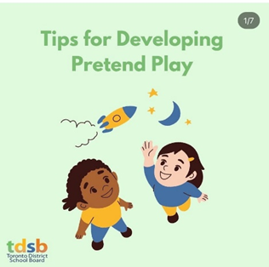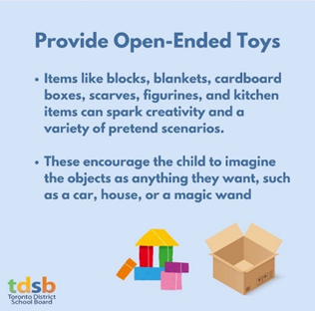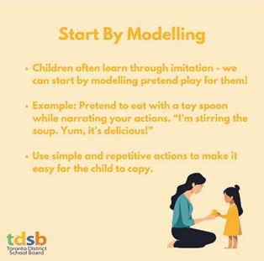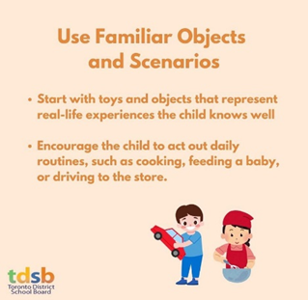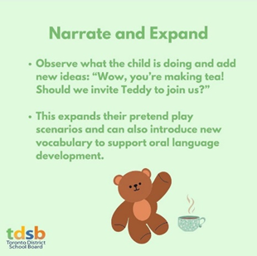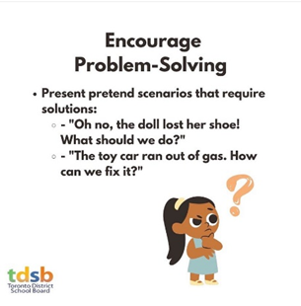

[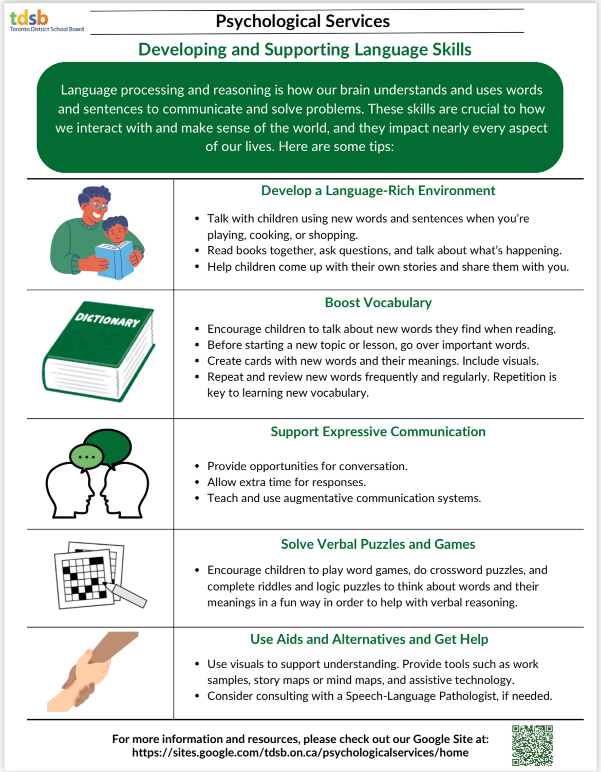](https://drive.google.com/file/d/1x-RximVfMdEY8G8tXZhixt7KM_5qPhIX/view)

**TDSB Social Workers**

The TDSB Social Workers present the Virtual Developmental Disabilities Connect. Supporting Parents/caregivers of children, youth and young adults with developmental disabilities and complex needs

Morning Session – January 20, 2025, from 9:30 a.m. to 12 Noon

Evening Session (a repeat) – January 27, 2025, from 5:30 p.m. to 8:00 p.m.

[**CLICK HERE TO JOIN THE SESSION**](https://tdsb-ca.zoom.us/j/94015815609?pwd=zvXKxODRuh6GCza1hVFlNtdGaxj1UQ.1#success)

**Transitions Resources**

Supporting the Transition to Post-Secondary Pathways

Transition planning for post-secondary starts early for students with special education learning needs. It is one of the most significant transitions. The transition process requires careful planning and documentation. The links below are resources to refer to through this transition process.

[**Planning for Life After High School For Youth with Disabilities**](https://docs.google.com/presentation/d/1sGcVQxhAl7R1tW5bbvj997XHKO1FnW0dTDs9f7pLejw/edit)

[**Supporting Transitions to Post-Secondary for Students with ASD**](https://drive.google.com/drive/folders/1Z4Hd8JFEBz30j5i98hL72CF-eF_Xq2RF)

The Autism Services website provides resources to support with transition beyond secondary school**.**

