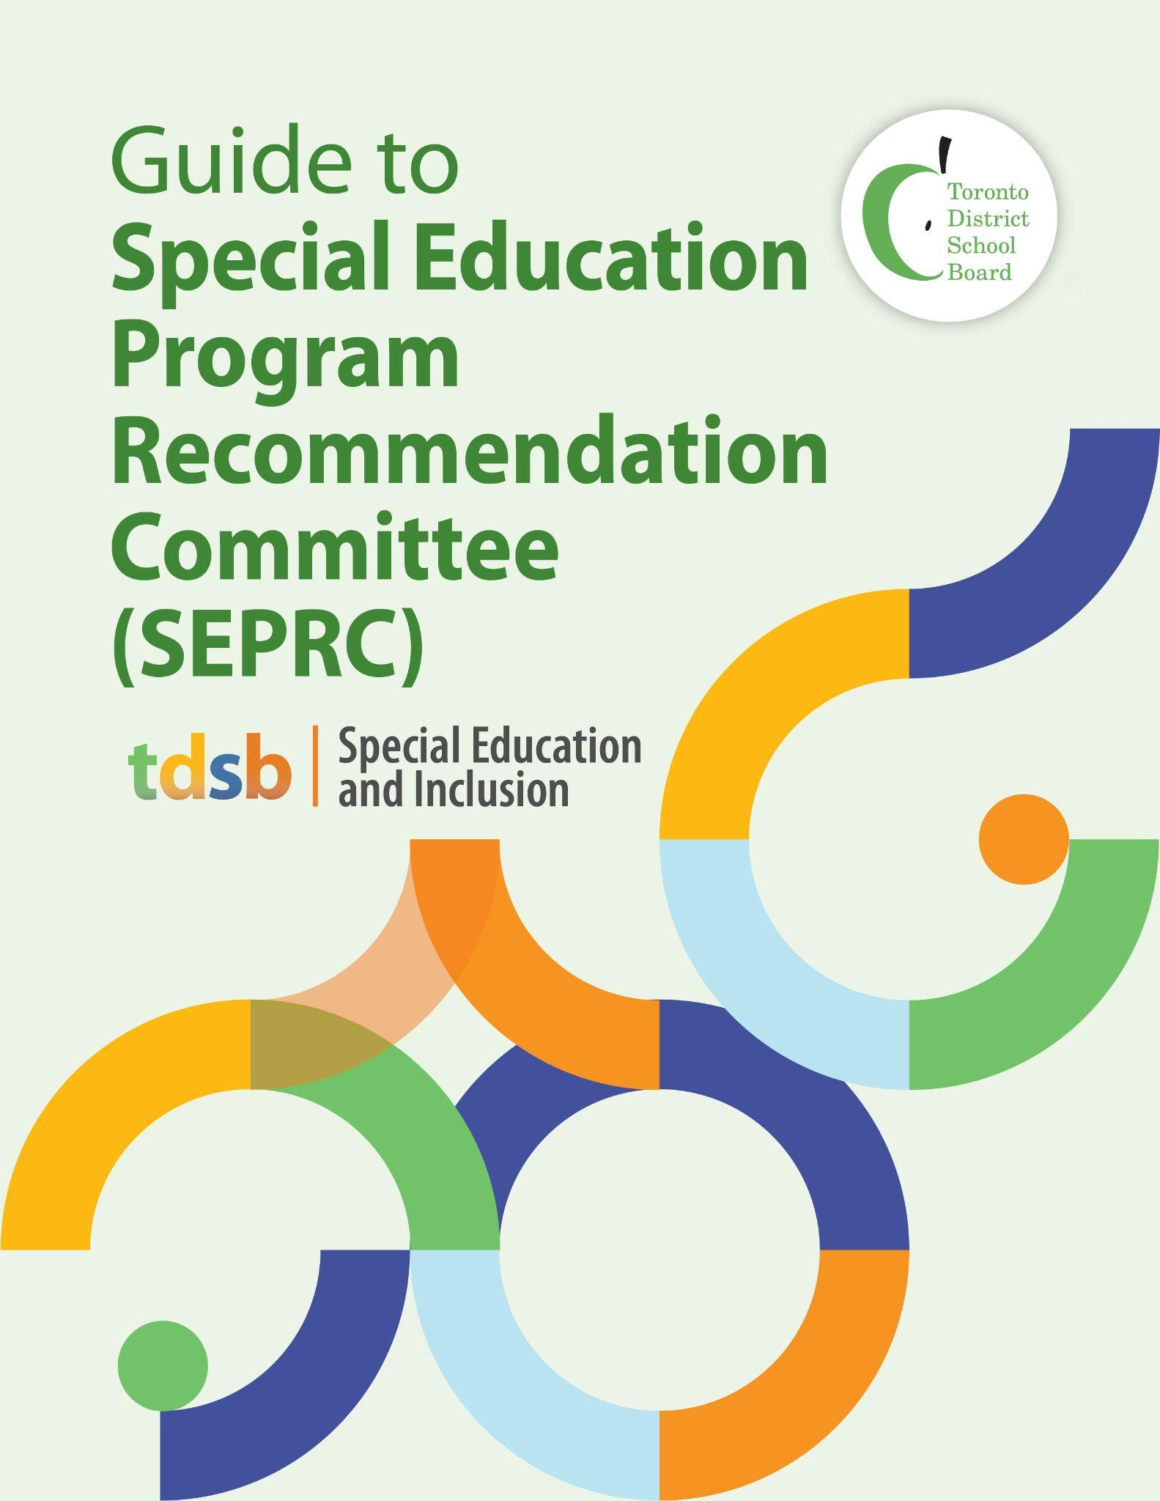

**March 2023**

*Guide to Special Education Program Recommendation Committee (SEPRC) for Parents/Guardians/Caregivers (cover page on first page with graphic with this title)*

*If, after reading this guide, you require more information, please contact the principal for your child’s school.*

*Throughout this guide, the word “parents” includes guardians and caregivers.*

*Some of the information in this guide has been directly copied from the Ontario Ministry of Education’s* [*Special Education in Ontario Kindergarten to Grade 12 - Policy and Resource Guide*](https://www.ontario.ca/document/special-education-ontario-policy-and-resource-guide-kindergarten-grade-12)*,* [*Appendix D-1: A sample parents' guide to special education*](https://www.ontario.ca/document/special-education-ontario-policy-and-resource-guide-kindergarten-grade-12/appendix-d-1) *and other documents created by the Toronto District School Board’s Special Education and Inclusion Department.*

**Guiding Principle**

The Special Education and Inclusion Department, in collaboration with all staff, is committed to providing equitable access to learning opportunities for all students. This includes our ongoing commitment to human rights, equity, anti-oppression, anti-racism, and anti-ableism. The Toronto District School Board (TDSB) champions inclusion and, in line with Regulation 181/98, believes all students, including students with disabilities and special education needs, should receive their education to the fullest extent possible in their neighbourhood school. However, TDSB recognizes that some students with complex needs require additional supports to access learning and therefore provides special education classes in both integrated and congregated learning environments.

**Special Education Placement Recommendation Committee (SEPRC)**

The Toronto District School Board (TDSB) has a duty to accommodate students registering in the district who have complex physical/medical/safety needs and/or complex disabilities/special education needs. To address this duty to accommodate, TDSB uses a process called the Special Education Program Recommendation Committee (SEPRC).

The SEPRC process provides differentiated support for students new to the TDSB with complex medical/physical/safety needs and/or complex disabilities/special education needs by ensuring timely access to learning in an appropriate learning environment. Students whose needs cannot be met in a regular classroom even for a short period of time and/or students who require access to a specialized placement such as an Intensive Support Program (ISP) can access a SEPRC and eventually an Identification, Placement and Review Committee (IPRC).

**SEPRC Criteria**

A student who meets the criteria for a SEPRC is one who may have been receiving intensive, full-time special education class support in another school system or specialized preschool or daycare prior to their arrival in the TDSB. This may be a student who has complex medical needs which may include a combination of intellectual communication and/or behavioral needs, including persistent challenges in daily living. This may also be a student in need of care, treatment or rehabilitation through the Education and Community Partnership Program (ECPP). The student may also require access to specialized equipment and specialized support whereby the neighbourhood school is not able to adequately address the student’s complex medical/physical/safety needs or complex disability, even for a short period of time.

**Registration**

**Regular Class**

TDSB upholds the tenets of equity and inclusion and believes that all students enter school capable, competent and ready to learn. TDSB adheres to [Regulation 181/98](https://www.ontario.ca/page/identifying-students-special-education-needs) which states that all students, including students with complex medical/physical/safety needs and/or complex disabilities will be welcomed, registered and placed in their neighbourhood school in a regular class when new to the school district.

The first step for parents is to go to their neighbourhood school and register their child in a regular class. Parents are encouraged to make an appointment to meet with the school principal to discuss their child’s complex medical/physical/safety needs and/or complex disability/special education needs to ensure the student is set up for success in the regular classroom.

In the regular classroom, the teacher will identify the student’s areas of strength and growth and design an educational program incorporating Universal Design for Learning (UDL), Differentiated Instruction (DI) and Culturally Relevant and Responsive Pedagogy (CRRP). The student’s progress and development will be monitored through an Individual Learning Plan (ILP).

Based on on-going assessment and evaluation and in collaboration with the principal, an IPRC may be held and an Individual Education Plan (IEP) may be developed through the [Referral Process](https://docs.google.com/presentation/d/e/2PACX-1vRYO7W_J3eXAGXF3o8W5HkSQxwgxb9RwT937ObUFAuJowMVsUukyiADjnvT1i-K75FoJc9wYGMKByDQ/pub?start=false&loop=false&delayms=3000&slide=id.p).

**Special Education Class (Intensive Support Program or ISP)**

TDSB also recognizes that there are some new students with complex medical/physical/safety needs and/or complex disabilities/special education needs who may require differentiated support in a specialized placement as their needs cannot be met in a regular class for even a short period of time. In these cases, TDSB implements the SEPRC process to specifically enable timely placement and access to learning in an Intensive Support Program (ISP). These classes may be outside the neighbourhood school, but transportation may be provided to the program.

Parents who believe their child may meet the criteria for a SEPRC are to still go to their neighbourhood school and register their child, and share all relevant documentation with the school principal. The principal will work with staff from the Special Education and Inclusion Department to determine whether the child meets the criteria for a SEPRC and subsequently for an ISP.

**The SEPRC Process**

Once it has been confirmed that the student’s profile meets the SEPRC criteria and the parents have received, signed and returned the SEPRC invitation letter back to the neighbourhood school, the SEPRC meeting will occur. The meeting will discuss student’s strengths, areas for growth and review which special education program will best meet the student’s needs for potential special education placement.

**Function of the SEPRC**

The SEPRC will:

* Determine whether to make a program recommendation for an Intensive Support Program (ISP) based on student’s profile; and
* Provide a written statement of recommendation, as applicable, outlining the student’s strengths and needs and any program/services recommendations of the SEPRC.

**Prior to the SEPRC Meeting**

Parents whose child may meet the criteria and have requested a SEPRC with the principal of their child’s homeschool are to have an initial meeting with the principal to discuss the student’s strengths and areas of growth. Parents are to bring all medical documents and any important information relating to their child’s medical/physical/safety needs and/or complex disabilities to the meeting. Once the meeting is concluded, the principal will share the gathered information with the Special Education and Inclusion Consultant, Coordinator and/or Centrally Assigned Principal to review and ensure the child’s profile meets the SEPRC criteria. At times there may be a need to gather more information and the Special Education and Inclusion Department will arrange a visit to the student’s current program to gather more information.

Parents are invited to share the following documentation with the school principal:

* An educational assessment from the student’s specialized preschool/daycare or other school
* The most recent Provincial Report Card (and where the most recent Report Card is the Progress Report Card, the previous Provincial Report Card as well)
* An Individual Education Plan (IEP)
* A psychological assessment
* Other relevant professional assessments (e.g., speech-language, OT/PT, hearing, vision, neurological, medical, other)
* A Developmental History Form (for Junior Kindergarten to Grade 2 aged students)
* A current professional observation/assessment
* Student work samples that reflect that the teacher’s pedagogy is responsive to the child’s identity and lived experiences and is culturally relevant (part of the school presentation)

If the student’s profile does meet the criteria and may be eligible for an ISP, a SEPRC invitation letter along with a copy of the TDSB Guide to Special Education and all documentation to be considered at the SEPRC will be sent to the parent or legal guardian. Parents or legal guardians are to respond to the invitation letter and return it to the neighbourhood school. If the student does not meet the criteria for a SEPRC, the student will be welcomed and registered at their neighbourhood school in a regular class.

**Attendance at the SEPRC Meeting**

The SEPRC is made up of the following members:

* Principal (Chair) who is not associated with the student or the student’s school
* Special Education and Inclusion Coordinator
* Psychological Services Staff
* Parent or Legal Guardian

**During the SEPRC Meeting**

The SEPRC meeting allows all voices to be heard as the student’s profile of strengths, areas of growth and academic needs are unpacked to better understand how to best serve the student:

* Parent voice, identity, lived experiences, and any parental concerns prior to attending the SEPRC will be honoured and addressed.
* Parents are encouraged to invite any resource personnel currently involved with the student to attend the SEPRC meeting.
* Parents may request an interpreter and/or translator, and TDSB will provide one.
* The SEPRC Chair will invite parents and any other attendees to participate in discussions about the student, to determine current strengths, areas for growth, academic performance and presenting concerns.
* An administrator (principal or vice principal) from the referring school will attend to provide a general overview of the student’s history and to understand the full context of the SEPRC discussion and recommendation to guide any follow-up action at the school.
* Work samples, if available, are reviewed to provide a sense of the student’s potential and performance in the current setting.
* Parents are presented with information to help them fully understand all documentation, and placement options and pathways that the SEPRC may lead to for their child.
* Parents are encouraged to ask questions of clarification throughout the process.

**After the SEPRC Meeting**

Where special education class placement (ISP) has been recommended by the committee and accepted by parents or legal guardians, the student will be offered a placement and a visit will be arranged at the offered location. The location of the program placement will be based on available space in the ISP and distance to the student’s home. Transportation via school bussing will be arranged by the TDSB.

The referral process for an Identification, Placement and Review Committee (IPRC) meeting will be followed by the school where the special education class (ISP) is located. The IPRC is typically convened after the student has been in the ISP for a period of approximately 6 to 9 months and where possible before the end of the school year, based on the timelines of the student’s entry into the TDSB and the needs of all students at the school.

An exception to the 6 to 9 month provision involves students in the Diagnostic Kindergarten (DK) program. Students in Junior Kindergarten will have their program recommendation re-evaluated in the spring at a School Support Team (SST) meeting to determine if the recommended full-time support should continue for Senior Kindergarten, and will have an IPRC during their final year of Kindergarten in preparation for schooling in the primary division.

**Considerations for Parents**

* A SEPRC can only occur at the request of the parents of the student and parents **must be** present at the SEPRC meeting.
* Parents can still decline a recommended Intensive Support Placement (ISP) and have their child attend a regular class in their neighbourhood school.
* The SEPRC decision cannot be appealed. Instead, an IPRC can be requested once the student is attending school in the regular classroom.
* The SEPRC placement decision is temporary until an IPRC decision occurs.

**Additional Information**

If you have questions about special education in the TDSB, your first point of contact is the principal of your child’s [neighbourhood school](https://www.tdsb.on.ca/Find-your/School).

You can also find information on the [TDSB Special Education and Inclusion website](https://www.tdsb.on.ca/Learning-Equity-and-Well-Being/Special-Education-and-Inclusion) or refer to the [TDSB Guide to Special Education for Parents/Guardians/Caregivers](https://docs.google.com/presentation/d/e/2PACX-1vS9iRFwtww1zR6UiNUmBTPU90kJzjFhM3S-3eqeWpZ9IcOXeUyKjdaXQy7NyQLI0g/pub?start=false&loop=false&delayms=3000&slide=id.p1).