Tuesday, September 22
Learning Goal:  - I can listen to, and understand the story.  - I can look at the pictures to understand the story.  - I can communicate the different things I can do. | Task:  - Click on the image of the book cover  - Click through the slides shared from our friends at Peel District School Board  - Listen to the story Giraffe Problems by Jory John  - What can you create that is cool about you?  https://docs.google.com/presentation/d/1kIwS0cQ4LV_gECXFZ4QPAC4OWnAJIsfIsmZs0Un92Jk/present?slide=id.g98e6734ef5_0_62 | 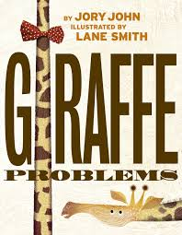

Wednesday, September 23
Learning Goal:  - I can listen to, and understand the story.  - I can look at the pictures to understand the story.  - I can communicate the different things I can do. | Task:  - Click on the image of the book cover  - Click through the slides shared from our friends at Peel District School Board  - Listen to the story I Believe I Can by Grace Byers  - What are some things you can do?  - Create a work of art that shows what you can do!  https://docs.google.com/presentation/d/1sPTaLRgv8HOv5a2HSe1XgZDhuK3SDdskvEFlz6G7Uog/present?slide=id.g98e67354d6_0_7 | 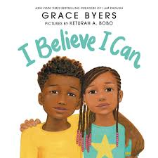

Thursday, September 24
Learning Goal:  - I can make predictions about the story.  - I can listen to, and understand the story.  - I can look at the pictures to understand the story.  - I can communicate different ways to be kind. | Task:  - Click on the image of the book cover  - Click through the slides shared from our friends at Peel District School Board  - Listen to the story The Kindness Book by Todd Parr  - What does kindness mean to you?  - What are all the ways you can be kind?  - Do a kind act for someone in your household.  https://docs.google.com/presentation/d/1QmIU_3-Gfu4E3E_KO38MijC0DCJto68c-4foo-Fv4E8/present?slide=id.g97736df38a_0_2 | 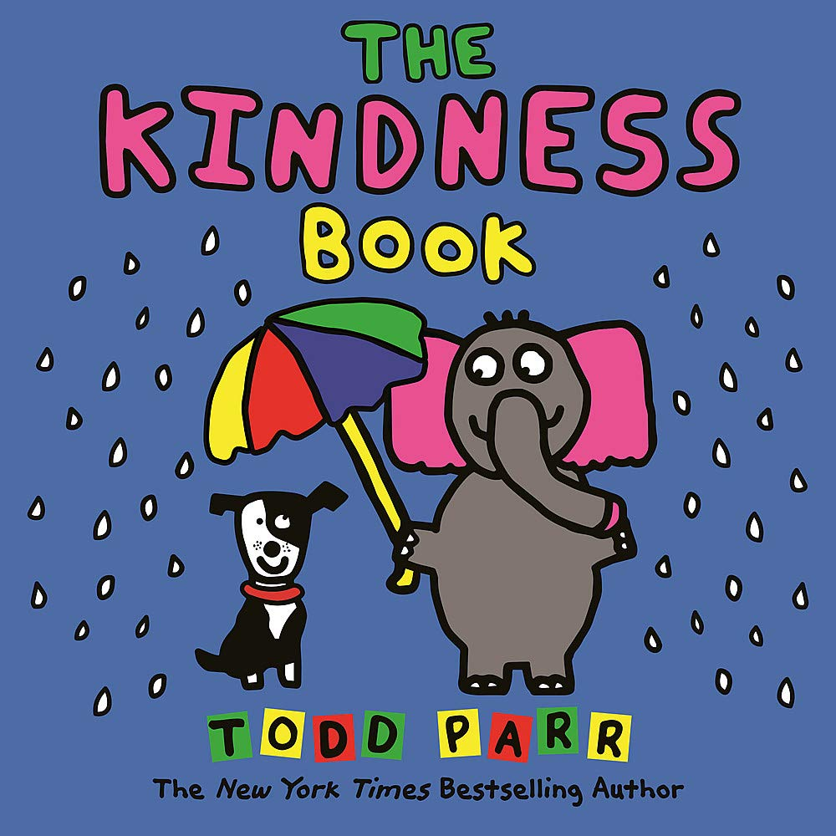

Friday, September 25
Learning Goal:  - I can make predictions about the story.  - I can listen to, and understand the story.  - I can look at the pictures to understand the story.  - I can create and tell a story about things that make me happy. | Task:  - Click on the image of the book cover  - Click through the slides shared from our friends at Peel District School Board  - Listen to the story My Heart Fills With Happiness by Monique Gray Smith  - What does kindness mean to you?  - What are all the ways you can be kind?  - Do a kind act for someone in your household.  https://docs.google.com/presentation/d/1Q5yF7YnVNyt4hjc9Piw7mNx6M0_7bUDx5erZcKuDl3I/present?slide=id.g97736df38a_0_78 | 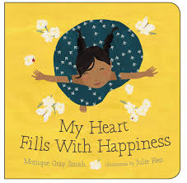

Reference: Adapted and used with permission from Peel District School Board Online School Resources
<https://sites.google.com/pdsb.net/pdsb-online-school/elementary-students/september-14>

