ACHIEVEMENT, PATHWAYS AND POST-SECONDARY TRAJECTORIES OF STUDENTS WITH SPECIAL EDUCATION NEEDS IN THE TDSB
This fact sheet is the final in a series of four fact sheets examining a range of topics impacting students with special education needs (SEN) within the Toronto District School Board (TDSB). The first fact sheet provided an introductory overview of TDSB students with SEN in the 2022-23 school year, the second and third fact sheets examined the different categories of exceptionalities and settings (self-contained, ISPs or regular classes) through an intersectional lens. Here we examine academic outcomes for students with SEN as they move through the TDSB, as well as access to post-secondary education. This includes comparisons between students with SEN and students without SEN on Education Quality and Accountability Office (EQAO) assessments, as well as an analysis of pathways, graduation and post-secondary confirmations using Grade 9 cohort data.

EQAO Achievement and SEN
The table below demonstrates considerable differences in achievement on EQAO assessments for students with SEN (excluding gifted), gifted students and students without SEN. Table 1 outlines 2022-23 EQAO results in mathematics for Grades 3, 6 and 9 students. Gifted students achieved at a much higher level than the TDSB average. On the other hand, all students with SEN excluding gifted and non-identified/IEP-only achieved at a much lower level than the TDSB average.
Table 1: EQAO 2022-23 Math Results for Students with and without SEN
Subgroups | Levels 3-4 EQAO Grade 3 Mathematics | Levels 3-4 EQAO Grade 6 Mathematics | Levels 3-4 EQAO Grade 9 Mathematics
Gifted | * (N=<10) | 98% (N=774) | 99% (N=758)
Students with SEN excluding Gifted | 25% (N= 1,605) | 22% (N=2,580) | 26% (N=2,807)
Students without SEN | 64% (N=13,109) | 60% (N=11,793) | 64% (N=12,734)
Overall TDSB | 64% (N=14,714) | 54% (N=14,373) | 57% (N=15,541)

In addition to looking at the most recent EQAO scores across the system, an analysis of EQAO scores over time was also completed using Grade 6 mathematics results at three time points: 2013-14, 2018-19 and 2021-22. Clear differences in achievement again emerge between groups of students (see Figure 1). While the same overall pattern of gifted students achieving at a much higher level than the TDSB average and students with SEN excluding gifted achieving at a much lower level than the TDSB average can be seen in this data, student placement also had an impact. Students in congregated settings (particularly students with SEN excluding gifted) achieved at lower levels than students in regular classes.
Figure 1: EQAO Grade 6 Mathematics Results for Students at Level 3 or 4 from 2013-14, 2018-19, and 2021-22*
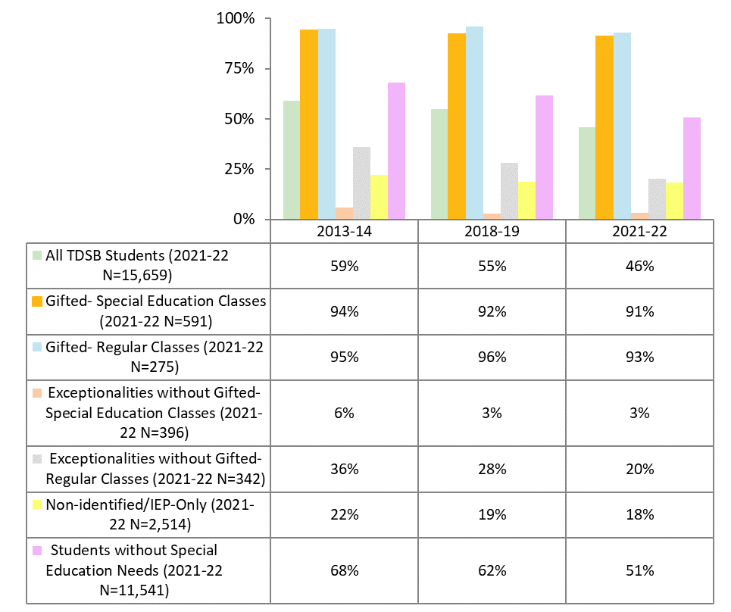
*Please note the EQAO assessment was changed to an online format in 2021-22 and therefore comparability with past years may be limited.

Pathways and Post-Secondary Access: Grade 9 Cohort Tracking
In order to examine pathways and post-secondary access for students with SEN, Grade 9 students who started in Fall 2016 were traced back to when they were in Kindergarten (2006-07 and 2007-08 school years) and then from Grade 6 (Fall 2013) through to 5 years of secondary school (June 2021).

Diagnostic Kindergarten Program
One of the Intensive Support Programs (ISPs) that the TDSB provides is the Diagnostic Kindergarten Program. This program serves Kindergarten students who have complex and/or medical needs in intellectual, communication, and fine/gross motor skills, including persistent challenges in daily living. Prior to Grade 1, students go through the Identification, Placement and Review Committee (IPRC) process to determine if the student is an exceptional learner and what supports will be required for the upcoming school year.
Within the 2016-21 Grade 9 cohort, we were able to identify 216 students who were in the Diagnostic Kindergarten Program in Junior or Senior Kindergarten.

- Virtually all of these students would later be identified as having SEN excluding gifted or non-identified/IEP-only.
  - 90% of students were in special education congregated classes and 3% were non-identified or had an IEP-only in Grade 6.
- Nearly all of these students (94%) would go on to have a reported exceptionality by Grade 6 - the most frequent being autism (36%), followed by developmental disability (23%), and mild intellectual disability (20%).
- Academic trajectories and outcomes for these students were generally lower than students without SEN. The graduation rate was lower than other students in ISPs (-11.0%), however, despite a lower graduation rate, university confirmations were slightly higher (+3.8%) (see Figure 2).

Figure 2: Academic Trajectories and Outcomes for Students in the Diagnostic Kindergarten Program (2016-21 Grade 9 cohort)

Grade 9 Academic
6.9%

Graduation
31.9%

University Confirmation
7.4%

College Confirmation
12.5%
Secondary School Outcomes by Exceptionality Category
Out of 15,699 students in the Grade 9 cohort of 2016-2021, 13,023 or 83% could be matched to Grade 6. The other 2,676 students or 17% entered the TDSB after Grade 6 and are therefore excluded from this analysis. From those 13,023 students, outcomes were examined for the six exceptionality categories which account for 97% (as of the 2023-24 school year) of students with SEN at TDSB (developmental disability, mild intellectual disability, autism, learning disability, gifted, and behaviour).
Within the 2016-21 Grade 9 cohort, we were able to identify 134 students with autism, 45 students with developmental disability, 138 students with mild intellectual disability, 614 students with learning disability, 601 gifted students and 71 students with a behaviour exceptionality.

Table 2 highlights key differences in pathways and post-secondary access for students.
- Nearly all students with a gifted exceptionality achieved Levels 3/4 in EQAO testing, took academic programming in Grade 9, and graduated within 5 years.The vast majority also confirmed post-secondary with over three-quarters confirming university.
- Around half of students with the four largest exceptionalities (excluding gifted and developmental disability) achieved Levels 3/4 in EQAO testing while far fewer took academic programming in Grade 9. Graduation rates varied greatly, from 34% for students with mild intellectual disability to 77% for students with a learning disability. Less than half of students with exceptionalities (excluding gifted) confirmed post-secondary.
Table 2: The Grade 9 Cohort 2016-2021 - Outcomes for Students with a Gifted, Autism, Developmental Disability, Mild Intellectual Disability, Learning Disability or Behaviour Exceptionality
Exceptionality (Grade 6 Status) | Gr 6 EQAO Math  level 3/4 | Gr 6 EQAO Writing level 3/4 | Gr 6 EQAO Reading level 3/4 | Grade 9 Academic | Graduated | Confirmed University | Confirmed College | Confirmed Post-  Secondary
Students without SEN (N=9,561) | 81.7% | 77.8% | 80.5% | 91.0% | 92.9% | 65.3% | 14.3% | 79.6%
Gifted (N=601) | 98.5% | 95.9% | 95.4% | 99.5% | 96.0% | 77.3% | 3.5% | 80.8%
Learning Disability (N=614) | 62.4% | 51.4% | 61.1% | 30.8% | 76.8% | 21.6% | 25.1% | 46.7%
Mild Intellectual Disability (N=138) | 67.9% | 55.9% | 59.0% | 2.2% | 34.4% | 1.6% | 15.6% | 17.2%
Autism (N=134) | 64.4% | 54.9% | 62.7% | 24.6% | 55.6% | 16.1% | 17.7% | 33.9%
Behaviour (N=71) | 52.2% | 45.1% | 43.6% | 15.5% | 46.3% | 7.5% | 9.0% | 16.4%
Developmental Disability (N=45) | 0.0% | 0.0% | 25.0% | 0.0% | 0.0% | 0.0% | 0.0% | 0.0%

Secondary School Outcomes by Exceptionality and Placement
Table 3 highlights key differences in pathways and post-secondary access for students in regular classes versus special education classes:
- Nearly all students with a gifted exceptionality took academic courses in Grade 9, as did a majority (53%) of students with SEN in regular classes. In contrast, only one in twenty students in ISP and one in five students in Home School Program (HSP) took academic Grade 9 courses.

- Almost all students with a gifted exceptionality (96%) graduated, as did most students with SEN in regular classrooms (79%) and HSP (73%). Conversely, less than half (43%) of those in ISP had graduated by 2021, although many were still in the TDSB in secondary Year 6.

- Most students with a gifted exceptionality transitioned to university (65%). Over half (58%) of students with SEN in regular programming in Grade 6 also went directly to post-secondary, but their pathways were split between college (27%) and university (31%).

- Post-secondary was not the direct pathway for most students taking congregated programming in Grade 6: only 16% of those in ISP and 44% of those in HSP made the transition, generally into the Ontario community college system. We also know from previous research that for students with SEN, those who do transition to college are generally from higher-income neighbourhoods.

Table 3: The Grade 9 Cohort 2016-2021 - Students with SEN in Grade 6 (2013-14) and Status up to Grade 12 (2020-21)
Subgroups (Grade 6 Status) | Grade 9 Academic | Graduated | Confirmed University | Confirmed College | Confirmed Post-Secondary
Students without SEN (N=9,561) | 91.0% | 92.9% | 65.3% | 14.3% | 79.6%
Students with SEN (excluding Gifted) in regular classrooms (N=1,913) | 53.4% | 79.4% | 31.2% | 27.0% | 58.1%
Gifted - regular and special education classes (N=601) | 99.5% | 96.0% | 77.3% | 3.5% | 80.8%
HSP* excluding Gifted (N=488) | 19.3% | 73.3% | 11.8% | 31.7% | 43.5%
ISP excluding Gifted (N=460) | 5.4% | 42.9% | 3.6% | 12.6% | 16.2%

*Given the unfavourable outcomes stemming from HSP, the TDSB has phased out HSP as of 2022-23 in a shift towards more inclusionary practices.

Conclusion
The intersections between gender, race, SES, and SEN highlighted in previous fact sheets, combined with these findings regarding academic pathways and outcomes illustrates how some groups of TDSB students are disproportionately and negatively impacted relative to other groups of students.
EQAO mathematics results demonstrated marked differences in achievement between gifted students, students with SEN excluding gifted and students without SEN. Students in congregated settings (particularly students with SEN excluding gifted) achieved at lower levels than students in regular classes.
Data from the 2016-21 Grade 9 cohort revealed that students in the Diagnostic Kindergarten Program and/or ISP were far less likely to take academic courses in Grade 9, to have graduated after 5 years of secondary education, or to confirm an offer from a post-secondary institution. Outcomes for students in HSP were also generally negative. These students were overwhelmingly male, racialized, and from lower SES backgrounds, which led to the TDSB phasing out HSP as of 2022-23.

Robson, K. L., Anisef, P., Brown, R. S., & Parekh, G. (2014). The Intersectionality of Postsecondary Pathways: The Case of High School Students with Special Education Needs. Canadian Review of Sociology/Revue canadienne de sociologie, 51: 193–215. doi:10.1111/cars.12044
Special Education Plan 2020 (2020). Toronto, Ontario, Canada: Toronto District School Board.

