PLACEMENT OF STUDENTS WITH

SPECIAL EDUCATION NEEDS IN THE TDSB
This fact sheet will examine placement in relation to TDSB students with special education needs (SEN) (i.e., whether students are in regular classes or Intensive Support Programs (ISPs)).

Comparisons between TDSB and the Province
The following section explores comparisons between TDSB students with SEN and the province using special education data from the Ministry of Education. These comparisons were done using the most recent data available, which is from the 2021-22 school year.
Figure 1: Distribution of TDSB’s Students with SEN in ISPs Compared to the GTA and the Province, 2021-22
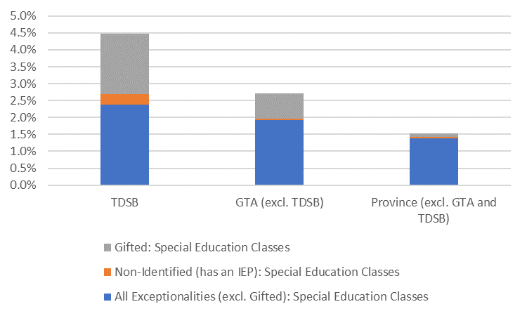
Figure 1 demonstrates the higher proportion of enrolment for students in ISPs in the TDSB compared to the province and the surrounding GTA. The bar on the left shows the distribution of students with SEN in ISPs at the TDSB between gifted, exceptionalities excluding gifted, and non-identified/IEP-only students. The centre bar shows the distribution in GTA school boards (excluding TDSB), and the bar on the right shows the Ontario distribution, excluding the TDSB and GTA because they make up such a large portion of the provincial numbers (see Table 1 for more details).
Table 1: Special Education Categories (Exceptionalities and Placement Types) Within TDSB, GTA** and the Province (2021-22)
 | TDSB |  | GTA** (excl. TDSB) |  | Province (excl. TDSB and GTA)
Exceptionality and Placement Category | Number of Students | Percent of Enrolled Students | Number of Students | Percent of Enrolled Students | Number of Students | Percent of Enrolled Students
All Exceptionalities (excl. Gifted): Regular Classes | 5,495 | 2.4% | 40,349 | 5.9% | 59,900 | 5.4%
All Exceptionalities (excl. Gifted): Special Education Classes | 5,533 | 2.4% | 13,158 | 1.9% | 15,456 | 1.4%
Gifted: Regular Classes | 3,119 | 1.3% | 6,123 | 0.9% | 4,259 | 0.4%
Gifted: Special Education Classes | 4,141 | 1.8% | 5,099 | 0.7% | 1,054 | 0.1%
Non-Identified (IEP-Only): Regular Classes | 24,174 | 10.4% | 33,693 | 4.9% | 116,035 | 10.5%
Non-Identified (IEP-Only):Special Education Classes | 744 | 0.3% | 300 | 0.0% | 431 | 0.0%
Non-Identified/No-IEP: Regular and Special Education Classes | <10 | <0.1% | 8,030 | 1.2% | 5,639 | 0.5%
Students Not Receiving Special Education | 189,509 | 81.4% | 578,751 | 84.4% | 907,572 | 81.7%
Total Enrolment | 232,716 | 100% | 685,593 | 100% | 1,110,382 | 100%

**GTA (excl. TDSB) includes the following school boards: Dufferin-Peel CDSB, Durham CDSB, Durham DSB, Halton CDSB, Halton DSB, Peel DSB, Toronto CDSB, York CSDB, York Region DSB.
Overview of TDSB Exceptionality and Placement Categories, October 2023
While data for comparisons outside of TDSB was not available beyond 2021-22, in this section we were able to use exceptionality and placement data from October 2023 using the TDSB’s Student Information System.
There were 41,075 students with SEN in the 2023-24 school year (17% of the overall TDSB student population). Below you will find the breakdown of placements within each exceptionality category.

Exceptionalities excluding Gifted – ISPs: 6,034 students (2.5%) – IPRC’d as one of the 10 exceptionalities excluding gifted and taking 50% or more of their classes in special education settings.
Exceptionalities excluding Gifted – Regular Classes: 4,201 students (1.8%) – IPRC’d as one of the 10 exceptionalities excluding gifted and taking 50% or more of their classes in regular classroom settings.
Gifted – ISPs: 4,274 students (1.8%) – taking 50% or more of their classes in special education settings.
Gifted – Regular Classes: 2,992 students (1.3%) – taking 50% or more of their classes in regular classroom settings.
Non-identified/IEP-Only- ISPs: 819 students (0.4%) – no IPRC but were receiving special education programming as of October 2023, or had an IEP and were receiving direct assistance in special education settings.
Non-identified/IEP-Only- Regular Classes: 22,755 students (9.5%) – no IPRC but receiving special education programming as of October 2023, or had an IEP and were receiving direct assistance in the classroom.
Non-identified/IEP-only students account for 57% of all TDSB students with SEN.

Figure 2: Placement Information for TDSB Students with SEN, October 2023
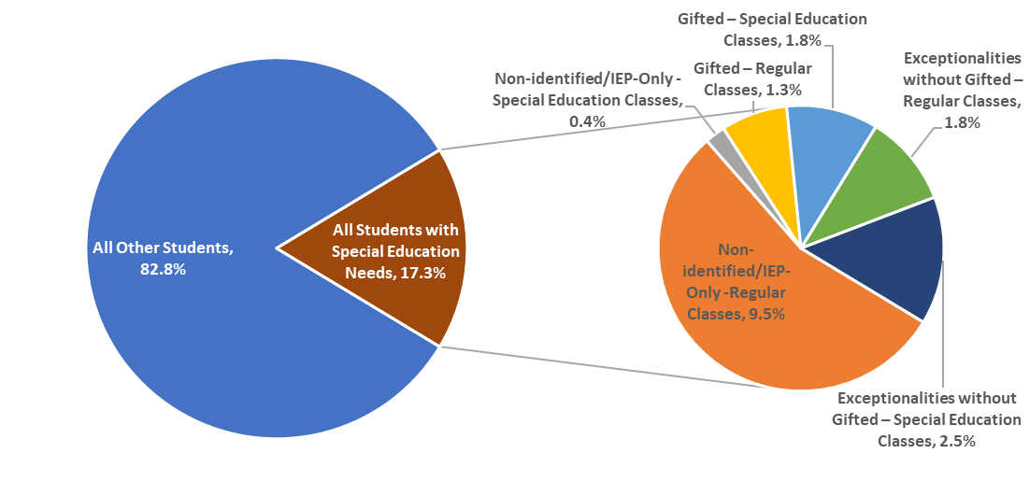

Intersectionality of Race, Income and Gender with SEN
Using preliminary data from the 2022-23 Student Census, the following section provides information on the demographic characteristics of students within different placement categories (exceptionalities (excl. gifted) in regular classes or special education classes, gifted in regular or special education classes and all IEP-only students (regular and special education classes)).

Figure 3: Exceptionality and Placement Intersected with Race*, October 2023
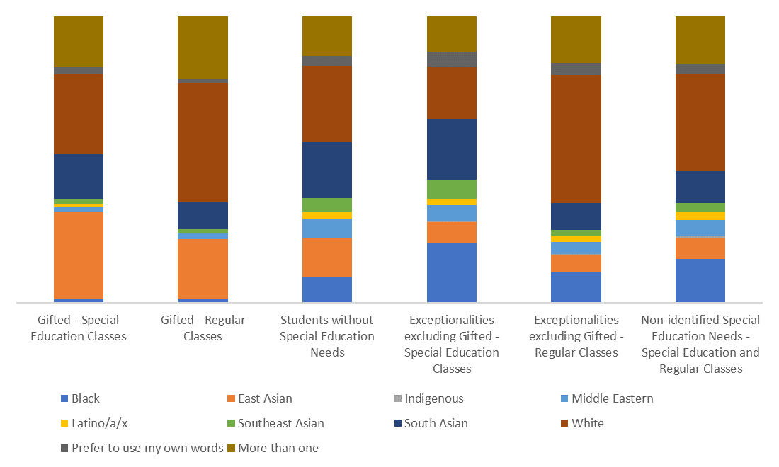
*The 2022-23 Student Census typology for race differed from previous Censuses by including the Prefer to use my own words category and replacing Mixed with the More than one racial category.

Placement and Race:
- Black, South Asian, Middle Eastern, and Southeast Asian students with an exceptionality (excluding gifted) are more likely to be in ISPs than regular classes.
- Students with special education needs (gifted and other exceptionalities) identifying as White or with more than one racial category are more likely to be in regular classes than ISPs.
- Gifted students identifying as Latino/a/x, East Asian, Southeast Asian, or South Asian are more likely to be in gifted ISPs than in regular classes.
- Similar proportions of Black and Middle Eastern students with a gifted exceptionality can be seen in regular classes and ISPs.

Figure 4: Exceptionality and Placement Intersected with Income, October 2023
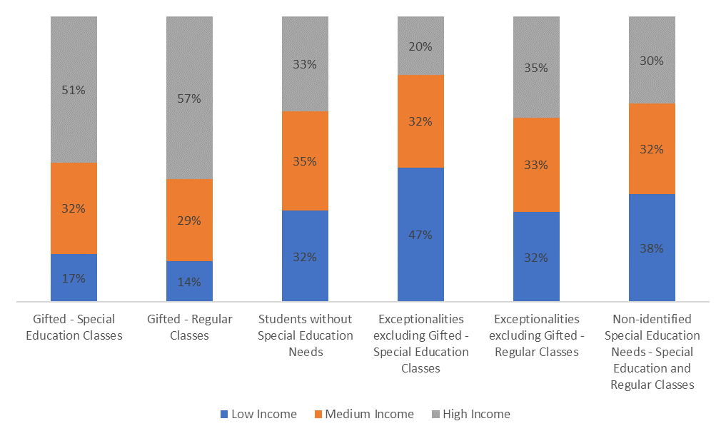

Placement and Income:
- Over half of students with a gifted exceptionality, regardless of placement, came from high income families, however, a higher proportion of gifted students in regular classes (57%) came from high income families than gifted students in ISPs (51%).
- Nearly half of students with exceptionalities (excluding gifted) in special education classes were from low income families.
- The income distribution for students with exceptionalities (excluding gifted) in regular classes was closest to the distribution of students without SEN.

Figure 5: Exceptionality and Placement Intersected with Gender*, October 2023
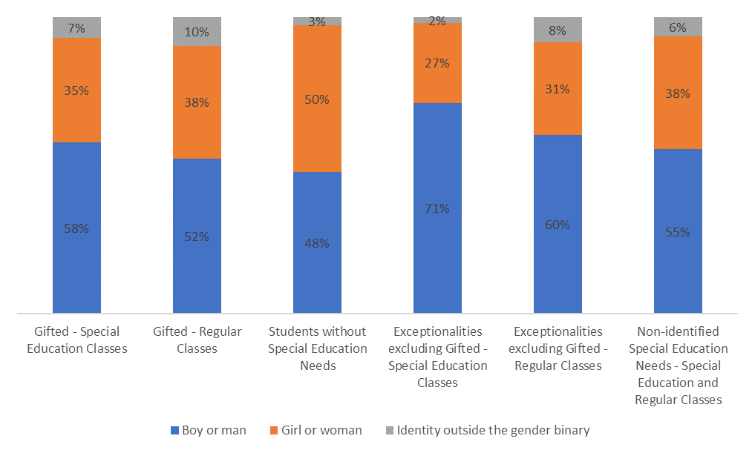
*The 2022-23 Student Census typology for gender identity differed from previous Censuses by including many more gender identities for students to select (or write-in) and were grouped here as Identity outside the gender binary.

Placement and Gender:
- Boys/men are overrepresented across all special education placements, with gifted-regular classes having the smallest degree of overrepresentation.
- Identities outside the gender binary are also more highly represented in gifted (up to three times more) compared with students without SEN.
- Boys/men are highly overrepresented in students with exceptionalities (excluding gifted) (both regular and special education classes), particularly in ISPs where boys/men represent nearly three-quarters of the group.
- The proportion of students with an exceptionality (excluding gifted) identifying outside the gender binary in ISPs is comparable with the proportion in students without SEN; however, the proportion in regular classes is nearly three times higher.

Summary
Compared to the GTA Boards and the province, the TDSB has higher proportions of students in ISPs (both gifted and other exceptionalities) relative to the TDSB’s proportion of the total provincial enrolment.
When special education placement is examined with intersections of race, income and gender, significant differences are apparent between special education classes and regular classes:
- Black and South Asian students with an exceptionality (excl. gifted) are more likely to be in ISPs rather than regular classes, whereas White students and those who identify with more than one racial category are more likely to be in regular classes rather than ISPs.
- Over half of students with a gifted exceptionality, regardless of setting, came from high income families and nearly half of students with exceptionalities (excluding gifted) in ISPs were from low income families.
- Boys/men are overrepresented in all special education programming (gifted and other exceptionalities both in regular classes and ISPs), but the highest disproportionalities can be seen in ISPs for exceptionalities excluding gifted - boys/men represent nearly three-quarters of this group.

Looking Ahead
The final fact sheet will focus on the following areas:
- Outcomes (achievement, pathways and post-secondary trajectories)

