**DECEMBER HIGHLIGHTS**

* Important Dates, Link to Parent Guides, Check It Out Videos, Drop-in Sessions
* International Day of Persons with Disabilities
* Surrey Place Family Events
* Bell Let’s Talk Wellbeing Resources
* Speech Language Pathology Services
* OT/PT Services
* Supporting the Grade 8 to Grade 8 Transition
* Supporting Executive Functioning
* Social Work Virtual Session, Developmental Disabilities Connects

**IMPORTANT DATES:**

**KEY DATES 2024-2025**

**ELEMENTARY PD DAYS:**

September 27, 2024: Professional Development

October 11, 2024: Professional Development

November 15, 2024: Parent-Teacher Conferences

November 29, 2024: Professional Development

January 17, 2025: Professional Development

February 14, 2025: Parent-Teacher Conferences

June 6, 2025: Professional Development

**SECONDARY PD DAYS:**

October 11, 2024 - Professional Development

November 15, 2024 - Professional Development

November 29, 2024 - Professional Development

January 30, 2025 - Professional Development

February 14, 2025 - Professional Development June

26, 2025 - Professional Development

June 27, 2025 - Professional Development

**SCHOOL YEAR HOLIDAYS** (as per Ministry of

Education)

Labour Day: September 2, 2024

Thanksgiving: October 14, 2024

Winter Break: December 23, 2024 – January 3,

2025

Family Day: February 17, 2025

Mid-Winter Break: March 10-14, 2025

Good Friday: April 18, 2025

Easter Monday: April 21, 2025

Victoria Day: May 19, 2025

**CHECK IT OUT!**

* [**Brain Break - Square Breathing Exercise**](https://www.youtube.com/watch?v=xaXvd8XiAcQ)
* [**Dear Teacher: Heartfelt Advice for Teachers from Students**](https://www.youtube.com/watch?v=lTMLzXzgB_s)

[**Special Education and Inclusion Parent Guides**](https://www.tdsb.on.ca/Learning-Equity-and-Well-Being/Special-Education-and-Inclusion/Parent-Guides-to-Special-Education-and-Inclusion)

Special Education and Inclusion Drop-in Sessions for Parents/Guardians/Caregivers

Learn more about navigating special education services, resources and supports, ask questions, and connect with other families.

[**Calendar of Drop-In Sessions for the 2024-2025 School Year**](https://docs.google.com/presentation/d/1ikPieHXCM7jMFjSvfw1L6JOypowiQ--C/edit)

**Community Resources**

**International Day of Persons with Disabilities**

December 3rd **International Day of Persons with Disabilities** (#IDPD). It is a globally recognized observance dedicated to promoting the rights and well-

being of persons with disabilities in all spheres of society, and to increase awareness of the situation of persons with disabilities in every aspect of political, social, economic and cultural life.

The 2024 theme of the International Day of Persons with Disabilities is Amplifying the leadership of persons with disabilities for an inclusive and sustainable future.

For more information, click [**here**](https://www.un.org/en/observances/day-of-persons-with-disabilities)**.**



**Listed below are FREE events offered through Surrey Place. OAP Number is required.**

[**Teaching Early Communication Skills**](https://f90e74a012b04344b3738e42e0833664.svc.dynamics.com/t/t/qv8wTjldtdtnpSPyXvh6Vwz7RvADMfeLTISy1FsvztYx/rls4MMEp6PDloA2ZmkJA8mvRuwr13Aeax2lURxuWsMsx)

**December 2, 2024**

[**Supporting Social Skills**](https://f90e74a012b04344b3738e42e0833664.svc.dynamics.com/t/t/psUEQGK8AXAVnhfGhStxkAMU3rqU5dVfpZG77pBc55Mx/rls4MMEp6PDloA2ZmkJA8mvRuwr13Aeax2lURxuWsMsx)

**December 3, 2024**

[**Supporting Mental Health in Teens**](https://f90e74a012b04344b3738e42e0833664.svc.dynamics.com/t/t/QR4GnBZhswjB7C0lTPL32Si7ZWt5XCdPBaIaDAx7VU4x/rls4MMEp6PDloA2ZmkJA8mvRuwr13Aeax2lURxuWsMsx)

**December 4, 2024**

[**Community Resources and Funding**](https://f90e74a012b04344b3738e42e0833664.svc.dynamics.com/t/t/ntr4vAiZUXYILBmTVMJyK4WYdDjHK6NxBYCrzVvrWhkx/rls4MMEp6PDloA2ZmkJA8mvRuwr13Aeax2lURxuWsMsx)

**December 10, 2024**

[**Identity Affirming Books and Resources**](https://www.tdsb.on.ca/Portals/0/docs/Identity_Affirming_Resources.pdf)

**Speech and Language and OT/PT Services**

TDSB Speech Language Pathology (SLP) Services focus on the early identification and prevention of speech and language difficulties. Every year, TDSB SLP Services create monthly Kindergarten calendars filled with activities to support oral language and literacy at home. Download your [**December Kindergarten Calendar**](https://drive.google.com/u/0/drive-viewer/AKGpihYsvGMgEHHWKzJFHtmjK665Fv8HF2GmnjD6ePz21WNp54Xp-AZhBSQQY9tYxSB57vTEluHeRyPSvJZOtwyfT55tThvEbxD1QQ=s1600-rw-v1) here or ask you child’s Kindergarten teacher to send you a copy today!

**From TDSD OT/PT Toolbox - Parents/Caregivers**

[**Electronic Accessible Books**](https://drive.google.com/file/d/1UXQPzTUJBVk6fB3anjg_9sfgkXvrltKz/view)

**(select above link for full handout)**

**Electronic Accessible Books**

Electronic books or ebooks can be fun for all students!

They are great for students who may not be able to hold a regular book or turn the pages by themselves.

Students may use a mouse, a touchscreen or a switch to access the ebooks on this handout.

There are many different types of electronic books.

[**LEARNING TO TYPE**](https://drive.google.com/file/d/1g8ev10elBfJ5FwaERoiEUYxOYDJ35pbB/view)

With technology access at our fingertips, the skill of typing is becoming more crucial to ensure academic success. Refer to our [**typing handout**](https://drive.google.com/file/d/1g8ev10elBfJ5FwaERoiEUYxOYDJ35pbB/view)for specific strategies to support your child’s typing skills.

Refer to[**https://bit.ly/tdsbotpt**](https://bit.ly/tdsbotpt)for more resources.

**Learning and Resources**

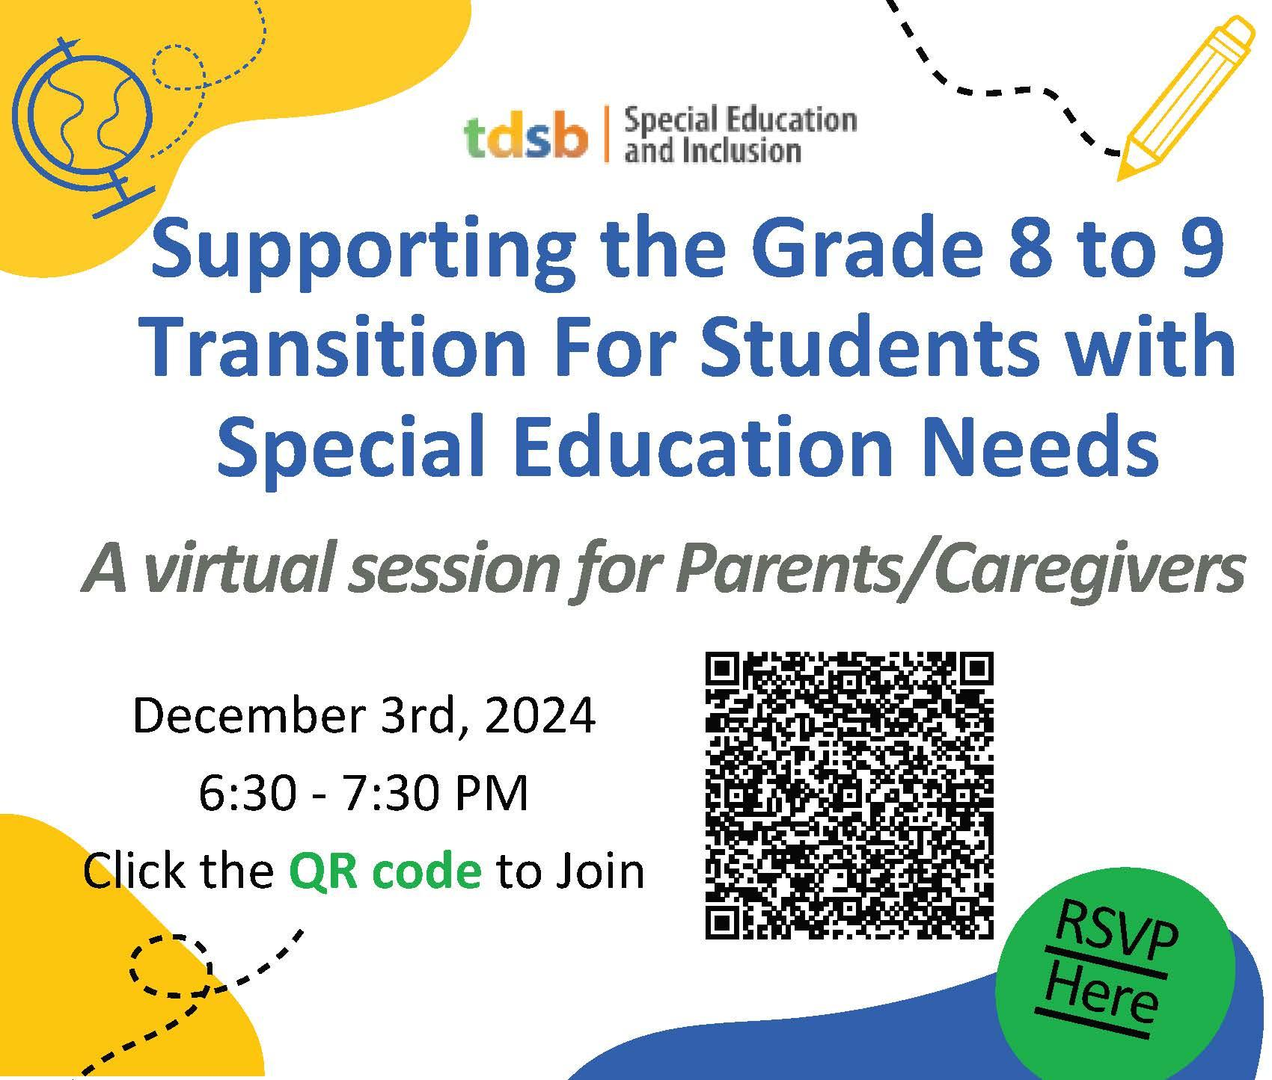

**Tips for Supporting Grade 8 to 9 Transitions**

* Take advantage of TDSB parent/guardian/caregiver drop-in sessions to deepen understanding of the supports and resources available to support transitions.
* Read the Special Education and Inclusion Newsletter for information on transition planning.
* Attend school information/orientation sessions and/or visit the school with your child before they start Grade 9.
* Find out what you and your child need to know before school starts (i.e. dress code, code of conduct, timetable, map of the school, and extra-curricular opportunities).
* Stay involved in your child’s learning by asking questions about how they are feeling about school.
* Learn about the supports that will be available for your child (i.e. who to speak to and where to go for support throughout the day).
* If your child has an Individual Education Plan, discuss the instructional and environmental accommodations outlined in the IEP with school staff.

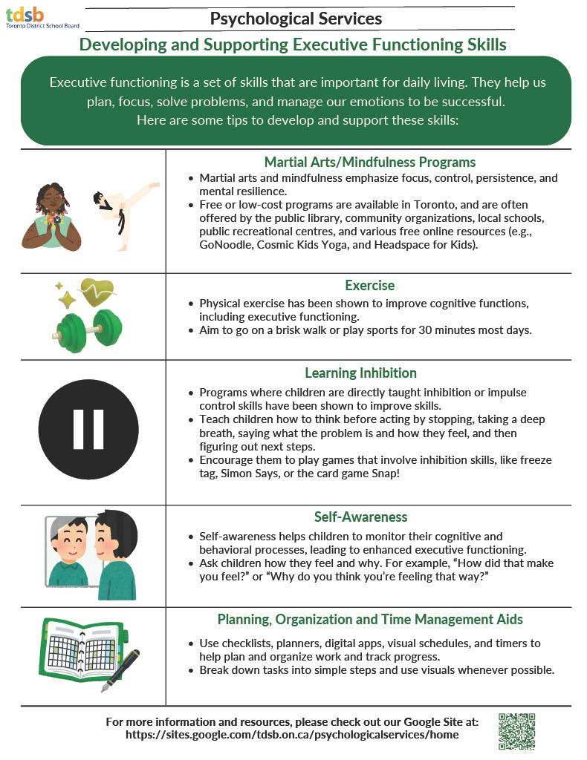

[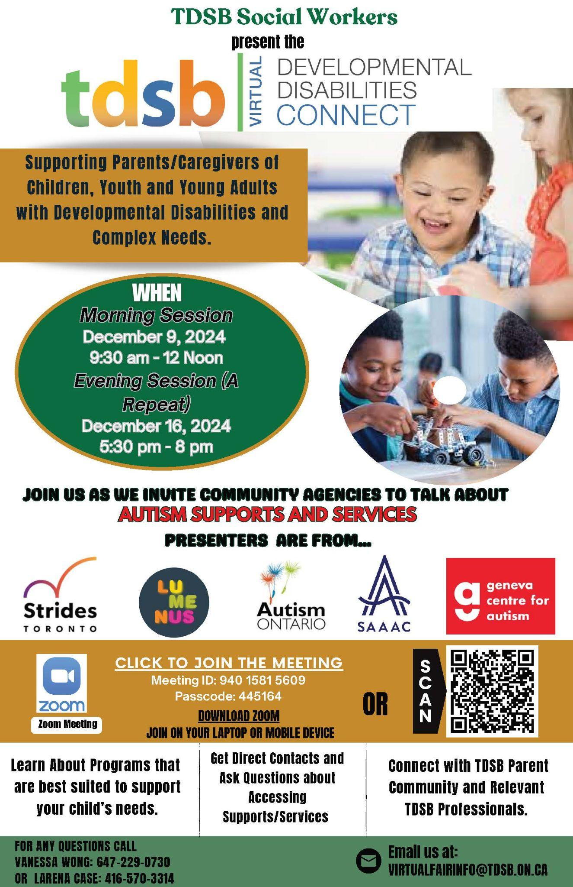](https://tdsb-ca.zoom.us/j/94015815609?pwd=zvXKxODRuh6GCza1hVFlNtdGaxj1UQ.1#success)

[Click here to join Zoom](https://tdsb-ca.zoom.us/j/94015815609?pwd=zvXKxODRuh6GCza1hVFlNtdGaxj1UQ.1#success)