Name of Committee: Alternative Schools Community Advisory Committee (ASCAC)
Meeting Date: 25 April 2022
A meeting of the Alternative Schools Community Advisory Committee convened on Monday, April 25, 2022, from 6:30 p.m. to 9:00 p.m. via Virtual Meeting (Zoom) with Angela Matich and Laurie McAllister (Co-Chairs) presiding.
Membership  Attendance: | Joanne Huber (Parent, High Park Alternative JS, ASCAC Member), Olga Ingram (Parent, Alternative Scarborough Education 1, ASCAC Member), Shelley Laskin (Trustee Ward 8, ASCAC Trustee Member); Angela Matich (Parent, Equinox, ASCAC Co-Chair); Dan MacLean (Trustee Ward 2, ASCAC Member), Laurie McAllister (Parent, Avondale Secondary Alternative School, ASCAC Co-Chair), Ben Singer (Parent, Mountview Alternative JS, ASCAC Member), Sara Wilken (Parent, Beaches Alternative & Horizon, ASCAC Member)
Staff Resource Person: | Peter Chang (System Superintendent, Interim)
Recorder: | Anna Catalano, ASCAC Committee Assistant
Regrets: | Gaia Friedman (Student, Spectrum Alternative Senior School, ASCAC Elementary School Student Member), Yo’av Kaplan (Parent, Avondale Secondary Alternative School, ASCAC Member), David Smith (Trustee Ward 17, ASCAC Member)

ITEM | DISCUSSION | ACTION ITEM
Land Acknowledgement & Welcome | Laurie McAlister, ASCAC Co-Chair read the Land Acknowledgement. Laurie also welcomed everyone and introduced the Committee Members.
Approval of Agenda | The agenda was approved.
Declarations of Possible Conflicts | No conflicts were declared.
2022-23 Secondary Alternative Schools: Staff Allocation | Caroline Lam, Manager, Staff Allocation & Reporting and Associate Director, Audley Salmon, presented information about the 2022-23 Staff Allocation for the Secondary Alternative Schools. The stated principles of staffing allocation include: allocating within established limits; fairness and equity; transparency; complies with legislative and collective agreement requirements. Caroline mentioned that due to the pandemic and families moving out of the city we have seeing a decline in enrolment. Caroline reviewed how staffing is determined (for teachers, guidance, and librarians) through the formula that is used, and that supplementary allocations are determined by the Staff Allocation Committee. Caroline and Associate Direct Salmon answered questions after the presentation.
Elementary Alternative Schools: Enrolment Allocation | Andrew Gowdy, System Planning Officer, and Giovanna De Girolamo, Educational Planning Coordinator, presented information on the enrolment allocation for elementary alternative schools. Andrew explained the general methodology used by the Planning staff and talked about the allocation for elementary alternative schools and what parameters are applied to ensure that class sizes are consistent with those across the system.  The Planning department are discussing the use of waiting lists and developing a process for elementary alternative schools to request expansions to their enrolment. The expansion process would consider number of applicants in prior years and number of current applicants; space availability with no fit-up cost; and the proposed expansion must achieve the class size with those across the system. Andrew and Giovanna answered questions after their presentation.
P023 – Parent and Community Involvement Policy Review | Michelle Munroe, Central Coordinator for Parent and Community Engagement Office (PCEO) presented information about the Parent and Community Involvement Policy (P023) review. Michelle mentioned that the policy is being reviewed to establish a framework for shared responsibilities of parents, caregivers, the Board, and the trustees for the implementation of effective strategies to increase and improve parent and caregiver engagement in the Board. Michelle reviewed some of the key and slight differences between the current policy and the new policy. Michelle encourages everyone, either individually or as a group, to provide their feedback. The consultation link can be found on the TDSB’s Public Consultation site and will be open until the end of May 2022.
ASCAC Secondary Alternative Schools Sub-Committee | Laurie McAllister, ASCAC Co-Chair provided for the ASCAC Secondary Alternative Schools Sub-Committee. The next meeting is scheduled for Monday, May 9 starting at 7pm. ASCAC’s Secondary Alternative School Staffing recommendation to PSSC in February resulted in a supplement of 17 teachers for the 21 secondary alternative schools. Sub-committee feels the staffing allocation formula across all schools needs to be reviewed.  ASCAC’s Secondary Alternative School Staffing recommendation to PSSC in February included a definition of “program viability”, it was noticed that it wasn’t included as part of the recommendation and the sub-committee would like to know how/ why the definition which formed part of the recommendation was missing, Trustee MacLean offered to follow up. Once Trustee MacLean reports back, the subcommittee can discuss how they want to approach the interpretation of “program viability” and if this is something they will be addressing next.  The ASCAC Secondary Alternative Schools Sub-Committee would like to ensure that ASCAC is engaged in meaningful consultation on the Secondary Alternative Schools Program Review, including its mandate, process, rollout, and regular updates and opportunities for feedback throughout the Review.  Laurie also mentioned that Denis Lopes and Rizwana Jafri will be retiring at the end of this school year and mentioned that between the two of them they supervised 18 secondary alternative schools. Laurie thanked them for all their hard work and wished them well.
ASCAC Community Building Sub-Committee | Angela Matich, ASCAC Co-Chair, provided an update for the ASCAC Community Building Sub-Committee. The Sub-Committee has two more events that need to be completed before the end of the 2021-22 school year. The first event, scheduled for Wednesday May 4, is the Secondary Alternative Student Community Share & Learn Zoom Event. Purpose of this event is for ASCAC to meet/ connect with student representatives from each secondary alternative schools to hear directly from the students as to how ASCAC could assist them with any issues/ challenges they may have.  The second event (still in the works), hoping to take place in May, is the Middle School Fun Day event. The event is being piloted with two middle schools and will be for students in grades 7 and 8 in hopes that they will do some knowledge sharing and community building. Megan Wiigs, a Sub-Committee member, is taking a lead on this event.
ASCAC Equity Sub-Committee | Angela Matich, ASCAC Co-Chair, provided an update on the ASCAC Equity Sub-Committee which met in April. The Sub-Committee has two suggestions/recommendations they want to bring forward. The first suggestion, Angela has already reached out to Peter, is that at a future ASCAC meeting staff from the Special Education Department be invited to speak/present about Special Education Staffing Allocation.  The second suggestion is about School Councils’ email address being a challenge. Angela has received a possible solution which she will send to Peter. She asks that Peter forwards the email to the appropriate person for consideration.
TDSB Website – Find Your School | Peter Chang, System Superintendent and ASCAC Staff Resource Person, provided a quick update regarding ASCAC’s TDSB Website – Find Your School recommendation (passed at the January 19, 2022, PSSC meeting). The updating of the Find Your School web page has been in place since 2019 when the Board wanted to harmonize the website to ensure equity of access for all our students. To ensure equitable access and that ASCAC’s recommendation, the mapping functionality will be updated to show not only the designated schools by address but also the System-Wide offerings available throughout the city. The new mapping feature will include the legacy technical commercial schools, the student interest programs (formerly known as specialized programs), and the elementary and secondary alternative schools. The Planning Department will be invited to a fall ASCAC meeting to provide an update.
Alternative Schools Policy (P062) | Peter Chang provided an update on the Alternative Schools Policy (P062). The Alternative School Policy Work Plan went to the April 27, 2022, Governance and Policy Committee meeting to get their approval to commence the review of P062 during the 2021-22 school year instead of the 2022-23 school year. At the May 2021 Board meeting ASCAC’s recommendation to have a centralized elementary alternative schools admission form was approved though we were also asked to create one set of clear and detailed admissions procedures. The Working Group has been working on the form and procedures and was informed that the procedures need to align with a policy. Since Alternative Schools are not a part of the Out of Area or Student Interest Programs policies, we need to revise P062 to ensure that the procedures have a policy to align to. Once the revised policy is approved the Alternative Schools Procedure (PR584) will be reviewed and revised as required.
Open Floor | Meeting participants were welcomed to ask questions, provide feedback and or let the Committee know of any concerns they may have.
Closing Remarks & Adjournment | Meeting was adjourned at 8:10 pm
Next Meeting | April 25, 2022 from 6:30 pm to 8:30 pm

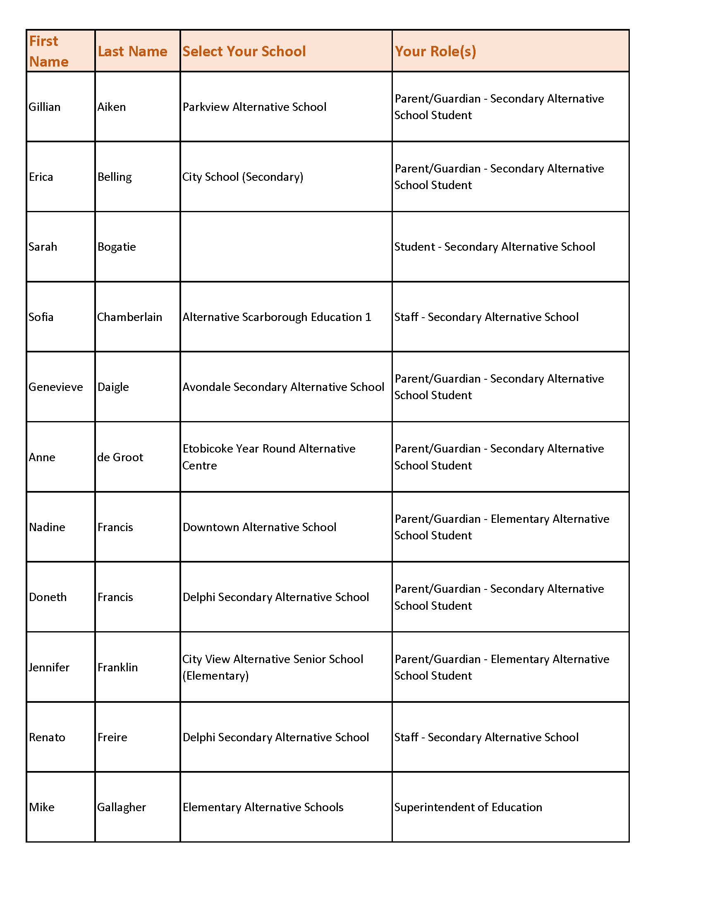
APPENDIX A
