PROGRESS OF CONSTRUCTION WORK

- Trinity Construction have fully mobilized to site. Interior and exterior hoarding is complete.
- Occupancy is scheduled for Summer 2025.
- Removal of existing stair complete.
- Electrical removals, demolition, and rough ins in progress.
- Mechanical and sprinkler disconnection and demolition ongoing.

UPCOMING WORK

- Inflector demolition to continue.
- Excavation to continue.
- In situ steel and structural elements in progress.
- Off-site modular construction commencing, with scheduled completion and arrival on site for January 2025.

COMMUNITY UPDATE:
Structural and demolition works started on site and will continue with additional renovation works until January 2025. The modular addition that is to be built offsite is scheduled to be delivered for early January 2025. The school will be active throughout the full construction period and will be separated by hoarding and appropriate construction signage to ensure there is no impact to ongoing school activities. The school will not be active during the delivery of the modular unit.
CONSTRUCTION PROGRESS PHOTOS:
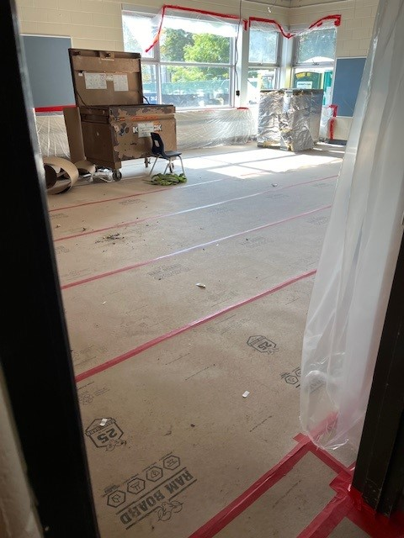  Interior demolition, with installed floor and room protection. | 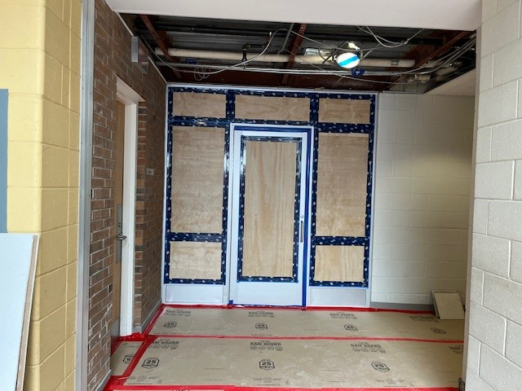  Interior demolition, with installed floor and room protection.

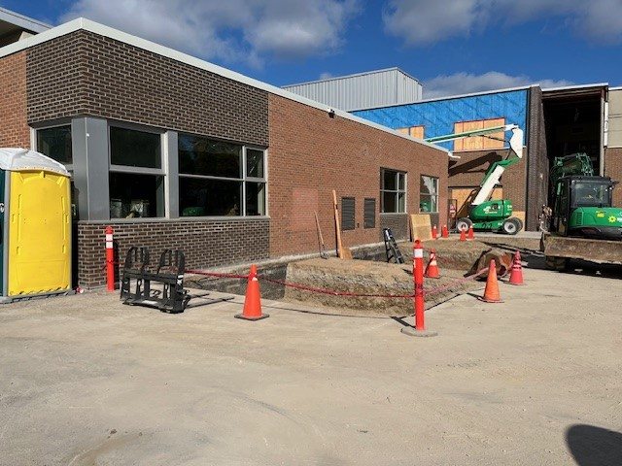

Exterior demolition and excavation.
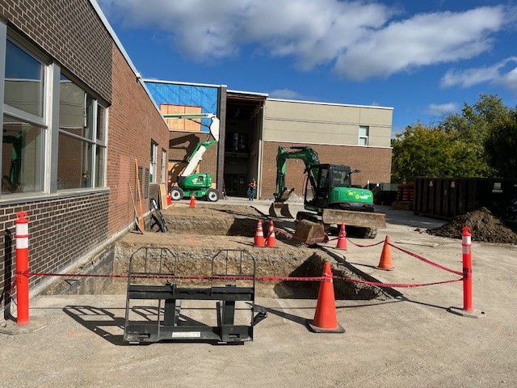

Exterior demolition and excavation.

