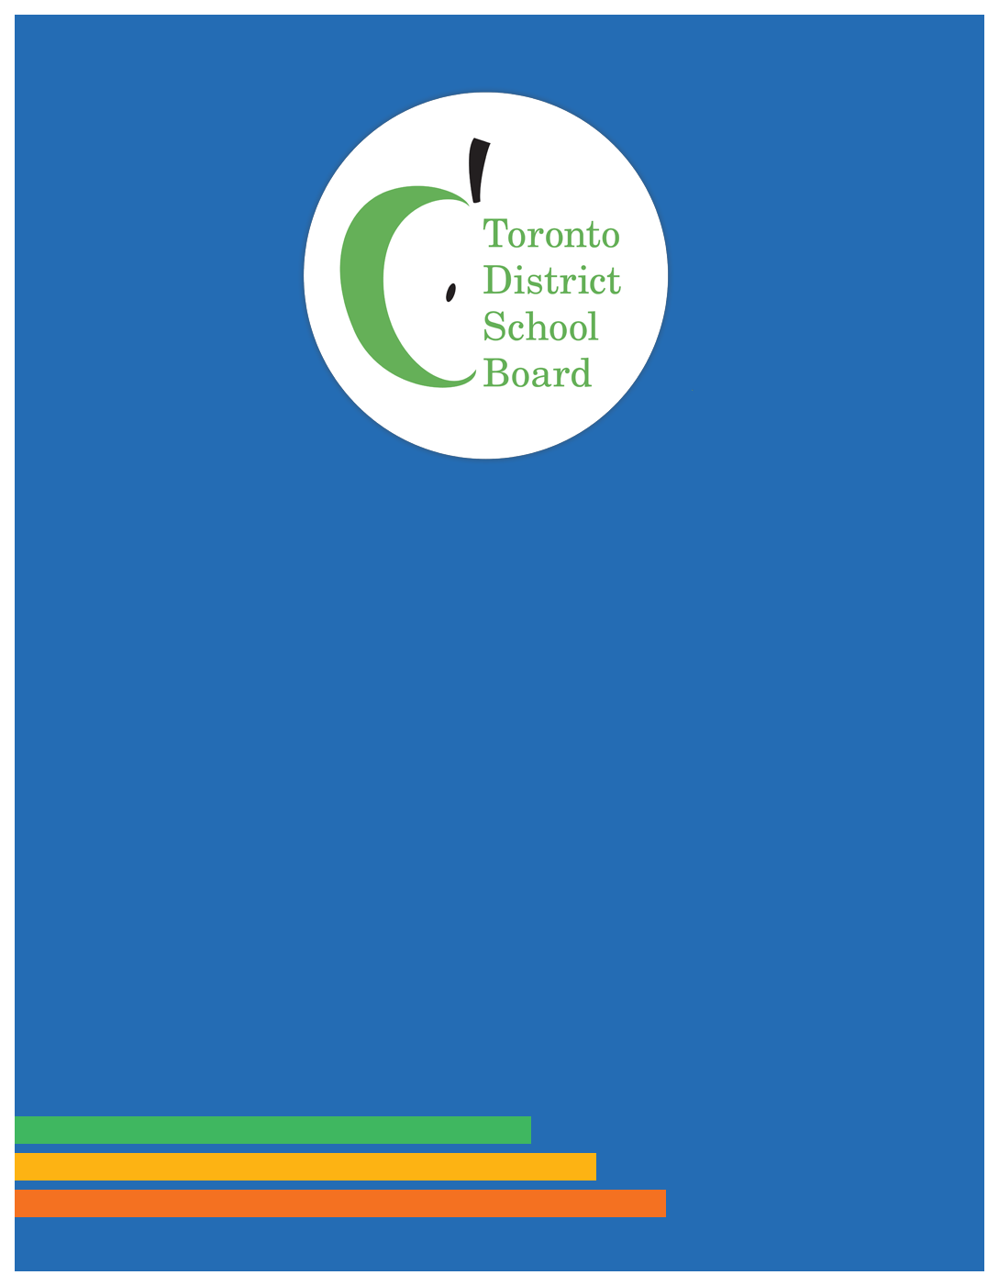

# French as a Second Language Community Advisory Committee (FSLCAC) June 18, 2024 ANNUAL REPORT

**Committees**

**Advisory**

## French as a Second Language Community Advisory Committee (FSLCAC) June 18, 2024

## ANNUAL REPORT

## Table of Contents

Parent Co-Chair Message-Lynne Leblanc 3

Mandate/Purpose 4

Meetings 5

Outreach initiatives 6

Committee Members 7

2024-2025 Executive and Meetings 8

## Parent Co-Chair Message-Lynne Leblanc

The FSLCAC discussed opportunities to achieve growth and excellence in Core, Extended and Immersion French programs and shared our lived experiences as parents with children in TDSB French programs with staff and our Trustee. We appreciate the support from staff and all Trustees for student achievement and parent engagement in French programs. Congratulations to the Board on the September 2024 reopening of Bannockburn PS as a French Immersion Centre and opening of Lakeshore CI’s as a new French immersion site.

In the 2023-24 school year, we focused on the Learning Opportunities Index and French Immersion. We welcomed Karen Murray, System Superintendent, Anti-Oppression and Equity at our November meeting and Dr. David Cameron at our January meeting. At our May meeting, Angela Caccamo presented the report on the Learning Opportunities Index and French Immersion that was in response to Trustee King’s November 2023 motion and the finding that French immersion enrolment has limited, if any, impact on LOI status. The FSLCAC supports the continued inclusion of all students in the LOI data collection. The presence of students from all household income levels and all races in French immersion is encouraging and we will continue to challenge the barriers to equity of access and to work with staff and Trustees on encouraging participation in French immersion by under-represented groups.

We continue to follow up on these recommendations made just prior to and during COVID (2019-2021) which were referred back to staff:

* Provision of a briefing note on TDSB DELF (Diplôme d'études en langue française) capacity building and cohort results (from 2013 on).
* Results reporting on the impact of the French Review changes (JK entry, Middle Immersion, phase out of Extended) on achieving the goals set out in the FSL. Program Review staff recommendations and Trustee decisions (June 2019) and in Policy 80 FSL Programs. The last update to Board was November 2021.
* Parent-friendly revision of Special Education information in Procedure 597 French Immersion and Extended.

We continue to share concerns at our meetings about:

* Additional barriers to accessing before/after school care for French immersion students.
* TTC support for secondary French immersion students which was cut from the 2019 budget and was to continue to be offered to FI students in financial need at their FI school.
* The one-week delay of bussing for French immersion students in September that was a response to COVID but is still in place.
* Aligning the start date for registration for JK French immersion with the start date for registration for regular JK.

## Mandate/Purpose

The French as a Second Language Community Advisory Committee (FSLCAC) was created by the Board in 2005. In 2007, our mission was adopted by the Board and was reconfirmed with the adoption of our Terms of Reference in 2016:

“To consult with and advise the Board on French as a Second Language matters. As a Board community advisory committee, the FSLAC will contribute to the work of trustees and staff. This partnership of trustees, staff and parents will foster excellence and growth in FSL programs at the Board.”

NB: FSL (French as a Second Language) programs are: Core, Early and Middle French Immersion. Extended French programs are being phased out.

**Terms of Reference Update Recommendations**

With the adoption of the 2024-28 Multi-Year Strategic Plan, the Community Advisory Committee Procedures (PR741, PR742, January 2024) and in advance of the upcoming review of selected Community Advisory Committees, our committee reviewed our Terms of Reference. At our Annual General Meeting in June 2024, the committee passed recommendations for consideration by the Board of Trustees to align our name and mandate with the 2024-28 Multi-Year Strategic Plan. As advised by staff, these recommendations may be submitted to the Governance and Policy Committee after the review of the FSLCAC is completed at the November 2024 Organization Board meeting.

The proposed update to our name is: “French Student Achievement Community Advisory Committee”. This name would centre our work on students and their achievement in Core and Immersion French programs. Note that “second language” has been removed, as has been done by the TDSB French department, to be inclusive of our multi-lingual students for whom French is a third or subsequent language.

The proposed update to our mandate is “To consult with and advise the Board on French program matters. As a Board community advisory committee, the French Student Achievement Community Advisory Committee will contribute to the work of Trustees and staff. This partnership of Trustees, staff, parents/caregivers/guardians and community will foster equity, excellence and growth in French programs at the Board.”

### Meetings

Regular Meetings 7:00 – 9:00 pm:

* September 19, 2023 (hybrid)
* October 17, 2023 (hybrid)
* November 14, 2023 (hybrid)
* January 9, 2024 (hybrid)
* March 19, 2024 (hybrid)
* April 16, 2024 (zoom)
* May 14, 2024 (zoom)
* June 18, 2024 (hybrid)

Orientation and Informal Gatherings:

* November 26, 2023
* June 11, 2024

Executive Meetings:

The parent co-chair, vice co-chair and Canadian Parents for French met as needed throughout the year to coordinate and advance committee work and communications.

Committee Meetings:

Prior to regular meetings, the parent co-chair met with staff and Trustee co-chair to collaborate on the agenda.

In 2023-24, we improved our attendance and punctuality for regular meetings significantly compared to 2022-23. The new CAC Procedure 742 requires that we have 5 members (other than staff) present in person in order to hold a hybrid meeting. Getting firm RSVPs from parents is an added organizational task.

While participating from home via Zoom is convenient, it continues to present many challenges. This year, we have experienced faulty links that require a flurry of texting and emailing to get meetings started and at two meetings, in person participants had to gather around staff laptops because there was no technical support. Efforts to integrate and engage new parent members who have only attended via Zoom with cameras off are volunteer intensive. Parents come from across the city and do not know each other at all when they join the committee. Building lasting, productive relationships and establishing a ‘new normal’ while also meeting the requirements of the new CAC procedures is a work in progress that requires creative solutions and patience.

### Outreach initiatives

Email:

FSLCAC volunteers continue to use our Gmail account: fslactoronto@gmail.com for correspondence. Parents and stakeholders write to us with FSL related questions. Common enquiries are on accessing programs and special education support and for referrals to the appropriate staff member on FSL specific concerns.

Newsletter and E-blasts:

The FSLCAC newsletter was produced and distributed in December 2023, March 2024 and June 2024. E-blasts were sent out for time sensitive items and French immersion registration. Emails are sent out to more than 150 schools with French immersion/extended programs, Trustees, and over 900 individual parents and FSL stakeholders who have signed up. It shares information about new developments in FSL and tips for parents in supporting their children learning French. The sign-up button and past newsletters are available at www.tdsb.on.ca/fslcac . We continue to seek email addresses for Parent/School Councils to add to our distribution to fulfill our mandate as a partnership between Trustees, staff and parents.

Conferences, Workshops & Meetings:

In November 2023, we presented at the Elmlea PS school council meeting. Our “Intro to the FSLCAC” is available for school/ward council meetings. Power point slides are posted at www.tdsb.on.ca/fslcac. Inquiries about having this presentation done may be directed to fslactoronto@gmail.com .

In our continued effort to reach out to more parents directly, FSLCAC members hosted an information table at the Parents and Caregivers as Partners conference in February 2024.

### Committee Members

Parent members/alternates are elected by parents/guardians/caregivers in their ward in odd numbered years to serve a two-year term on the FSLCAC. Trustees who have vacancies in their wards for members/alternates are asked to hold elections at their ward meetings. To be eligible to be an FSLCAC voting member/alternate, one must be a current TDSB parent/guardian/caregiver who wishes to further the mission of the FSLCAC and is available to attend about eight evening meetings during the school year. Trustees needing more information or assistance recruiting members to fill vacancies may contact the FSLCAC at [fslactoronto@gmail.com](mailto:fslactoronto@gmail.com).

Parent/Community Membership as of June 18, 2024:

|  |  |
| --- | --- |
| **Trustee Co-chair Dan MacLean** | **Parent Co-chair Lynne LeBlanc** |
| **Parent Members** | Lisa McAvoy (W2 – parent vice co-chair)  Devon Pool (W3)  Andrew Waters (W3 Alt/9) |
|  | Sharlene Henry (W5/6 – parent vice co-chair) |
|  | Elizabeth Carvalho (W7) |
|  | Lynne Leblanc (W8) |
|  | Cheryl Batty (W8 Alt) |
|  | Maeve Gray (W10) |
|  | Charles Zhu (W11/8) |
|  | Divya Chandra (W11 Alt) |
|  | Randy Samuel (W14) |
|  | Madelaine Hamilton (W16) |
|  | Moosa Anwar (W19) |
|  | Zuojun Han (W20) |
|  | Gail Miller (W22) |
|  | **Note:** where there is more than 1 ward next to a parent/guardian’s name, it indicates that they live in one ward, but their child(ren) attend school in another ward. |
| **Community Members** | Mary Cruden (Canadian Parents for French) |
|  | Sharon Beason (CPF Alt) |
|  | Rosemary Sutherland (CPF Alt) |
| **Staff Members** | Audley Salmon, Associate Director |
|  | Roni Felsen, Superintendent |
|  | Angela Caccamo, Principal, French programs |
|  | Kirsten Johnston, Coordinator, French programs |
|  | James Jarrett, Administrative Assistant. |

### 2024-2025 Executive and Meetings

**2024-25 FSLCAC Executive:** At the June 18, 2024 Annual General Meeting,Lynne LeBlancwas elected as parent co-chair for a 1-year term. Charles Zhu, Charlene Henry and Moosa Anwar were elected as parent vice co-chairs for a 1-year term. Canadian Parents for French member/alternates are appointed to a 2-year term renewable in 2025 and serve as non-voting community members.

**Upcoming Meetings:** **2024 –** September 10, October 15, and November 12. When available, agendas and **2025** meeting dates will be posted at [www.tdsb.on.ca/fslcac](http://www.tdsb.on.ca/fslcac) .