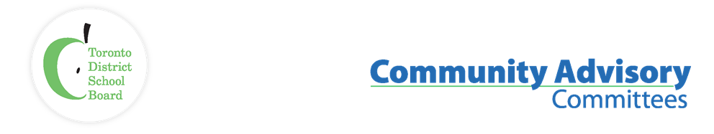
Name of Committee: Black Student Achievement Community Advisory Committee
Meeting Date: October 2nd, 2023

A meeting of the Black Student Achievement Community Advisory Committee convened on October 2nd, from 6:30 p.m. to 8:30 p.m. at TDSB Education Centre, 140 Borough, Scarborough. Comm Rm 3/4 on 1st floor

Voting Members: | Sharon Beason (Community Co-Chair), Trustee Co-Chair Liban Hasan, Sophia Ruddock (Education/Health/Law), Tina Beason (Student) M. Blacksmith Ben-Moodie (Education), Yasmina Drame,
Staff Representatives: | Lorraine Linton, Interim Executive Superintendent, Employee Services  Karen Murray, System Superintendent Equity, Anti-Racism, Anti-Oppression  Lisa White, Administrative Support
Student Trustee: | Angelika Bell
Staff/Community | Cherie Mordecai-Steer, Rosalie Griffith, Khadra Hussein, Mahnaz Mirkhond-Chegini, Mohamed Ahmed, Deborah, Yvette Blackburn, Amani Kwadwo Ausar, Jeffrey Caton (Centre of Excellence for Black Student Achievement), Trustee D. Williams, Trustee Dan MacLean, Novlette Mitchell
ITEM |  | DISCUSSION | ACTION/ RECOMMENDATION / MOTION
Land & African Ancestral Acknowledgement
Call to Order / Quorum |  | Quorum was reached. The meeting was called to order.
Approval of Agenda |  | The motion to accept the agenda was moved and carried.
Declaration of conflicts of interest |  | No conflict was declared.
Introductions |  | Committee members and staff introduced themselves.
Student Trustees |  | Angelika Bell, the new Student Trustee, introduced herself and shared information about the student council president/vice president. She wants to make sure they connect with students from each school.  Angelika was interviewed on CBC radio about students starting the new school year.  She highlighted the Equity Collective, a group of 24 students from high school and middle school who meet to discuss the Multi-Year Strategic Plan.  Angelika also went to ICON, a group that helps students, who are from Black and Indigenous identities, and KPMG, where she is the National Director of High School partnership. They supported an event at KPMG headquarters and heard from over 30 speakers from companies like Google, KPMG, and the Toronto Raptors.
Co-Chairs Update |  | Trustee Hassan  Shared that in October, we celebrate Somali and Muslim Heritage Months, Sister in Spirit Day, Seniors Day, Missing and Murdered Indigenous Girls Day, and World Teachers Day. In September we acknowledged National Day of Truth and Reconciliation Day, (Orange Shirt Day). National Seniors Day on October 1st.
Staff up-date |  | Lorraine Linton  BSACAC committee is encouraged to view Director, Colleen Russel-Rawlins September video report.  https://www.tdsb.on.ca/About-Us/Director-of-Education  The Governance Policies Committee reviews the policies and makes changes that are up for renewal. BSACAC community may be interested to know when the Governance and Policy Committee meets.  Karen Murray  The Director’s report further states that the affirming identities of students will be included in the curriculum.  The Minister of Education has emphasized the importance of reading fluency as a new area of focus.  Numeracy funding has been allocated to all districts across the province to bring about intentional changes in the way students are taught in our schools.  TDSB is one of the leading boards that is moving away from separating students into academic and applied streams.  This year, the TDSB continues to emphasize Science and Technology, especially in the fields of STEM (Science, Technology, Engineering, and Mathematics) and STEM learning.  The census has been finished and now the Research Department is studying the data to share with others.
Area of focus 2023-2024 |  | The community gave suggestions for areas of focus for BSACAC.  - Student Success Gr 1-6. Literacy for Black students.  - Looking at the Developmental Reading Assessment (DRA)  and the CASI Reading Assessment scores. Look at the  documents that we use to see what’s working and what’s not  working for our children.  - Update on the practical rollout of the advanced pathways de-  streaming.  - How will the initiative Right to Read support our Black  students?  - Make sure BSACAC is at the table when budgeting takes  place.  An update from Safe School, Executive Superintendent Jim Spyropoulos regarding cases still pending:  - What are some of the outcomes?  - Was there any mediation?  - Were students returned to school?  - Were they able to attend summer school or after-school  programs?  - What is the data follow-up with the Black students who have  been dealing with suspension and expulsions?  An update from the Human Rights Office.  - How many cases of anti-Black racism have been filed  between teachers? How many between parents to teachers?  Parents to administrators? Parents to board?  - Motion that has passed in the past, that has not been  completed.  - More details of what’s being done for minority students.  what supports are available for them?  - Have events specifically targeted at mental and spiritual  well-being, awareness, and growth  - Staff, a spiritual retreat for the staff and administrator  celebrating Black staff, Black excellence, and leadership  in the system.
Centre of Excellence for Black Student Achievement Jeff Caton |  | Jeffrey Caton presented the activities taking place at the Center of Excellence for Black Students.
Nomination Committee:  Dennis Keshniro |  | Deferred
Membership update |  | Sharon Beason  We are working on improving our attendance at meetings. | Reach out to the previous membership.
Cherie Mordecai-Steer |  | Could the staff arrange for a speaker to address the Alternative Schools Admissions Lottery system, or could they gather the necessary information and present a report to the committee? | Trustee Hassan will collaborate with the staff to ensure that the community receives the appropriate answers during an upcoming meeting. It is important to note that the policy is currently undergoing review.
Adjournment
Next Meeting Date |  | November 6th @ 5:30 p.m.

