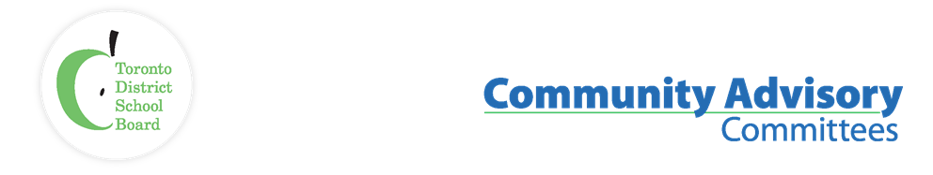
Name of Committee: Black Student Achievement Community Advisory Committee
Meeting Date: December 4th, 2023

A meeting of the Black Student Achievement Community Advisory Committee convened on December 4th, from 6:30 p.m. to 8:30 p.m. at 5050 Yonge Street, Boardroom
Voting Members: | Sharon Beason (Community Co-Chair), Sophia Ruddock (Education/Health/Law), Tina Beason (Student) Dennis Keshinro, Cherie Mordecai-Steer,  Regrets: Trustee Co-Chair Liban Hassan
Staff Representatives: | Lorraine Linton, Interim Executive Superintendent, Employee Services  Lisa White, Administrative Support  Regrets: Karen Murray, System Superintendent Equity, Anti-Racism, Anti-Oppression
Student Trustee: | Angelika Bell
Staff/Community | Trustee Debbie King, Regina Odofle Thompson, Novlette Mitchell, Jeffrey Caton, Centre of Excellence for Black Student Achievement) Alice Bhyat, Rosalie Griffith, Mohamed Ahmed, Blacksmith Ben-Moodie  Mon Shu Wong
ITEM |  | DISCUSSION | ACTION/ RECOMMENDATION / MOTION
Land & African Ancestral Acknowledgement
Call to Order / Quorum |  | A quorum was reached. The meeting was called to order.
Approval of Agenda |  | The motion to accept the agenda was moved and carried.
Declaration of conflicts of interest |  | No conflict was declared.
Mediation Follow-up Presentation |  | Regina Thompson gave a presentation recap of the mediation process and agreement. Ms. Thompson outlined her process for creating her report, followed by a question-and-answer period.  - Working with BSACAC (Black Student Achievement Community Advisory Committee) and TDSB (Toronto District School Board) staff in conflict resolution to help return focus to the mandate of Black Student Achievement  Part 2  - An Afrocentric committee governance would be created if agreed upon by the BSACAC committee. It was to begin after the completion of part one to end by 3 months of its commencements.
Student Trustee |  | Angelika Bell  She reported that her work is centered on engaging the students in person and virtually.  Focusing on school visits, to ensure that students' voices are being advocated. Angelika has visited middle and secondary schools in Ward 5 and was able to connect with approximately 100 students. There are 4 other school visits planned for December.  The Student Senate had their first meeting, where students shared their concerns from the various Learning Centers.  Student Trustees have created a School Student Council President contact list.  The student senate went on a retreat in early November. They were able to discuss a wide range of topics to best advocate for the student body. They also discussed an AI (Artificial Intelligence) motion that, if passed, will affect the staff and students in the future.  Angelika was invited to moderate/keynote speak at Faskin Law firm regarding the power of first impressions and student-based leadership.
Co-Chairs Update Sharon Beason |  | Deferred
Trustee Ward 7 (Parkdale/High Park) |  | Trustee Debbie King introduced herself and gave a brief presentation of her first-year term as Trustee, followed by a question-and-answer period.
Staff up-date |  | Lorraine Linton  BSACAC committee is encouraged to view Director, Colleen Russel-Rawlins video report.  https://www.tdsb.on.ca/About-Us/Director-of-Education  BSACAC requested to have someone attend a future meeting to review and explain the Elementary/Alternative school application. As this is currently being reviewed, we will have to differ on this item at a future meeting.
Centre of Excellence for Black Student Achievement |  | Jeffrey Caton presented the activities taking place at the Center of Excellence for Black Students.
Membership update: Sharon Beason |  | Deferred
Adjournment
Next Meeting Date |  | January 8, 2024 @ 5:30 P.M-7:30 P.M

