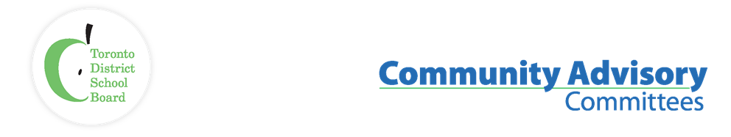

Name of Committee: Alternative Schools Community Advisory Committee
Meeting Date: 17 October 20222
A meeting of the Alternative Schools Community Advisory Committee convened on October 17, 2022, from 6:30pm to 8:45pm pm via Virtual Meeting (Zoom) with Angela Matich and Laurie McAllister (Co-Chairs) presiding.
Membership  Attendance: | Joanne Huber (Parent, High Park Alternative JS, ASCAC Member), Olga Ingrahm (Parent, Alternative Scarborough Education 1, ASCAC Member), Shelley Laskin (Trustee Ward 8, ASCAC Trustee Member); Angela Matich (Parent, Equinox, ASCAC Co-Chair); Dan MacLean (Trustee Ward 2, ASCAC Member), Laurie McAllister (Parent, Avondale Secondary Alternative School, ASCAC Co-Chair)
Staff Lead: | Peter Chang (System Superintendent, Interim)
Recorder: | Anna Catalano, ASCAC Committee Assistant
Regrets: | Gaia Friedman (Student, Spectrum Alternative Senior School, ASCAC Elementary School Student Member), Yo’av Kaplan (Parent, Avondale Secondary Alternative School, ASCAC Member), Ben Singer (Parent, Mountview Alternative JS, ASCAC Member), Sara Wilken (Parent, Beaches Alternative, ASCAC Member)

ITEM | DISCUSSION
- Land Acknowledgement, Welcome/ Introductions | Laurie McAllister, Secondary Alternative School Parent Co-Chair welcomed everyone and on behalf of ASCAC thanked Angela Matich, outgoing Elementary Alternative School Parent Co-Chair, for all her hard work and dedication as the ASCAC Co-Chair for the past two terms. Laurie also introduced the other members of ASCAC.  ASCAC’s Staff Lead and System Superintendent Peter Chang introduced the Administrators for 18 of the Secondary Alternative Schools (East and West).
- Approval of Agenda | The agenda was approved.
- Declarations of Possible Conflicts | No conflicts were declared.
- Overview of ASCAC | Laurie provided a brief overview of Community Advisory Committees (CAC) and Alternative Schools Community Advisory Committee (ASCAC). The role of CACs is to look at Board policies, programs and issues and advocate at the Board level for the community that the CAC represents. ASCAC represents the alternative school communities. For additional information, please visit the Community Advisory Committees webpage.
- 2021-22 Activities & Highlights ASCAC Activities, including recommendations presented to the Board and their status. | Laurie reviewed some of ASCAC’s activities and recommendations presented to the Board during the 2021-22 school year.  Laurie mentioned that the activities and recommendations could be organized into three main categories:  - Access to elementary alternative schools  - Promoting alternative school options in the community to help with the growth of alternative schools and improve the students’ experience  - Stabilization of secondary alternative schools  Angela and Laurie reviewed the recommendations that ASCAC made to the Program and School Services Committee (PSSC) during the 2021-22 school year. Please see Appendix A: ASCAC’s Annual Report 2021-22, for the recommendations to PSSC and updates.  Angela also gave a brief overview of the Elementary Alternative Application Form recommendation that was brought forward to PSSC in April 2021. Please see Appendix B for additional information.  Laurie also mentioned that during the 2021-22 school year, ASCAC had three subcommittees (Equity Sub-Committee, Community Building Subcommittee, and Secondary Alternative School Subcommittee). Please see Appendix A: ASCAC’s Annual Report 2021-22 for additional information.  Laurie mentioned that this school year, the ASCAC terms of reference will need to be updated. A sub-committee will be formed to work on this.
- TDSB Alternative Schools Policy (P062)  Update on the proposed revisions to the alternative schools’ policy, the consultation process, and next steps. | Peter provided an update on the status of the revised TDSB Alternative Schools Policy (P062). The revised policy was presented to the Governance and Policy Committee (GPC) on October 6. The Policy was passed unanimously at GPC and went to Board on October 26 for final approval.  Update: TDSB Alternative Schools Policy (P062) was approved at the October 26 Board meeting. The Policy can be found here.
- 2022-23 Executive Member Elections for the following open positions:  - Elementary Co-Chair  - Elementary School Student Rep  - Secondary School Student Rep  - Members at Large | Elections/Appointments were held for the 2022-23 Executive Membership.  The 2022-23 Membership is as follows:  Elementary Co-Chair – Jacob Leibovitch  Secondary School Student Rep – Sarah Bogatie  Members at Large:  Joanne Huber, Elementary Alternative School Parent  Diana Grimaldos, Elementary Alternative School Parent  Serge Guschin, Elementary Alternative School Parent  Olga Ingrahm, Secondary Alternative School Parent  Update: at the November 15 Organizational Meeting, Trustee Laskin elected to be ASCAC’s Trustee Co-Chair
- Recording of Meetings – Vote Required | Vote Required: At the first meeting of each year, CACs may determine whether the virtual meetings will be recorded and posted.  Following discussion, it was determined that to make a decision, the Members required more information, including the purpose of the recording, how to ensure the recordings are secured, who has access, length of availability of the recording, can the recording be turned off if a speaker asks to have the recording turned off, etc. To record these meetings will stifle the conversations since most attendees are parents and students.  Voting was deferred to the next meeting as the above information is required.
- TDSB - Board Updates | Trustee Laskin gave a brief overview of the roles of Trustees and when their term ends (even though the Municipal Elections were held on October 24, the Trustees’ terms officially end November 15). Trustee Laskin mentioned a few items that were being discussed at the Trustee Committee meetings during the week of October 24. Click here to view webcasts of past Trustee Committee and Board meetings.  Trustee Laskin mentioned that TDSB staff have considered a Trustees’ motion that called for a review of the retention of expulsions and suspensions in students’ OSRs (Ontario Student Records). Staff have now recommended that records be expunged annually except in cases of serious infractions (e.g., sexual assaults). This is a positive step as it won’t have a negative perception for students as they transition from one school to another or to college/university.  Trustee Laskin shared information about the Virtual Secondary Alternative Schools Caravan being held on November 9 and that it will be recorded and posted for those who cannot attend.  Trustee Laskin also mentioned that high schools will have information sessions and open houses for the next few months.  To learn about the Elementary or Secondary School Open Houses and Information Nights, please visit  Elementary School Open Houses and Information Nights  High School Open Houses and Information Nights  Update: Virtual Secondary Alternative Schools Caravan - on November 9, 2022, the TDSB hosted a Virtual Secondary Alternative Schools Caravan for Grade 8 families. Click here to view a recording of the event.
- Open Floor | Meeting participants were welcomed to ask questions, provide feedback and or let the Committee know of any concerns they may have.
- Adjournment and Next Meeting | Meeting was adjourned at 8:39pm  Next meeting: Monday, December 12, 2022, from 6:30pm to 8:30pm via Zoom
- Future Meeting Dates | Monday, January 23, 2023; Monday, March 27, 2023; Monday, May 29, 2023

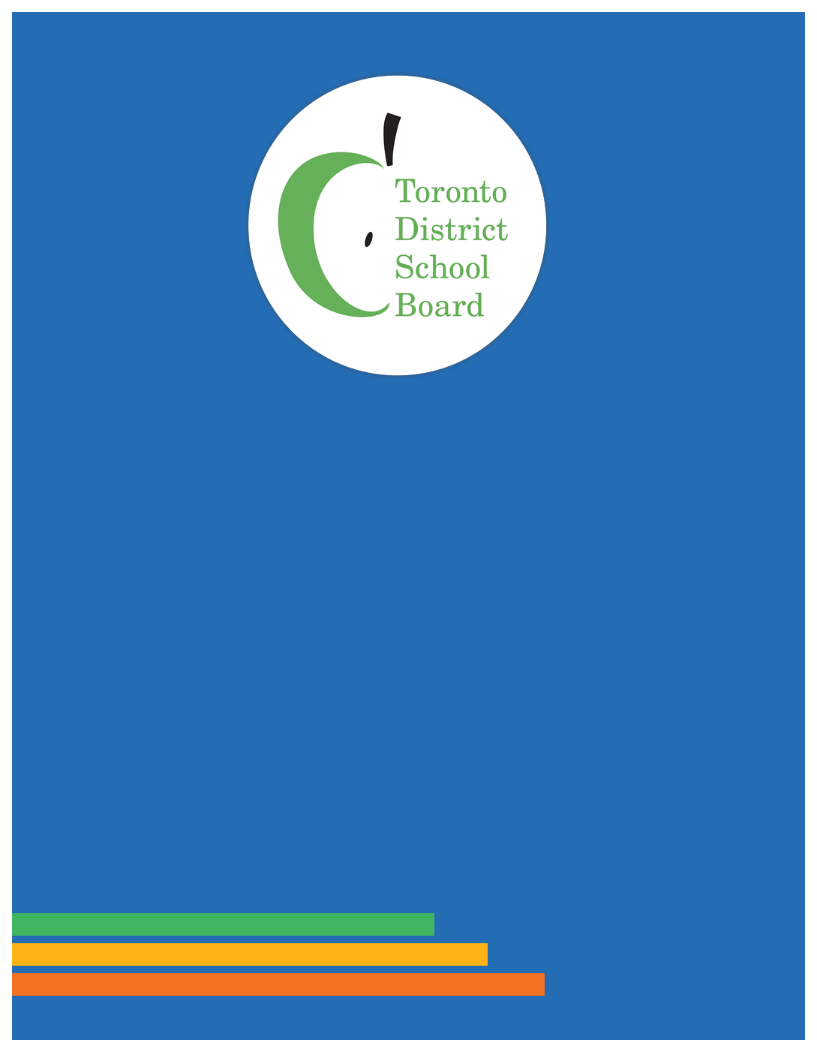
APPENDIX A

Committees

Advisory

Alternative Schools
Community Advisory Committee (ASCAC)
2021-2022 ANNUAL REPORT

Table of Contents
Alternative Schools Community Advisory Committee (ASCAC) 2021-2022 ANNUAL REPORT
Table of Contents 2
2021-2022 Co-Chairs Message 3
Advisory Committee Mandate/ Purpose 6
Advisory Committee Activities 7
Advisory Sub-Committee Activities 8

2021-2022 Message from the Co-Chairs
The Alternative Schools Community Advisory Committee (ASCAC) held four formal meetings this year, all meetings were well-attended with approximately 40 participants. The new Executive was formed at the first meeting: one Elementary student representative, three Elementary Members at Large, one Secondary Member at Large, the returning Elementary Co-Chair, and a Secondary Co-Chair to fill the previously vacant position. No other secondary school parents/caregivers in attendance were able to join the Executive. Given the importance of balanced representation between elementary and secondary school, ASCAC found and appointed an additional Secondary School Member at Large through outreach efforts following this meeting.
The Equity Subcommittee and Community Building Subcommittee formed in the 2020-21 school year, continued their work in relation to their respective mandates. A new Secondary Alternative School Subcommittee was formed in response to feedback that secondary and elementary school issues are very different given their student populations and needs, and secondary school participants wanted a forum to meaningfully engage on secondary school issues and concerns. The mandate of the new Secondary Alternative School Subcommittee is to develop proposals in support of Secondary Alternative Schools and students including as a pandemic-related priority and build awareness of the need for these schools in relation to equity, mental health, and student re-engagement.

ASCAC’s work and proposals this year can be categorized into three main objectives:
- Improve access to Elementary Alternative Schools
- Promote all alternative school options in the community, to promote growth and improve the student experience
- Stabilize Secondary Alternative Schools

Improve Access to Elementary Alternative Schools
Building on last year’s proposal for a new and centralized application process, ASCAC made the following request to remove additional barriers to entry to elementary alternative schools, which have enrolment caps despite long wait lists and space capacity:
- Enrolment Allocation: ASCAC requested that the Board provide a rationale for the allocated enrolment numbers for elementary alternative schools.
Status: Information on the general methodology was provided by TDSB staff at the April meeting. An expansion process is currently being considered by the Planning Department, which would consider number of applicants in prior years and current number of applicants; space availability with no fit-up cost; while achieving class size consistent with those across the system.

Promote Alternative Schools
ASCAC heard that parents, caregivers, and students were unaware that alternative schools were available to them and felt that they were not adequately informed of their options. Those registering for elementary school would miss the application window; and those in secondary school fell farther behind in mainstream, in some cases withdrawing from the school system. The following recommendations are intended to help fill this knowledge gap and better educate communities about all alternative school options, so that students have a better chance of finding an environment that meets their needs.
- Equitable Marketing: a recommendation that the TDSB review its marketing practices and consider how to maximize marketing materials to promote more school and program options using similar materials, campaigns, and budgets.
Status: passed at PSSC to the next stage. TDSB staff to report back to ASCAC in fall of 2022.
- Find Your School: a request to improve the Find You School feature on the TDSB website, so that all program and school options available to the user appear in search results, not just home schools, with more information related to each option.
Status: TDSB has been planning and working on updates to the Find Your School function since 2019 to harmonize the website to ensure equity of access for all students and will take into account ASCAC’s recommendation. The mapping functionality will be updated to show all system-wide offerings, including legacy technical commercial schools, student interest programs, and alternative schools. The Planning Department will be invited to a fall ASCAC meeting to provide an update.
- Community Outreach Ambassadors: a recommendation to dedicate outreach resources to educate communities about all programs available to them within the TDSB, with a focus on reaching communities who are currently underserved through current marketing approaches.
Status: referred to staff as part of budget considerations, in progress until the budget is finalized.
Stabilize Secondary Alternative Schools
Many parents, caregivers and students expressed how critical Secondary Alternative Schools are in providing a safe space for students whose needs cannot be met in mainstream collegiates, for a variety of reasons. They view Secondary Alternative Schools as their only chance to graduate high school and are very concerned about staffing reductions and loss of support.
- Secondary Alternative Schools: in consideration of supporting students in-risk, student mental health, and the pandemic recovery re-engagement plan, ASCAC recommended that “program viability” be used as the primary driver for staffing rather then projected enrolment, until the review of secondary alternative schools is complete, and its recommendations are implemented.
Status: Passed by PSSC, FBEC and the Board, resulting in additional supplemental teachers to secondary alternative schools for the 2022/23 year.
Update on ASCAC Proposals from 2020-21:
Elementary Alternative Schools Application Form and Admission Process Review
The elementary alternative school centralized application process and procedures are being developed by staff to address equity of access for students who have been historically, and are presently, underrepresented in these schools. This new procedure should be implemented this Fall/Winter for students registering for the 2023-24 school year.

Secondary Alternative Schools Review
The Review is tentatively scheduled to start in the 2022-23 year, ASCAC would like to have meaningful consultation and involvement.

Other Considerations & What We Heard
Alternative Schools Policy P062
TDSB staff are in the consulting phase of revising the Alternative Schools Policy P062, to be presented to the Board in the fall. When P062 is operationalized, ASCAC asks the TDSB to consider adding district created alternative schools, in addition to community-formed schools, to reduce barriers and improve access across all TDSB communities.
Alternative Middle Schools
ASCAC heard from middle school parents and students, distressed by the loss of support at their alternative schools and lack of special education resources. While they are considered elementary schools, middle school students and parents expressed that they don’t identify with elementary school issues but don’t fall under secondary schools, and as a result feel unsupported. They expressed frustration at the amount of time, effort, and privilege necessary to advocate for support within the system.
Advisory Committee Mandate/ Purpose
Terms of Reference:
https://www.tdsb.on.ca/Portals/0/Community/Community%20Advisory%20committees/asac/ASAC_Terms_of_Reference.pdf
- To facilitate effective and meaningful engagement with new, existing, and potential elementary and secondary alternative schools’ parents/ guardians, students and staff.
- To support the improvement of the well-being of elementary and secondary alternative schools’ parents/guardians, students and staff while enhancing the accountability of the education system.
- To support and advocate on behalf of each TDSB alternative school’s individual pedagogy and unique community.
- To consult, collaborate and make recommendations on any matter specifically referred to it by the Board or a standing committee.
- To advise the Board on matters of its own choosing, within its mandate as established by the Board when it was constituted.
- To exercise an advocacy role. It may indicate to the Board a preferred position on an educational issue under consideration by the Board with the understanding there is no obligation on the part of the Board or its staff to act on ASCAC recommendations.
Note: The Terms of Reference is scheduled for Committee review in the 2022-2023 school year, with consideration to the new CAC Guidelines.
Advisory Committee Activities
Formal Meetings & Meeting Minutes
ASCAC held four formal meetings during the 2021-2022 school year which are listed below.
- October 18, 2021
- December 13, 2021
- February 7, 2022
- April 25, 2022
Meeting minutes are available through the link.
https://www.tdsb.on.ca/Community/How-to-Get-Involved/Advisory-Committees/Community-Advisory-Committees/Alternative-Schools-Community-Advisory-Committee
2021-2022 ASCAC Board Recommendations
- JANUARY 2022
  - Elementary Alternative Schools Total Enrolment Allocation
  - TDSB Website - Find Your School Updates
  - TDSB Equitable Marketing
- FEBRUARY 2022
  - Secondary Alternative Staff Allocation
  - TDSB Community Outreach Ambassadors
Board Directed Events/Consultations
ASCAC participated in all Board requested 2021-2021 events/consultations, including emailed 2 surveys and Zoom meetings.

Advisory Sub-Committee Activities
Sub-committees are listed in alphabetical order.
ASCAC Community Building Sub-Committee
The Community Building Sub-Committee was tasked by ASCAC to develop recommendations, motions, projects, and events to help further build community, networking, and information sharing amongst alternative school communities. Below are links to their meeting/event notes for reference.
ASCAC Equity Sub-Committee
The Equity Sub-Committee is a volunteer working group of parents/guardians, students and staff tasked with developing equity recommendations, motions, and projects for the ASCAC Executive’s consideration. Below are links to their meeting notes for reference.
Secondary Alternative Sub-Committee
The Secondary Alt. Sub-Committee was created at the December 13, 2021 ASCAC meeting. It is a volunteer working group with approximately 25 parents, caregivers, students, and staff on its email list. Its purpose is to build awareness of the need for secondary alternative schools in relation to the TDSB’s commitment to equity, mental health issues, and student re-engagement; and develop recommendations to be presented to the Board on an urgent basis to stabilize secondary alternative schools, including as a pandemic-related priority.
Meeting dates:
- January 12, 2022
- May 9, 2022

ASCAC Recommendations from April 26, 2021, Mtg
APPENDIX B

Elementary Alternative Application Form
The Alternative Schools Community Advisory Committee recommends that the Director;
- conduct a review of the application and admission procedures across all elementary alternative schools to ensure they are consistent and equitable;
- consider creating one universal elementary alternative schools’ application form, as well as one set of clear and detailed admissions procedures for all elementary alternative schools to ensure consistency, equity and remove potential barriers;
- that the application process be clearly posted on the TDSB website to make it easily accessible to the schools and the general public for reference.
The Board decided:
(a) That the Director conduct a review of the application and admission procedures across all elementary alternative schools to ensure that they are consistent and equitable;
(b) That the following be referred to staff for a report on its feasibility in the fall 2021 cycle of meetings:
i) that the Director consider creating one universal elementary alternative schools application form, as well as one set of clear and detailed admissions procedures for all elementary alternative schools to ensure consistency, equity and remove potential barriers;
ii) That the application process be clearly posted on the TDSB website to make it easily accessible to the schools and the general public for reference

A Working Group was formed and have been working on this. Barring any unforeseen issues, the centralized online application form will be launched in January 2023 for admission to the 2023-24 school year.

