APPROVED MINUTES
Name of Committee: Special Education Advisory Committee
Meeting Date: June 7, 2021
A meeting of the Special Education Advisory Committee convened on June 7, 2021 from 7: 00 p.m. to 9:15 p.m. via Zoom with SEAC Chair Steven Lynette and VIce Chair Diane Montgomery
Attendance:
Melissa Rosen (Association for Bright Children (ABC), Tracey Burrel (Black Parent Support Group), Tracey O’Regan (Community Living Toronto) , Steven Lynette (Epilepsy Toronto), Richard Carter (Down Syndrome Association of Toronto), Aliza Chagpar (Easter Seals Ontario), Tania Principe (Integrated Action for Inclusion (IAI)), David Lepofsky (VIEWS for the Visually Impaired), Shanna Lino VOICE for Hearing Impaired Children), Nadia Persaud (Learning Disability Association), Juanita Beaudry CADDAC, Aline Chan LC1, Nora Green LC1, Jordan Glass LC2, Jean-Paul Ngana LC2, Olga Ingrahm LC3, Kirsten Doyle LC3, Diane Montgomery LC4, Izabella Pruska-Oldenoff LC4, Trustee Alexander Brown, Trustee Michelle Aarts (Alternates in attendance: Julie Diamond (Autism Society), George Petrovic (LC4)
Staff:
Andrew Gold, Associate Director, Angela Nardi-Addesa, Angela Nardi-Addesa, System Superintendent, Special Education and Inclusion, Janine Small, Centrally Assigned Principal, Special Education, Jennifer Newby, Centrally Assigned Principal, Special Education LC4, Effie Stathopoulos, Centrally Assigned Principal, Special Education LC1, Susan Moulton, Centrally Assigned Principal, Special Education LC2, Cindy Zwicker-Reston, Centrally Assigned Principal, Special Education LC 3, Vanessa Pfaff, Accessibility Coordinator, Wendy Terro, Centrally Assigned Principal, Special Education, Joy Reiter, Centrally Assigned Principal, Mun Shu Wong, Media Services, David Schwartzbein, Manager, Psychological Services, Yvonne Martinez, Manager, Psychological Services, Shameen Sandhu, System Leader, Mental Health, Lianne Dixon, SEAC Liaison

Regrets:
Item | Discussion | Motion | Recommendation
Call to Order - Quorum | Live stream announced | Quorum achieved
Land Acknowledgement | Read by Chair
Approval of Agenda | Addition to Other business – Agreement to address K-12 Policy Response under Other Business – to create a subcommittee to meet over the summer to create feedback on K-12 Policy to share with SEAC. | Motion to approve the agenda carried as amended.
Approval of Minutes from May 3 | Discussion about addition of Alternate members to attendance – follow up prior to September meeting. | Motion to approve minutes carried
Conflicts of interest | No Conflicts of Interest
Leadership and Learning Report | Summer School  Given the unpredictability of what the status of the COVID 19 pandemic will be in the summer and the need to begin planning well before that time, the decision has been made to offer all Summer Programs fully remote (online) for summer 2021.  The summer school programs that will be offered to TDSB students includes:  - Physical Disability classes grades 1 8  - Deaf Hard of Hearing classes grades 1 8  - Developmental Disability classes grade 1 12  Programs will follow the same virtual learning format as last summer.  Psychological Assessment Update  A chart was shared that outlined the number of completed and outstanding psychological assessment referrals by Learning Centre as of May. It was noted that 31 percent of these referrals were made in the month of May. (Appendix A)  IPRC/SEPRC Meetings  A chart showing the number of IPRC’s and SEPRC’s completed and outstanding by Learning Centre were shared and discussed. Efforts will be made to do some of these meetings in August if possible. (Appendix B) |  | .  Discussion took place around the importance of making sure that as many outstanding IPRC and SEPRC’s are done as possible as it is very disruptive for students to start the year in one school/program and then have to switch after their IPRC takes place.
Trustees Report  - Trustee Aarts  - Trustee Brown | Budget process ongoing  Staff coming back on June 16th to present a full budget for the coming school year.  Still waiting for direction on the province on September reopening. Plan expected in summer.
Working Groups -  - Budget/Communication/Sp. Ed. Plan/Action Plans | Special Education Plan Working group Motion (Appendix C)  Specialized School Motion (Appendix D)  Terms of Reference Group – been working on revising the current Terms of the Reference | Motion was approved  Motion was approved | Discussion took place around Specialized Schools with regards to the motion that was presented, due to concerns about the potential negative impact/lack of inclusion for special education students.  Motions will be presented to PSSC at June meeting.  The Specialized Programs Policy is still currently under Review and will be providing an opportunity in September for further input from CAC’s.  Terms of Reference  There are some questions for the committee around what is expected of the subcommittee. It will be looked at again in the fall.  Chair recommended that key points are: Membership, Voting Procedures
SEAC Member Reports/ Input | Epilepsy Toronto – Buskerfest in August  Views for Visually Impaired – conducting a survey of all school boards to find out how many teachers of the visually impaired are in each board, and what their caseloads are
Other Business  Correspondence: | K-12 Policy Response  Recommendations for what should be included in regulations (AODA) in school boards for K-12 students.  Recommendations have been made which outline what needs to be done and the document is ready for input from the public. |  | Discussion around the importance of developing a response from SEAC for the September deadline. A subcommittee was formed to meet in the summer so that a response can be developed and shared at the September meeting. Volunteers are to contact Liaison. David Lepofsky will chair this summer meeting.
Adjournment | The meeting was adjourned at 9:10  Next meeting September 13th at 7 pm (electronic)

Appendix A
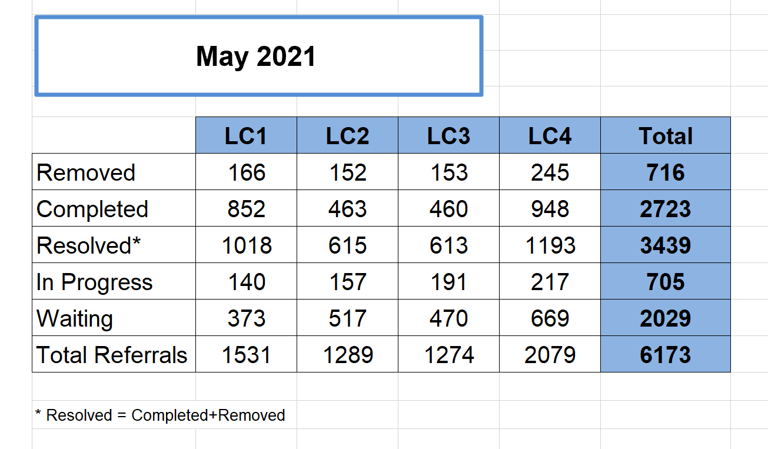
Appendix B

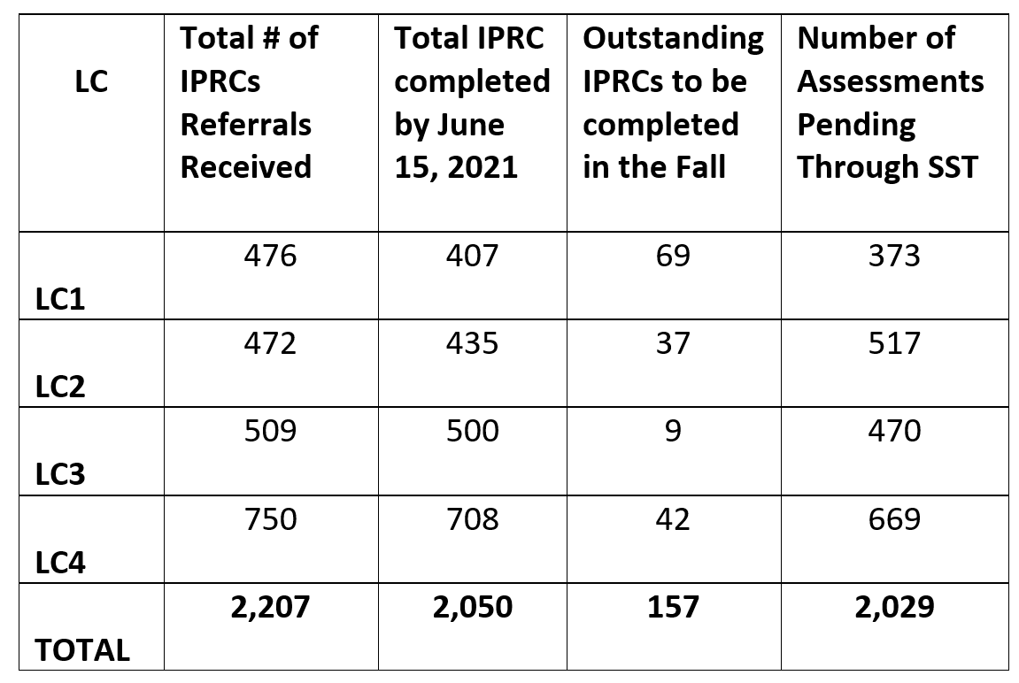
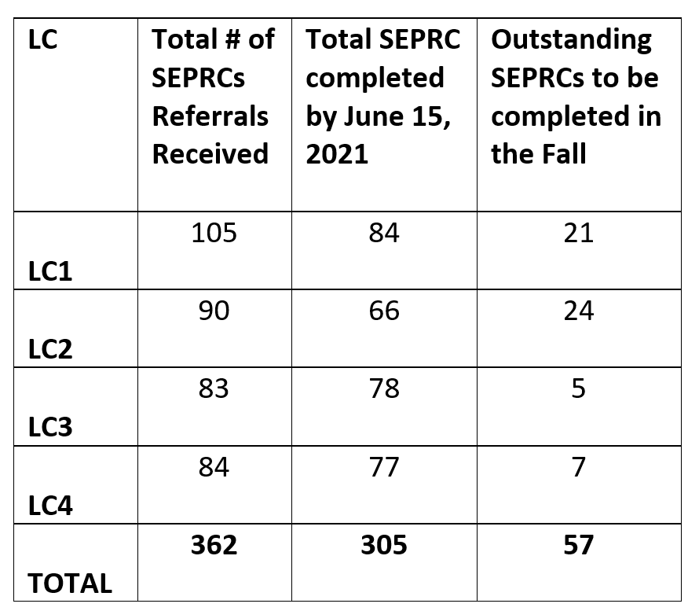
Appendix C
Special Education Plan
WHEREAS TDSB’s SEAC formed a working group to seek and facilitate feedback on TDSB’s Special Education Plan (the “Plan”); and
WHEREAS feedback on the Plan was sought and obtained from SEAC representatives, parents, and other advocates for students with special education needs, in order to help better educate and support these students; and
WHEREAS a variety of feedback and recommendations were obtained and SEAC wishes to communicate this feedback and these recommendations to SEAC, staff, Trustees and others;
BE IT RESOLVED that the attached feedback document and its recommendations for changes to the Special Education Plan be promptly forwarded to staff and Trustees for their review and consideration in formulating TDSB’s 2021 Special Education Plan and future policies and practices regarding educating students with special education needs.

Appendix D
Whereas the Board has stated that it has committed to equity of access to programs for all students;
Whereas the province and Board have begun to destream secondary pathways and typically specialized programs create streamed pathways;
Whereas the first priority of the Board should be to increase learning opportunities for students who are in academic risk;
Whereas Specialized Programs usually use screening processes that are based on performance standards which may be inaccessible to students with special education needs or students with income barriers;
Whereas, the Board has not examined the impact of specialized programs or French Immersion on the concentration of special education students in the “regular” stream of the school;
Whereas the Board has not stated how it would support the potentially higher concentration of special education students in the “regular” stream
Be it resolved that SEAC does not recommend the specialized program policy as it discriminates against students with special education needs and students with income barriers.

