PROGRESS OF CONSTRUCTION WORK

- Progress is continuing on enclosing the building with roofing started and the window installation underway.
- The brick veneer installation is schedule to begin in the next few days so the building should be weather-tight or close to it within the few weeks

UPCOMING WORK
- Brick Veneer
- Site Services.
- Interior work.

COMMUNITY UPDATE:
There is some construction work/street work required on Dennis Avenue from Guesville to the northwestern corner of the new building in order to connect the new building to the Toronto Hydro system. The permit has been issued and work will begin in the middle of May through the end of June.

CONSTRUCTION PROGRESS PHOTOS:
- Southeast Corner Looking Northeast
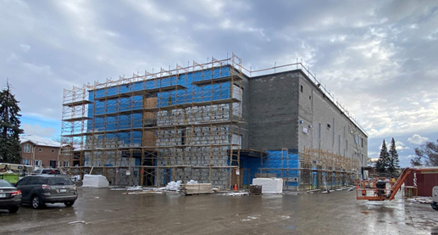

- Site Looking Southwest
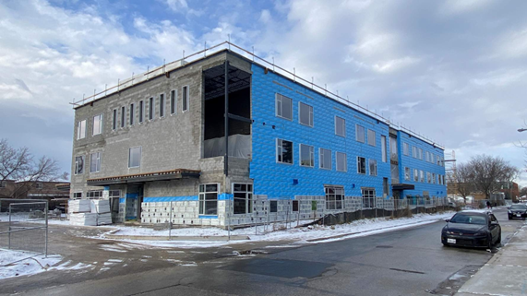

- Gym and Stage

