
Important – Please note that due to Covid-19 lockdown restrictions, our office will be closed until further notice. Most of our services are available virtually or over the phone. Please contact us using the following methods:
Call: 416-396-4631, text: 647-693-9919
e-mail: nsmalvern@tdsb.on.ca

31 Tapscott Road, Unit-T 81, Scarborough, ON
Tel: (416) 396-4631 Fax: (416) 396-4780

APRIL 2021 online workshop Schedule
MONDAY | TUESDAY | WEDNESDAY | THURSDAY | FRIDAY
File your tax returns. Call 416-396-4631 or  e-mail nsmalvern@tdsb.on.ca to book an appointment. |  |  | 1 | 2  Good  Friday
 |  |  | 9 am – 5 pm | Centre Closed
5  Happy Easter  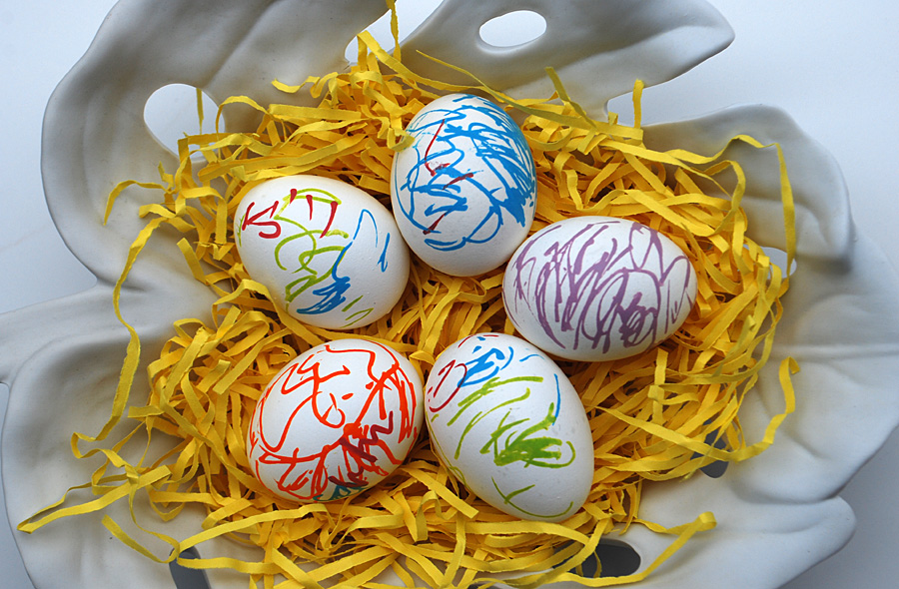 | 6  ***NEW***  English conversation circle - Online | 7  Data Analysis - Beginners  9:00 AM - 12:00 PM  Citizenship Preparation Class | 8  One-on-One Resume Review  (Online-please text or e-mail to book an appointment) | 9  Online  Canadian Citizenship Preparation Class
Centre Closed | 10 AM - 11 AM | 3:00 PM - 4:30 PM | 10:00 AM - 3:00 PM | 10 AM – 11:30 AM
12  Income tax filing  (by appointment only) | 13  ***NEW***  English conversation circle - Online | 14  Data Analysis - Intermediate  9:00 AM - 12:00 PM  Citizenship Preparation Class | 15  Income tax filing  (by appointment only) | 16  Online  Canadian Citizenship Preparation Class
9 am – 5 pm | 10 AM - 11 AM | 3:00 PM - 4:30 PM | 9 am – 5 pm | 10 AM – 11:30 AM
19  Income tax filing  (by appointment only) | 20  ***NEW***  English conversation circle - Online | 21  Data Analysis - Advanced  9:00 AM - 12:00 PM  Citizenship Preparation Class | 22  One-on-One Resume Review  (Online-please text or e-mail to book an appointment) | 23  Online  Canadian Citizenship Preparation Class
9 am – 5 pm | 10 AM - 11 AM | 3:00 PM - 4:30 PM | 10:00 AM - 3:00 PM | 10 AM – 11:30 AM
26  Income tax filing  (by appointment only) | 27  ***NEW***  English conversation circle - Online | 28  Basic computer skills  9:00 AM - 12:00 PM  Citizenship Preparation Class | 29  Income tax filing  (by appointment only) | 30  Citizenship Preparation Class
9 am – 5 pm | 10 AM - 11 AM | 3:00 PM - 4:30 PM | 9 am – 5 pm | 10 AM – 11:30 AM

