EARLY FRENCH IMMERSION INFORMATION PACKAGE
2021-2022

PARENTS/GUARDIANS/FAMILIES OF CHILDREN IN JUNIOR KINDERGARTEN

You have a choice to make about French programming for your child. For 2021-2022, across the TDSB, we will continue to offer two programs:
Early French Immersion (SK entry) and Middle French Immersion (Grade 4 entry).

Senior Kindergarten is the ONLY time your child may begin the Early French Immersion program.

WHAT IS EARLY FRENCH IMMERSION?

Early French Immersion programs are designed for students who do not speak French at home. The Early French Immersion program (SK Entry) provides the maximum French language experience available in our schools.

The French Immersion program for Senior Kindergarten to Grade 3 is a 100% model of instruction in French in most schools (with the exception of a PREP providing subject that may be delivered in English if required). English is introduced in Grade 4 for about one hour per day and increases to half-day by Grade 6.

The subjects taught in French SK through to Grade 8:
- Math
- Social Studies (Geography/History)
- French Language

After Grade 8, students continue the French Immersion program at designated secondary schools. Students who successfully complete a minimum of 10 credits in French at the secondary school level are eligible for a Certificate of Bilingual Studies in French within the TDSB.

For information on the Application process or how to find your associated Early French Immersion school for your area, please visit the website below and/or access the Frequently Asked Questions under Application Process – left menu bar:

https://www.tdsb.on.ca/Elementary-School/School-Choices/French-Programs

*Catchments are based on the student’s home address and may change in accordance with TDSB procedures.

FIND US AT: www.tdsb.on.ca/French

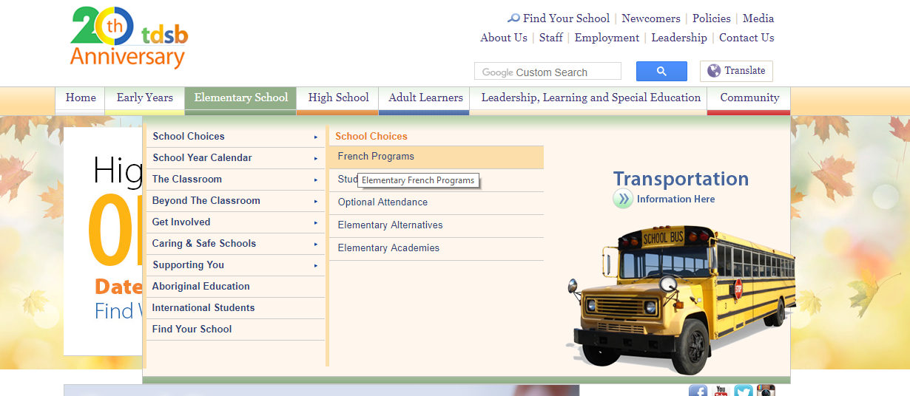
VIDEO INFORMATION ON THE APPLICATION PROCESS

At any time, parents/guardians can visit www.tdsb.on.ca/french to view a video that provides a great deal of information about our French programs as well as the application and placement process in the Early French Immersion and the Middle French Immersion programs.

Applications for the Early French Immersion Program
are completed online for September 2021

Applications to the Early French Immersion program (SK entry) are made the year the child is in Junior Kindergarten for entry in September of Senior Kindergarten.
- It is an entirely online application process.
- All communication will be sent via the email address provided online at the time of application.
- Please check this email regularly including junk mail.
- Families with an older sibling currently enrolled in the same French program and who will be in attendance the following year are still required to complete an online application for the new student. Please select the “sibling option” within the online application.

Please visit the application site www.tdsb.on.ca/pars during the application period:
- You will need your child’s date of birth and OEN (Ontario Education Number). The OEN is a 9-digit number found on any report card from the TDSB.

- For non-TDSB students, please select the “Non-TDSB Student” option and follow the steps to generate an identification number. You must then return to the PARS site and follow the application procedure with this number.

- Please select Early French Immersion from the drop-down menu and complete the application process.
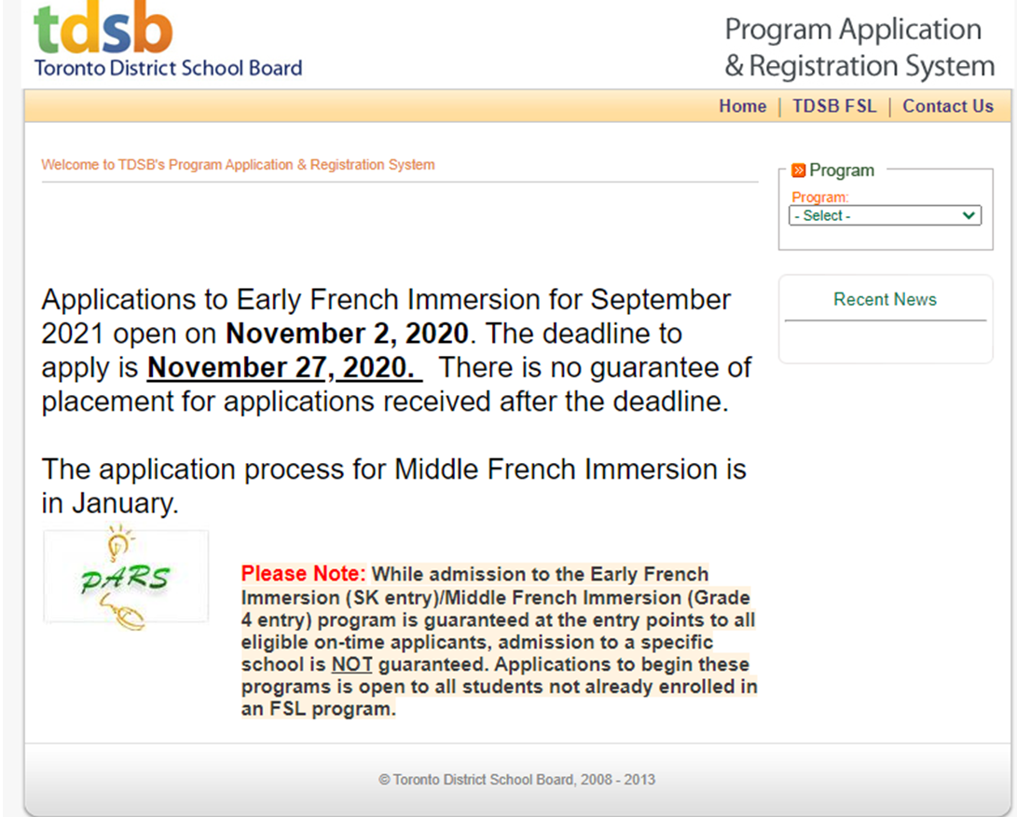

An offer of placement in Early French Immersion is guaranteed to all eligible on-time applicants, however placement in a particular school is NOT guaranteed.

On-time applicants will be offered a placement online via the email address provided at the time of application. Parents/Guardians MUST take action to accept this placement by the deadline requested when offered a placement in order to reserve a spot in the program.
Offers of placement will be on-going through the weeks and months following the close of the application period. Please check email regularly (including junk mail) and follow all instructions found therein.

IMPORTANT DATES:
Application process opens: November 2, 2020

Deadline for applications: November 27, 2020
Please note the following items: While every effort will be made to place students in the school identified as their area French Immersion school, this is not always possible. In cases where the number of applications in a given area is greater than the number of allotted program spaces in the school, students may be redirected to schools with available program space.
Placements are made based on the child's primary home address of record prior to the application deadline. If the address changes between the application deadline and the fall of the SK year, there is no guarantee of placement in the new area.
Applicants who have older siblings currently enrolled in the same program and who will be in attendance the following year have a priority placement in that school.

NB: Please note that classes with fewer than 25 students may not open.

CENTRAL PARENT/GUARDIAN/COMMUNITY INFORMATION SESSIONS

For information on specific sessions, please visit our FSL website regularly for updates:

https://www.tdsb.on.ca/Elementary-School/School-Choices/French-Programs/Information-Sessions

The scheduled information sessions are as follows:
- November 2, 2020, 7-8 p.m.
- November 12, 2020, 7-8 p.m.
- November 19, 2020, 10-11 a.m.
Please note: To participate in a live scheduled web chat, please visit the web page above and a link will be available to join on the dates/times as outlined above.

