

**Why Change Is Needed In Special Education**

***FACT SHEET TITLE***ISSUE #, DATE (MONTH YEAR)

**FACTS**

**Purpose: This fact sheet is to provide parents, educators and administrators with an overview of the research informing upcoming changes to the Home School Program and inclusive education practices.**

**Current status:** Over the last few years, the TDSB has been updating its special education program structure to ensure students are provided with the best possible instruction and engaging learning environments. In the Integrated Equity Framework and the TDSB’s Vision for Learning, inclusion of students with disabilities or special education needs has been a key commitment.

Traditionally, special education models of instruction have included withdrawal of students from regular class programming to provide more intensive instruction opportunities. However, research indicates that withdrawing students may not be in their best interest. In fact, the research supporting withdrawal methods of instruction is practically non-existent (Mitchell, 2010) whereas there have been many studies supporting the academic, social and emotional benefits to inclusive placements for students identified with and without special education needs.

Key research findings pulled from a synthesis of international empirical studies (Mitchell, 2010) include:

* Clustering students into ‘low-ability’ groups reduces academic expectations
* Students often experience less instruction in lower ability classrooms
* A great deal of academic learning occurs through students’ interaction with peers
* Being assigned to a ‘lower ability’ group is often permanent

As the TDSB works to remodel its Home School Program and special education processes, bare some of the rationales for why this work is important and timely.

**Rationale: Out of line with provincial proportions…**

**Figure 1: TDSB Students in Congregated Classes: Current Total and Projected Reflecting Ontario Proportions**





The first column in Figure 1 represents the number of students currently in congregated placements within the TDSB. The orange bar represents students in Intensive Support Programs, the purple bar are students who do not have an exceptionality but are in congregated placements (largely Home School Program or Kindergarten Diagnostic Program), and the green bar represents students in congregated gifted programs. The second bar represents the number of students who would be in congregated settings if the TDSB were to be in line with provincial proportions (a reduction of almost 10,000 students). However, because of the size and scope of the TDSB, its own figures actually influence provincial figures. The third bar represents the number of students who would be in congregated settings if the TDSB were in line with provincial proportions – proportions un-influenced by TDSB (a reduction of over 11,000 students from current figures).

**…despite being in line with provincial**

**proportions of identifications of exceptionality.**

Initial assumptions might be that the TDSB, being located in an a highly urban city with increased proximity to specialized Centres, would have a higher incidence of children identified with more complex disabilities than in other boards across the region. However, this is not true. In fact, TDSB is in line with many of the provincial proportions of student identifications across exceptionality categories (excluding gifted). The differences lie within the TDSB’s approach to their education.

**Table 1: Elementary and Secondary School Students with Special Education Exceptionalities as of October 31, 2014 (2014-15 Preliminary)**

|  |  |  |
| --- | --- | --- |
| Exceptionality | Percent of Students with an Exceptionality  **TDSB** | Percent of Students with an Exceptionality **Ontario** |
| Autism | 9.3% | 11.2% |
| Behaviour | 4.0% | 4.8% |
| Blind/Low Vision | 0.3% | 0.4% |
| Deaf/Hard of Hearing | 1.2% | 1.1% |
| Deaf/Hard of Hearing/Pre-school | 0.1% | 0.0% |
| Developmental Disability | 5.0% | 5.1% |
| Giftedness | 30.4% | 15.8% |
| Language Impairment | 0.8% | 5.6% |
| Learning Disability | 37.7% | 40.5% |
| Mild Intellectual Disability | 9.7% | 7.8% |
| Multiple Exceptionalities | 0.1% | 6.1% |
| Physical Disability | 1.5% | 1.4% |
| Speech Impairment | 0.0% | 0.2% |
| **Total Exceptionalities** | **100%** | **100%** |

Source: Ministry of Education; NA = Suppressed

**Gender, Race, and Class implications**

Students identified as having special education needs and placed in special education programs are disproportionality male, racialized, and students living in poverty. This trend is particularly true for students in the Home School Program (Parekh, Brown & Conley, 2016). Similar trends of disproportionality are also evidenced within secondary school pathways (academic, applied, and locally developed) (Parekh, 2013). Post-secondary access is critically connected to secondary school pathways. Through the construct of ability, the current system continues to replicate privilege and disadvantage of certain groups along lines of race, gender, and class.

**Importance of post-secondary education**

Many longituditional studies show that access to post-secondary (university or college) is critical to increasing long term health and economic independence (Pew Research Center, 2014; Irwin, 2015; Fonseca and Zheng, 2011; Kearney et al, 2015; Ballingall,2015). However, unless students take the majority of their courses in the academic/university pathway, access to post-secondary is increasingly limited.

Authors: Gillian Parekh & Robert S Brown

Research & Information Services

**Figure 2: Ontario PSE Confirmations across POS, 2011–12 (year 4)**

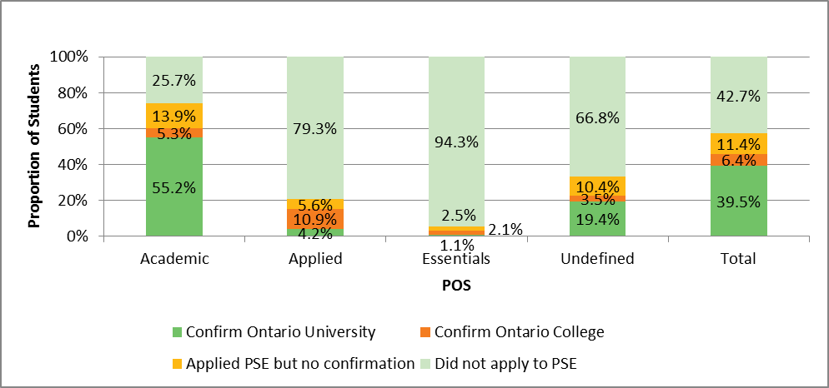

After 4 years of high school, close to 4/5 of students taking the majority of their grade 9-10 courses at the applied level do not apply for any post-secondary education.

**Direct pathway to non-academic programming**

Furthermore, recent studies have shown that the Home School Program is often a direct pathway to non-academic programming in high school, even in cases when students are achieving at or beyond the provincial average.

**Figure 3: Home School Program direct pathway to non-academic programming**

2017 Copyright Toronto District School Board