Governance and Policy Committee April 26, 2017 | Page  53 |  | Board Services Agenda Record  GPC:004A  Agenda Item 6.3

Report No. 04-17-3100

TORONTO DISTRICT SCHOOL BOARD

REVIEW OF P084 AND P069, INTEGRATED ACCESSIBILITY STANDARDS (P084) AND ACCESSIBILITY STANDARDS FOR CUSTOMER SERVICE (P069)
Policy Review (Phase 1)

TO Governance and Policy Committee 26 April 2017

RECOMMENDATION IT IS RECOMMENDED that the Policy Review Work Plan for
policies P084, Integrated Accessibility Standards and P069, Accessibility Standards for Customer Service, as presented in the report, be approved.

STRATEGIC DIRECTION

- Make every school an effective school
- Identify disadvantage and intervene effectively

RATIONALE Two policies, Integrated Accessibility Standards (P084) and Accessibility Standards for Customer Service (P069), are being reviewed in accordance with the Policy Review Schedule approved by the Board of Trustees on 23 November 2016.

Accessibility requirements for employers and public sector organizations operating in Ontario were previously split between Ontario Regulation 429/07 – Accessibility Standards for Customer Service and Ontario Regulation 191/11 – Integrated Accessibility Standards. Effective 1 July 2016, these two regulations were consolidated into a single Integrated Accessibility Standards Regulation through amendments contained in Ontario Regulation 165/16.

Staff proposes that the TDSB’s policies on Integrated Accessibility Standards (P084) and Accessibility Standards for Customer Service (P069) be consolidated into one and referred to as the Integrated Accessibility Standards Policy (P084). In order to better align the consolidated policy with the Accessibility for Ontarians with Disabilities Act and Ontario Regulation 165/16, the following amendments are being recommended by staff:

  - Expand customer service related requirements to include the provision of goods, services and facilities (previously only

Governance and Policy Committee April 26, 2017 | Page  54 |  | Board Services Agenda Record  GPC:004A  Agenda Item 6.3

goods and services);
  - Update applicable policy statements to reflect the requirement to provide documents in an accessible format or with use of communications supports upon request;
  - Update the definition of “service animal” in the policy to reflect current legislation which stipulates an expanded list of regulated health professionals who may certify a service animal (no longer only a medical practitioner);
  - Update the definition of “support persons” (and make appropriate changes where referenced) in the policy to align with current legislation;
  - Include a statement to reflect amendments contained in O. Reg. 165/16, requiring organizations to solicit feedback (under existing customer service specific feedback mechanisms) on the accessibility of any process itself and any alternate means provided for under that process;
  - Include a provision on regular reporting by staff to the Board of Trustees on progress with accessibility initiatives and im- plementation of the multi-year accessibility plan;
  - Ensure alignment with the TDSB’s Integrated Equity Framework; and
  - Ensure alignment with the Board’s Policy Template.

The proposed consolidated policy would ensure the Board’s policies on accessibility are in alignment and compliant with the legislation, as well as provide greater understanding and clarity around the roles and responsibilities of the system in preventing discrimination and improving accessibility to goods, services, facilities, employment, accommodation and buildings for persons with disabilities.

RESOURCES N/A

IMPLEMENTATION
AND REVIEW
Based on the Governance and Policy Committee’s input, the Integrated Accessibility Standards Policy and Accessibility Standards for Customer Service Policy will be reviewed in accordance with the Policy Review Work Plan (see Appendix C) and subsequently presented in a consolidated policy to the Governance and Policy Committee for consideration and recommendation.

APPENDICES Appendix A: Integrated Accessibility Standards Policy (P084) – Current Policy

Governance and Policy Committee April 26, 2017 | Page  55 |  | Board Services Agenda Record  GPC:004A  Agenda Item 6.3

Appendix B:

Appendix C: Appendix D:
Accessibility Standards for Customer Service Policy
(P069) – Current Policy

Policy Review Work Plan (Consolidated) Scan of Selected Ontario School Boards

FROM Angelos Bacopoulos, Associate Director, Facilities, Sustainability and Employee Services
angelos.bacopoulos@tdsb.on.ca Phone: (416) 393-8780

Chris Broadbent, Manager, Occupational Health and Safety
chris.broadbent@tdsb.on.ca Phone: (416) 397-3460

Governance and Policy Committee April 26, 2017 | Page  56 |  | Board Services Agenda Record  GPC:004A  Agenda Item 6.3

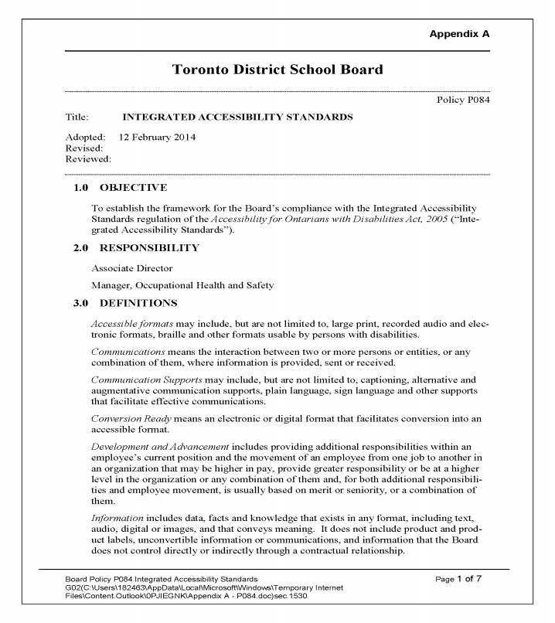

Governance and Policy Committee April 26, 2017 | Page  57 |  | Board Services Agenda Record  GPC:004A  Agenda Item 6.3

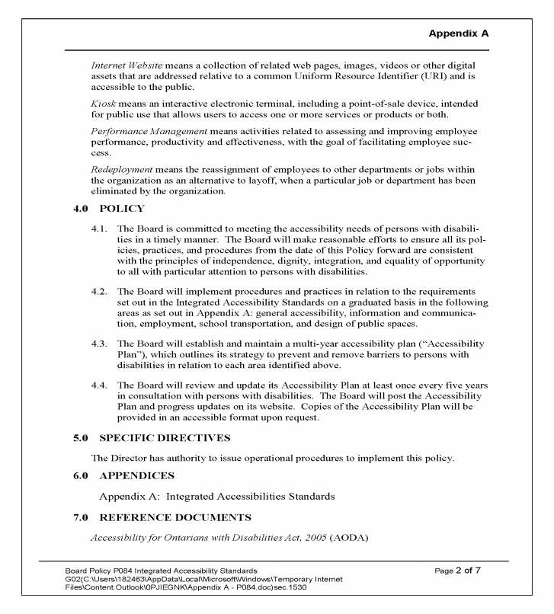

Governance and Policy Committee April 26, 2017 | Page  58 |  | Board Services Agenda Record  GPC:004A  Agenda Item 6.3

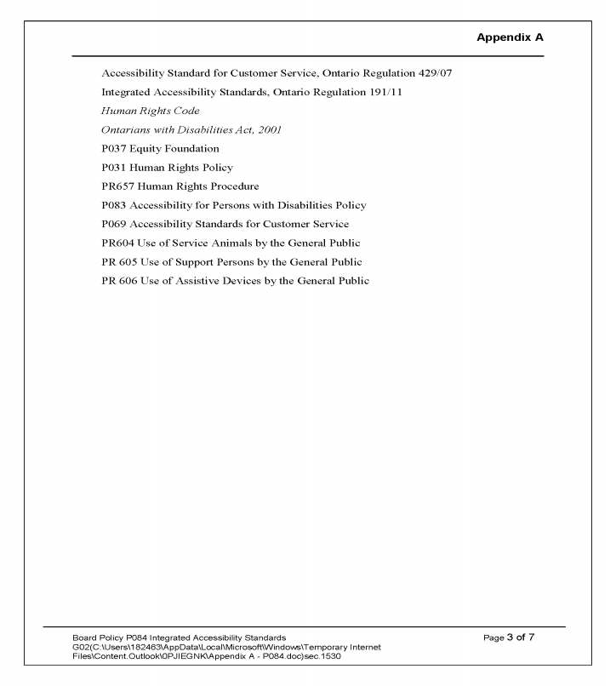

Governance and Policy Committee April 26, 2017 | Page  59 |  | Board Services Agenda Record  GPC:004A  Agenda Item 6.3

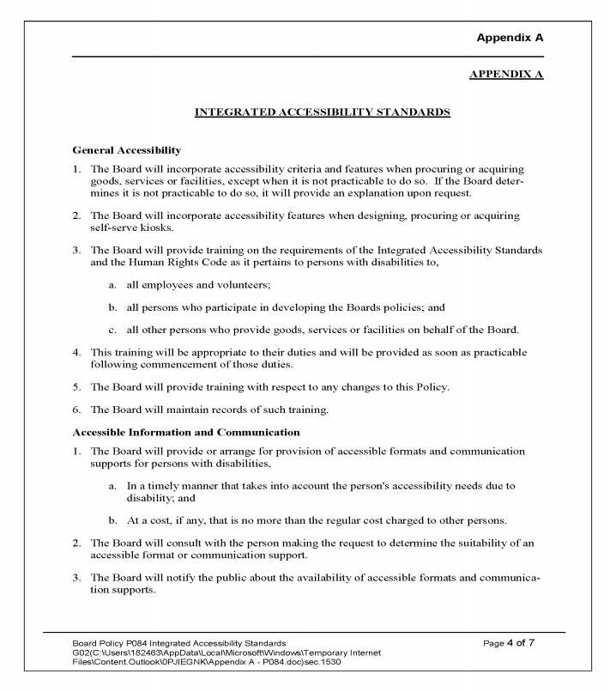

Governance and Policy Committee April 26, 2017 | Page  60 |  | Board Services Agenda Record  GPC:004A  Agenda Item 6.3

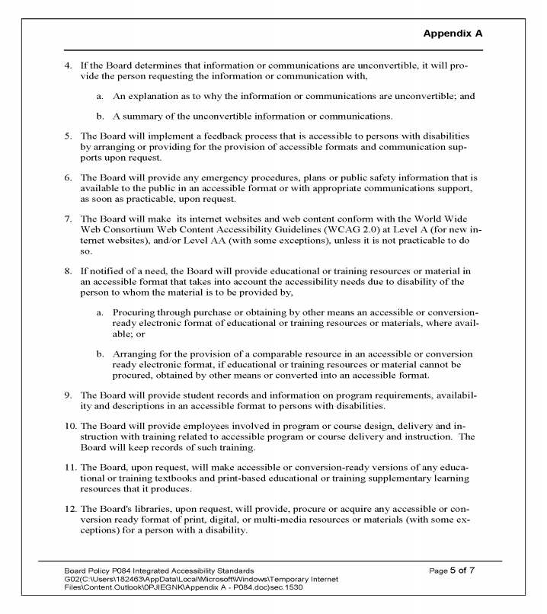

Governance and Policy Committee April 26, 2017 | Page  61 |  | Board Services Agenda Record  GPC:004A  Agenda Item 6.3

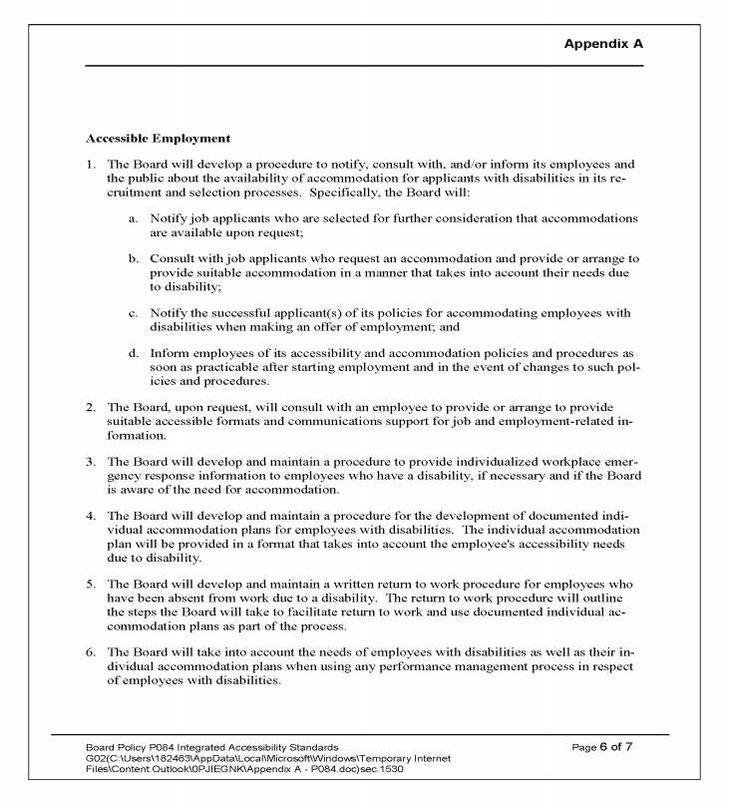

Governance and Policy Committee April 26, 2017 | Page  62 |  | Board Services Agenda Record  GPC:004A  Agenda Item 6.3

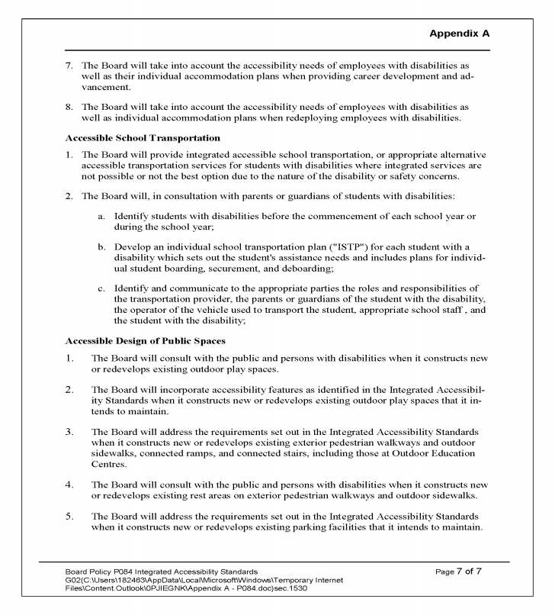

Governance and Policy Committee April 26, 2017 | Page  63 |  | Board Services Agenda Record  GPC:004A  Agenda Item 6.3

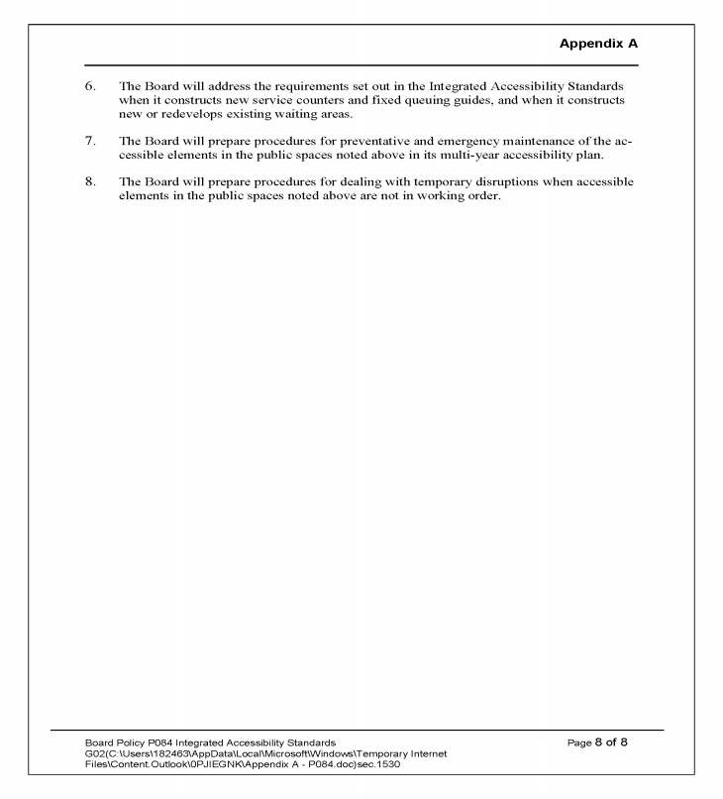

Governance and Policy Committee April 26, 2017 | Page  64 |  | Board Services Agenda Record  GPC:004A  Agenda Item 6.3

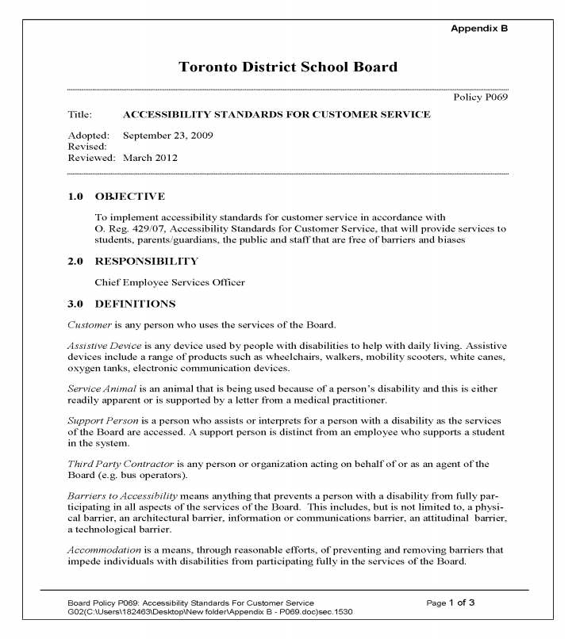

Governance and Policy Committee April 26, 2017 | Page  65 |  | Board Services Agenda Record  GPC:004A  Agenda Item 6.3

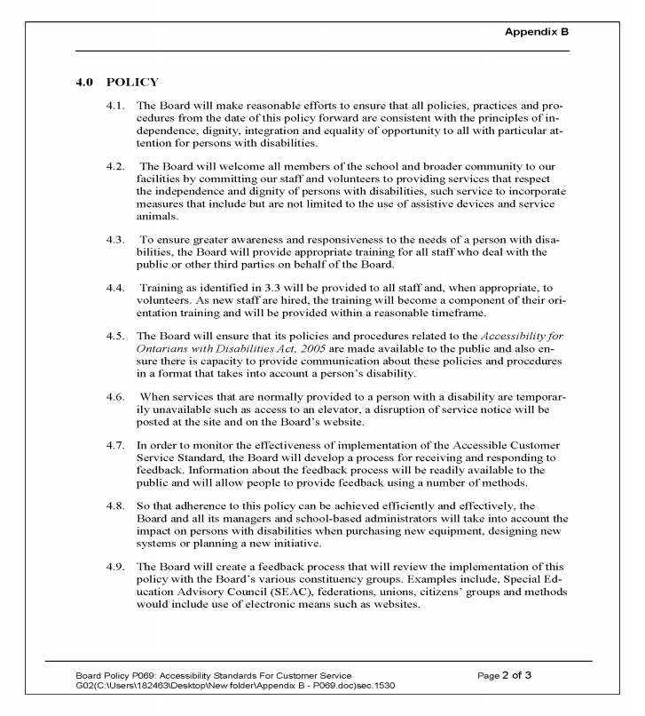

Governance and Policy Committee April 26, 2017 | Page  66 |  | Board Services Agenda Record  GPC:004A  Agenda Item 6.3

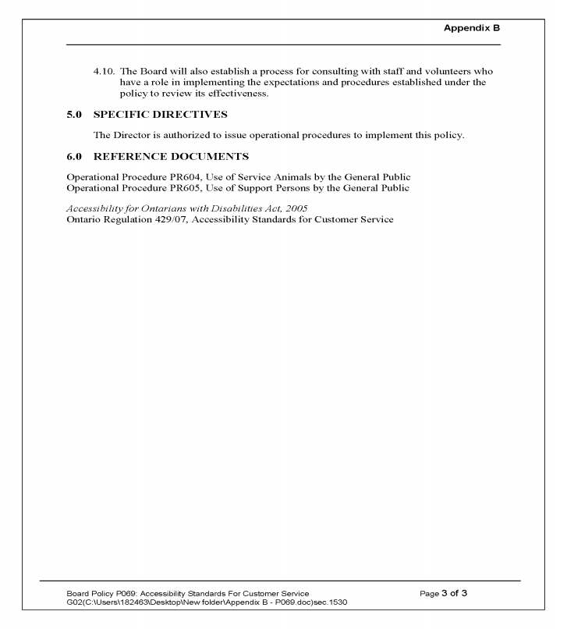

Governance and Policy Committee April 26, 2017 | Page  67 |  | Board Services Agenda Record  GPC:004A  Agenda Item 6.3

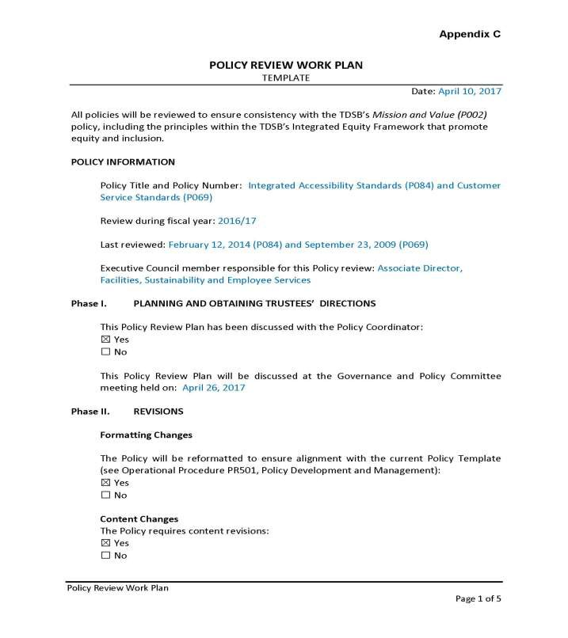

Governance and Policy Committee April 26, 2017 | Page  68 |  | Board Services Agenda Record  GPC:004A  Agenda Item 6.3

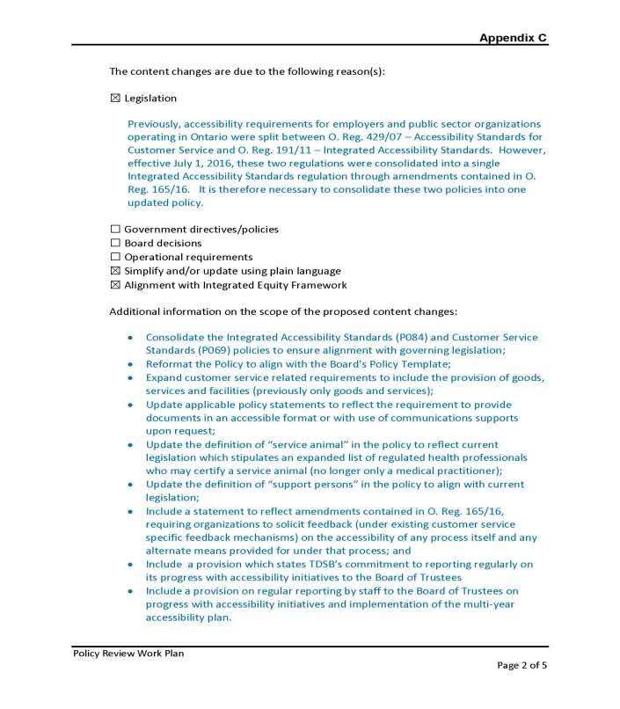

Governance and Policy Committee April 26, 2017 | Page  69 |  | Board Services Agenda Record  GPC:004A  Agenda Item 6.3

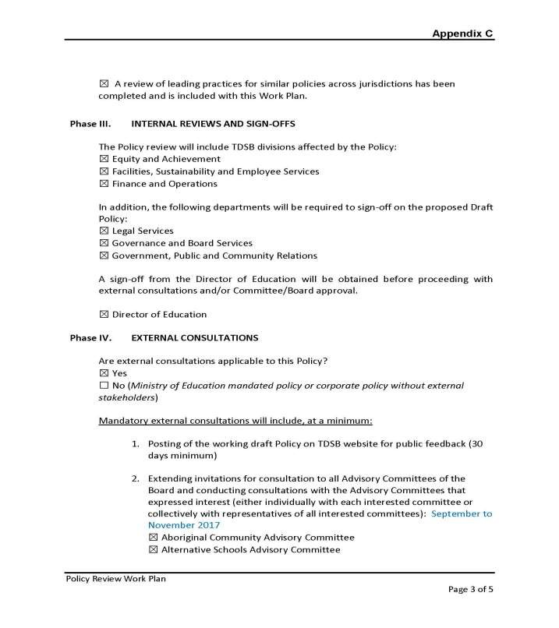

Governance and Policy Committee April 26, 2017 | Page  70 |  | Board Services Agenda Record  GPC:004A  Agenda Item 6.3

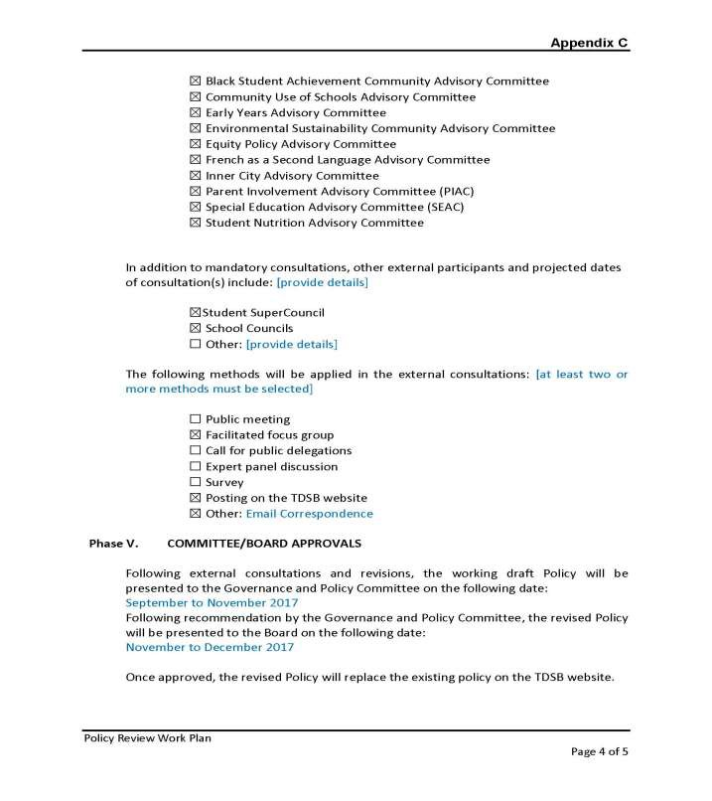

Governance and Policy Committee April 26, 2017 | Page  71 |  | Board Services Agenda Record  GPC:004A  Agenda Item 6.3

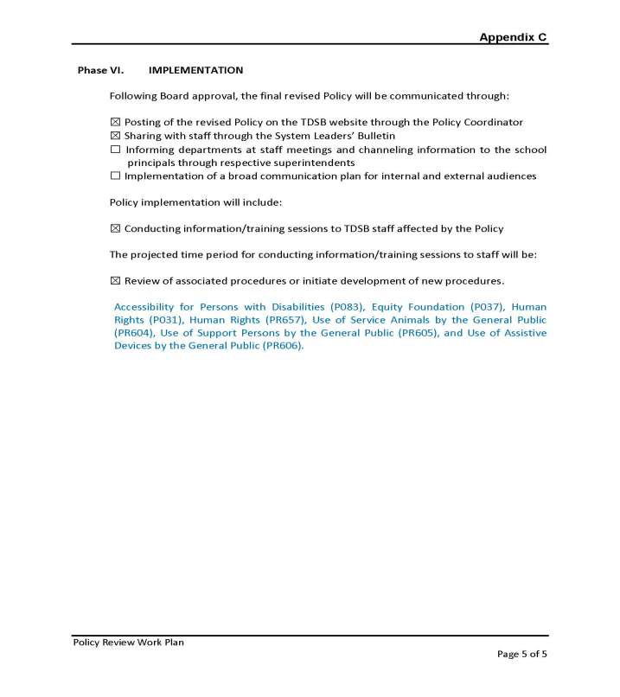

Governance and Policy Committee April 26, 2017 | Page  72 |  | Board Services Agenda Record  GPC:004A  Agenda Item 6.3

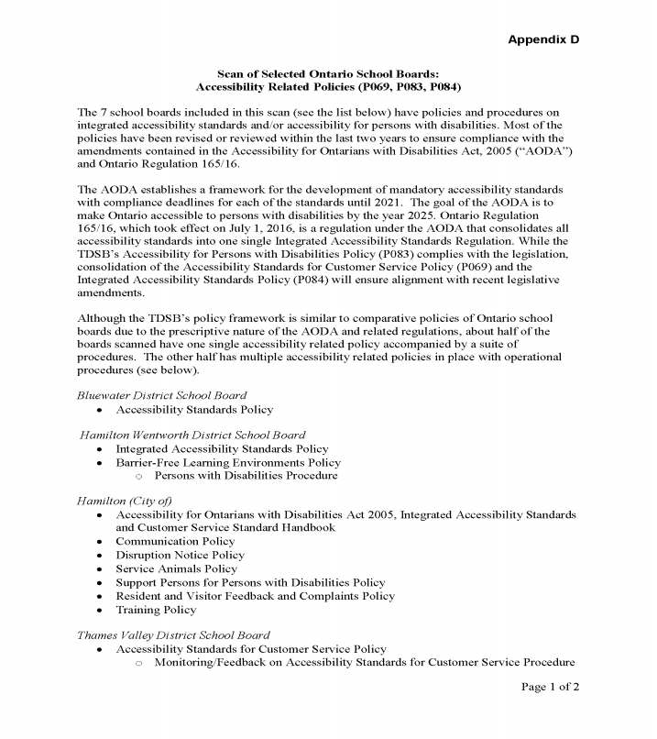

Governance and Policy Committee April 26, 2017 | Page  73 |  | Board Services Agenda Record  GPC:004A  Agenda Item 6.3

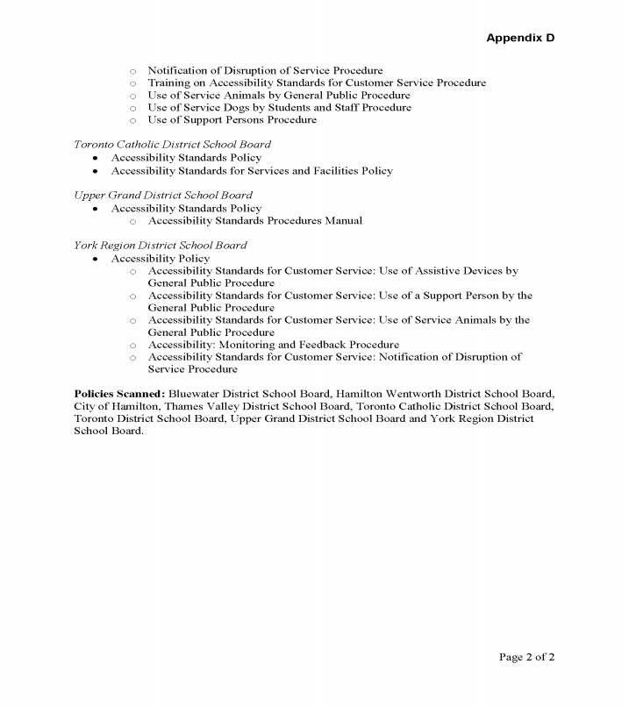

Governance and Policy Committee April 26, 2017 | Page  74 |  | Board Services Agenda Record  GPC:004A  Agenda Item 6.3

Blank Page

