OFFICE OF THE DIRECTOR OF EDUCATION
5050 Yonge Street, Toronto, Ontario M2N 5N8

January 1, 2018
Leola Pon
General Counsel
Legal Services
Dear Leola,
During the 2017-2018 school year, I would ask you to focus on the following key areas while fulfilling all of the duties of your position:
- Develop and manage improvements for the provision of strategic internal and external legal services based on principles of service excellence, modernization, cost efficiency, and effectiveness;
- Develop and implement strategies and resources to support the professional learning and strategic legal needs of Senior Team;
- Identify opportunities and actions for the Legal Services team to learn, experience and implement measures to support TDSB’s strategic direction under the Integrated Equity Framework;
- In collaboration with Carlene Jackson and Peter Singh, develop the new Senior Team (Service) leadership model to enhance leadership capacity and strengthen system-wide operations;
- Support the Governance Committee with Lori Barnes, Ross Parry and John Malloy.
Please develop an action plan with deliverables, measurements and budget and the date when various aspects of the plan will be completed.
Thank you for your Executive leadership in TDSB.
Sincerely,
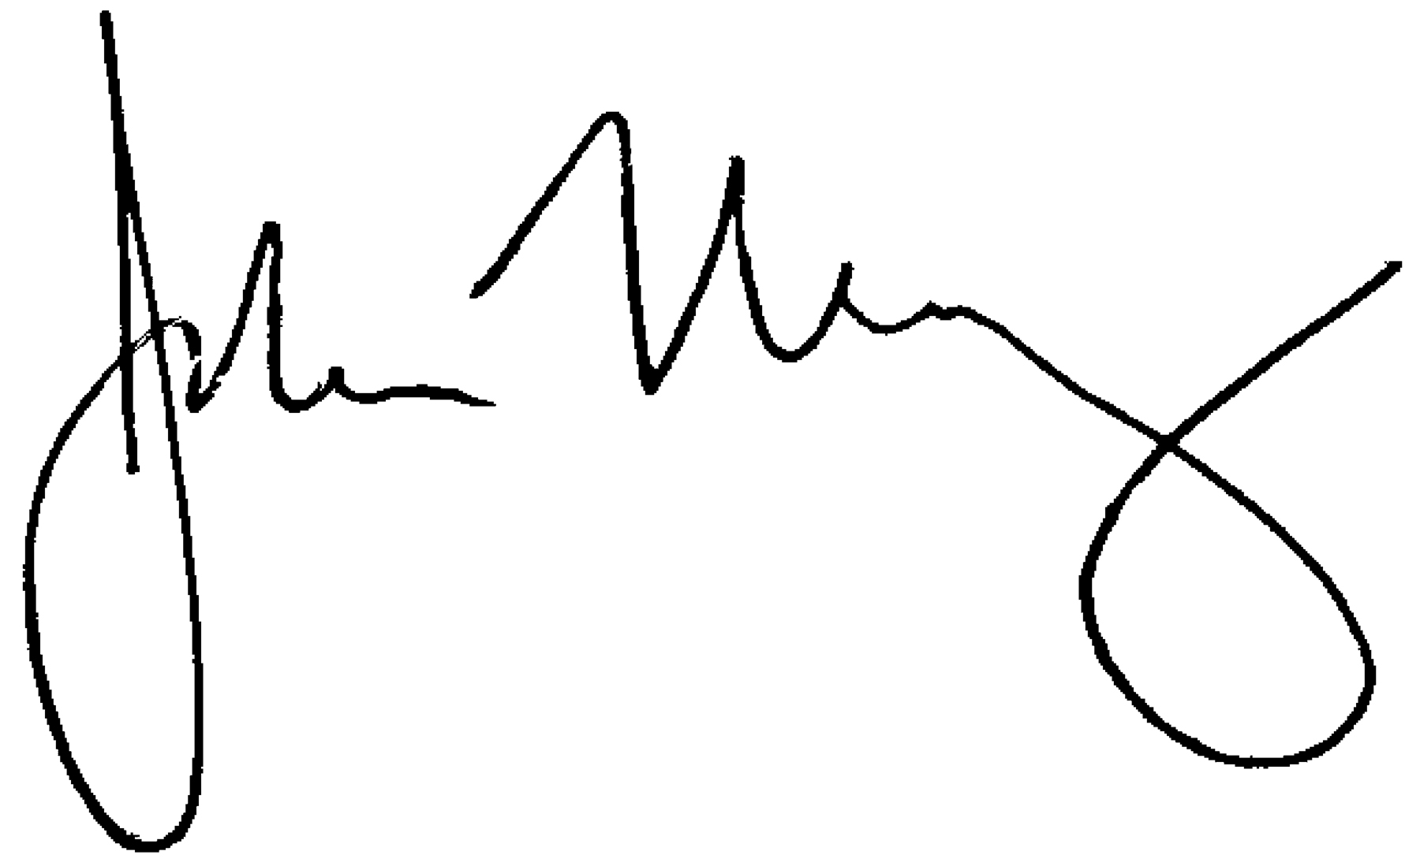
John Malloy
Director of Education

