STEP-BY-STEP INSTRUCTIONS:
- Visit https://tdsb.schoolcashonline.com/ to make online donations.

- Click on the “MENU” icon.
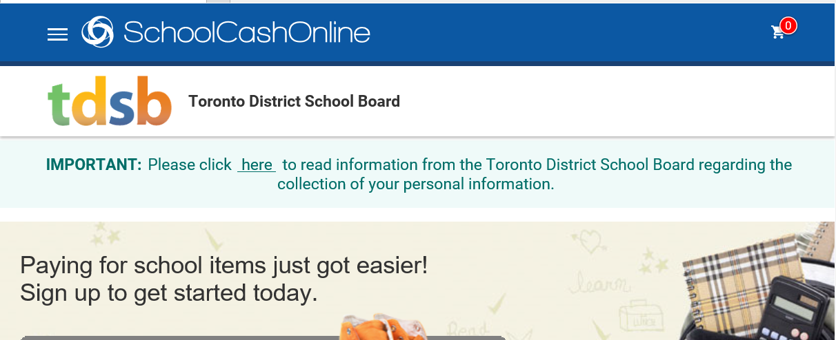

- Click on “ITEMS”.
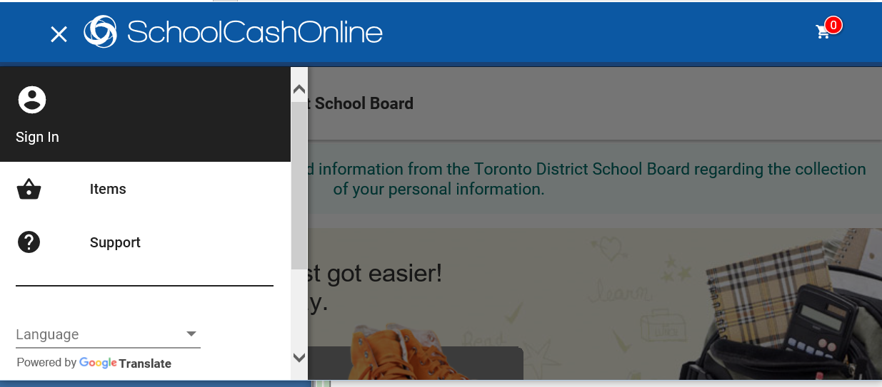

4) Click on the “MAKE A DONATION” button on the page (top right).
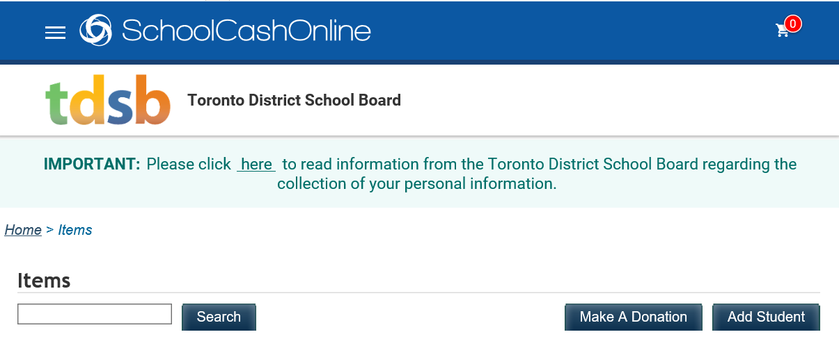
- Enter the donation amount under “Gift Information” and choose the school you wish to donate to by clicking the “Fund Destination” drop down menu. ***Please note that these donations are intended for TDSB internal fundraising purposes only, and are not intended for redistribution to other charitable organizations.***
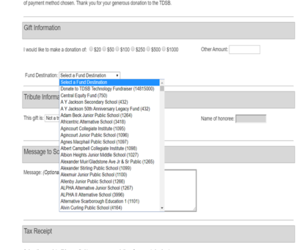
- If the funds are designated for a specific purpose, please indicate the purpose under the “Message field” in the “Message to School Board”.

- Click “Add to Cart” at the bottom of the screen.

- Review the items outlined in your cart. You may make donations to multiple schools in one transaction by clicking “Select more items”. Once you are ready to proceed to checkout, click “Continue” at the bottom of the checkout screen.
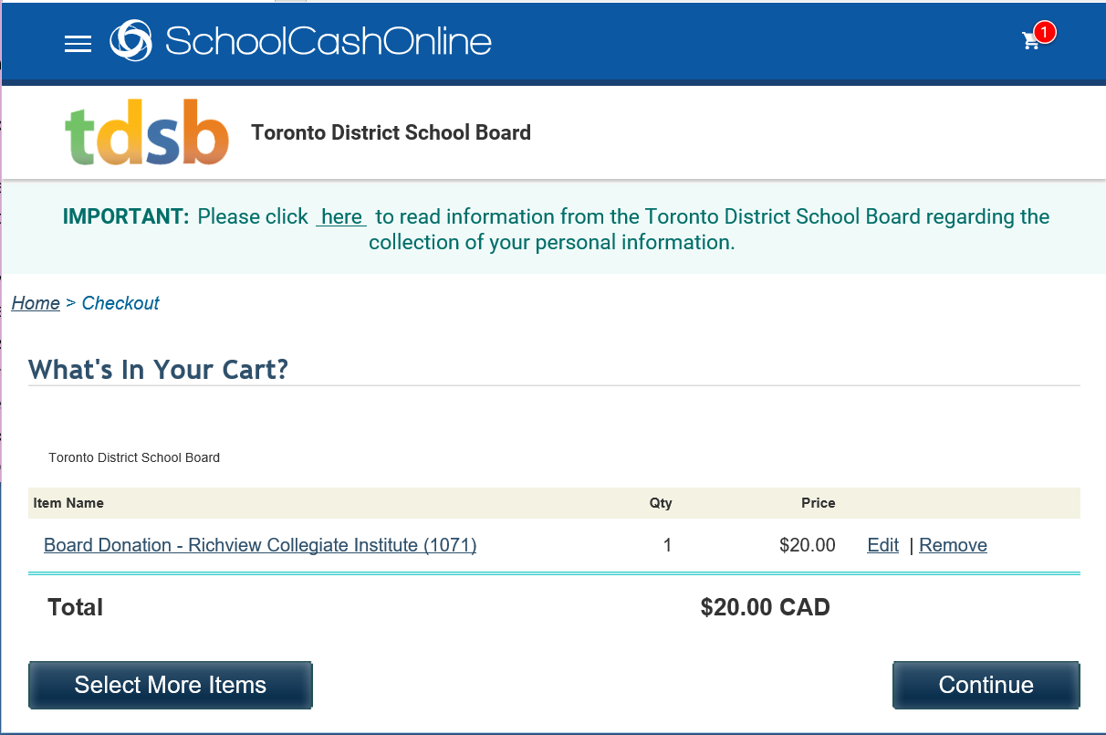
- Select Sign In (if you are a registered School Cash Online user) or Guest Checkout (if you have not registered) before proceeding to the payment page.
*Using Guest Checkout will limit the features you can access. For example: Additional payment methods; payment history; student specific items and installments. If you are or would like to be a new user, please click the hyperlink beneath the Sign In button, “Click here to register now” and follow the registration prompts.
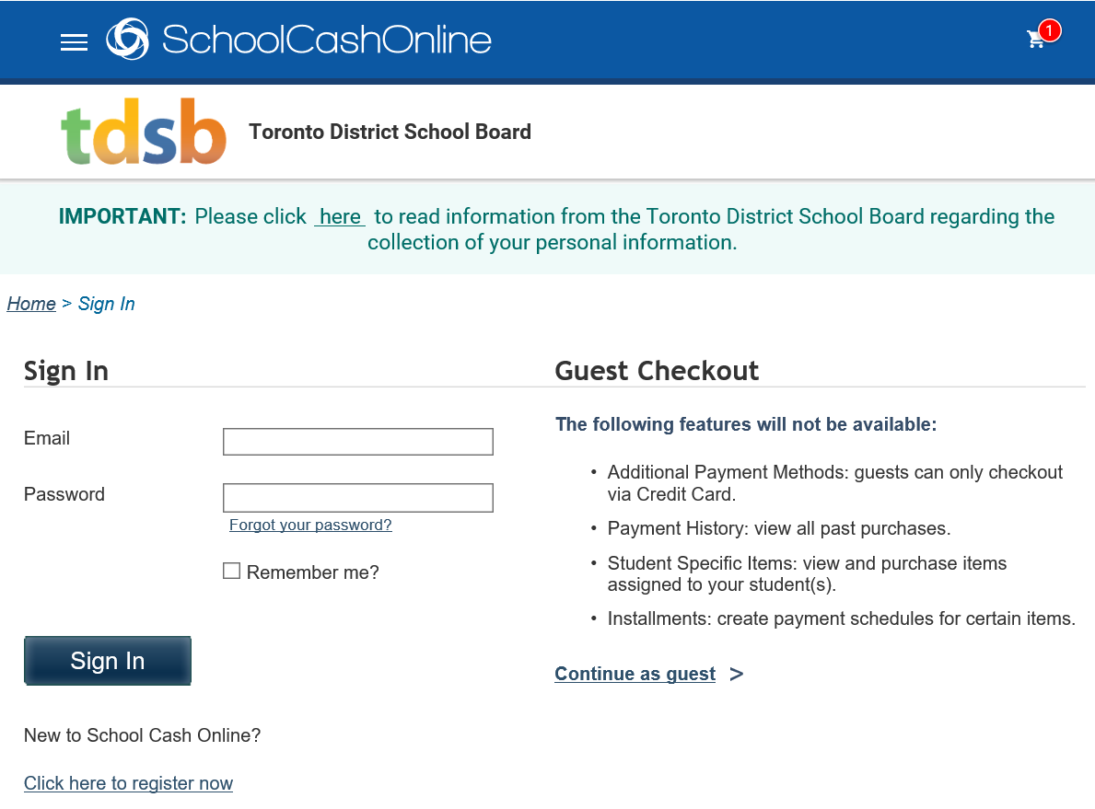

10) Once you have completed the registration and checkout process, you will receive a copy of the donation receipt via email. The donation will be made in the name of the School Cash Online account holder.

