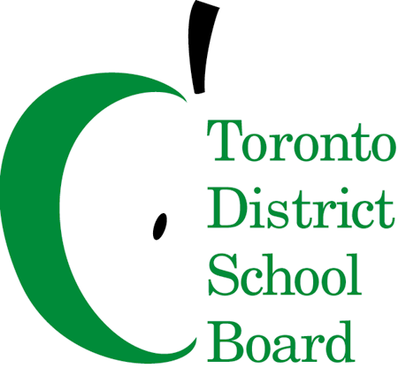

MEETING NOTICE

To: Members of the French-As-A-Second-Language Advisory Committee
FSLAC Meeting - Tuesday, September 20th, 2016
6:30 p.m. – Dinner
7:00 p.m. – Meeting
5050 Yonge Street, Committee Room A
Committee Co-Chairs: Kristina Laperle (Parent); Robin Pilkey (Trustee)

AGENDA
 | ITEM | LEAD | ACTION | TIME-LINE
 | Call to order - Welcome/Introductions | Kristina Laperle | N/A | 5 min
 | Approval of Quorum  - Membership Review | Betheney Maheu | N/A | 2 min
 | Approval of Agenda | Kristina Laperle | Decision | 3 min
 | Approval of Minutes | Kristina Laperle | Decision | 5 min
 | Guest: Millwood Parent, Ward 2 | Kristina Laperle | Information | 15 min
 | Chair’s Report  - Member Briefing Book/Google Docs update  - Communication plan  - Future guest speakers | Kristina Laperle | Information | 15 min
 | Staff Report  - Redesigned Virtual Library  - Professional Learning Plan  - Information Night Sessions | John Tancredi & Kirsten Johnston | Information | 25 min
 | Canadian Parents for French Updates | Mary Cruden | Information | 20 min
 | Ward Reports | All Members | Information | 20 min
 | Other Business | Kristina Laperle | Information | 5 min
 | Adjournment  Next Meeting October 27, 2016 | Kristina Laperle | N/A | 2 min

If you wish to participate by teleconference, call-in details are as follows:

• dial 416-849-1983 and enter 8944182 followed by the pound key (#).

