Governance and Policy Committee April 26, 2017 | Page  75 |  | Board Services Agenda Record  GPC:004A  Agenda Item 6.4

Report No. 04-17-3101

TORONTO DISTRICT SCHOOL BOARD

REVIEW OF P083, ACCESSIBILITY FOR PERSONS WITH DISABILITIES
POLICY – Policy Review (Phase 1)

TO Governance and Policy Committee 26 April 2017

RECOMMENDATION IT IS RECOMMENDED that the Policy Review Work Plan for
policy P083, Accessibility for Persons With Disabilities, as presented in the report, be approved.

STRATEGIC DIRECTION

- Make every school an effective school
- Identify disadvantage and intervene effectively

RATIONALE The Accessibility for Persons with Disabilities Policy (P083) (the “Policy”) is being reviewed in accordance with the Policy Review Schedule approved by the Board of Trustees on 23 November 2016 and the Policy Review Process.

The current Accessibility for Persons with Disabilities Policy (see Appendix A) is in compliance with the Accessibility for Ontarians with Disabilities Act. However, due to some changes including the consolidation of Ontario Regulation 429/07 – Accessibility Standards for Customer Service and Ontario Regulation 191/11 – Integrated Accessibility Standards, the following amendments are recommended by staff:

  - Add the definitions of guide dog, support person and service animal as set out in the Accessibility for Ontarians with Disabilities Act and related regulations;
  - Update the definition of ‘disability’ with a statement, referencing that the conditions listed are as set out in the Accessibility for Ontarians with Disabilities Act;
  - Expand policy statement 4.6 to make all documents available in an accessible format upon request, except where it is not practical to do so;
  - Include reference to the newly amalgamated policy which combines the statements of former policies on Integrated Accessibility Standards and Accessibility Standards for

Governance and Policy Committee April 26, 2017 | Page  76 |  | Board Services Agenda Record  GPC:004A  Agenda Item 6.4

Customer Service; and
  - Ensure alignment with the TDSB’s Integrated Equity Framework; and
  - Ensure alignment with the Board’s Policy Template.

The proposed revisions would ensure the Board’s policies on accessibility are in alignment and compliant with the legislation, as well as provide greater understanding and clarity around the roles and responsibilities of the system in preventing discrimination and improving accessibility to goods, services, facilities, employment, accommodation and buildings for persons with disabilities.

RESOURCES N/A

IMPLEMENTATION
AND REVIEW
Based on the Governance and Policy Committee’s input, the Accessibility for Persons with Disabilities Policy will be reviewed in accordance with the Policy Review Work Plan (see Appendix B) and subsequently presented to the Governance and Policy Committee for consideration and recommendation.

APPENDICES Appendix A: Accessibility for Persons with Disabilities Policy
(P083) – Current Policy

Appendix B: Appendix C:
Policy Review Work Plan

Scan of Selected Ontario School Boards

FROM Angelos Bacopoulos, Associate Director, Facilities, Sustainability and Employee Services
angelos.bacopoulos@tdsb.on.ca Phone: (416) 393-8780

Chris Broadbent, Manager, Occupational Health and Safety
chris.broadbent@tdsb.on.ca Phone: (416) 397-3460

Governance and Policy Committee April 26, 2017 | Page  77 |  | Board Services Agenda Record  GPC:004A  Agenda Item 6.4

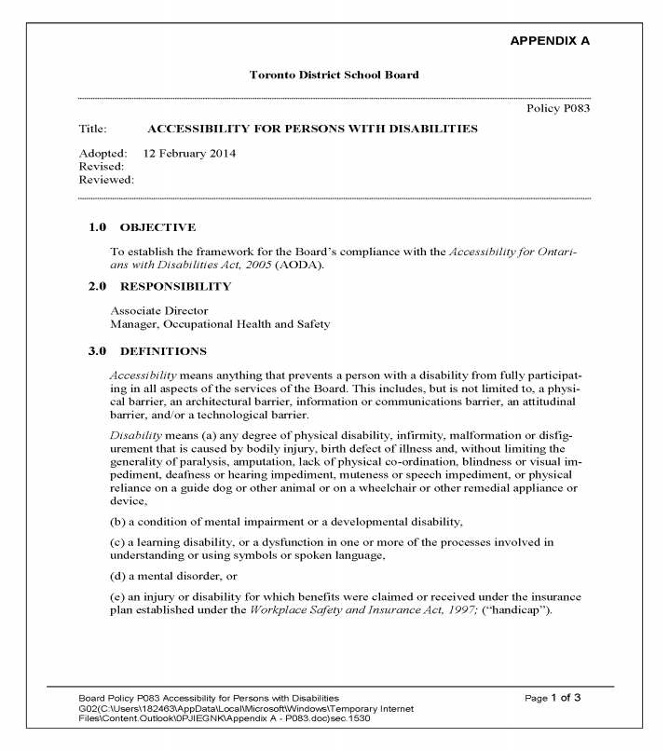

Governance and Policy Committee April 26, 2017 | Page  78 |  | Board Services Agenda Record  GPC:004A  Agenda Item 6.4

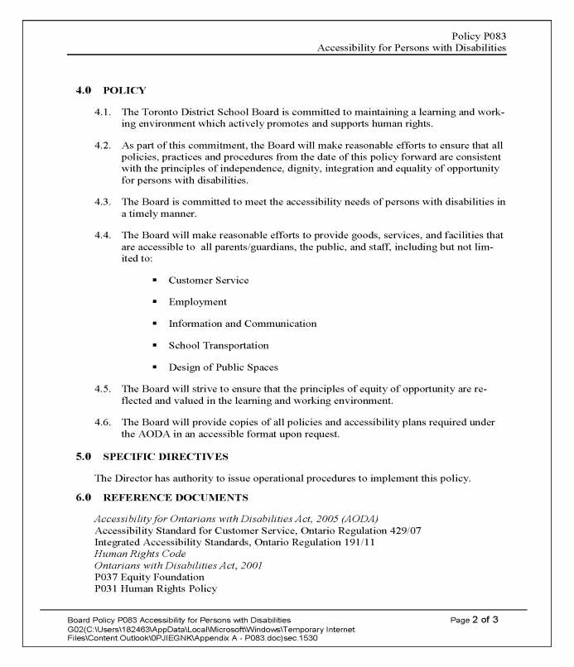

Governance and Policy Committee April 26, 2017 | Page  79 |  | Board Services Agenda Record  GPC:004A  Agenda Item 6.4

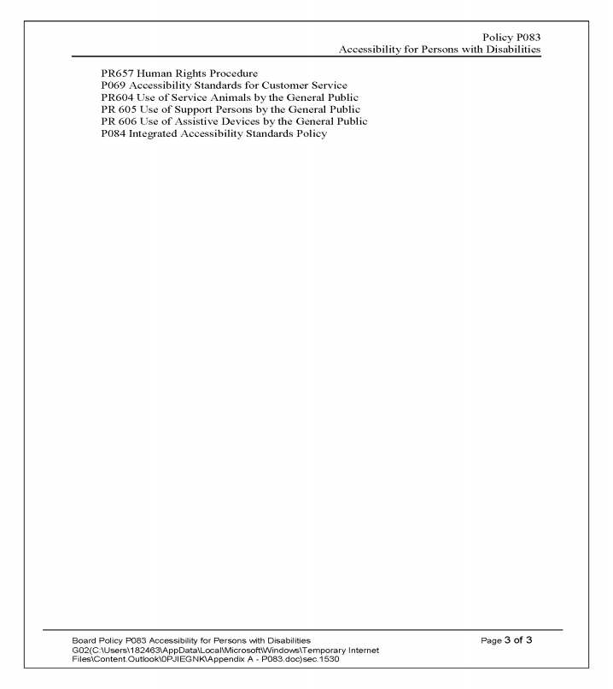

Governance and Policy Committee April 26, 2017 | Page  80 |  | Board Services Agenda Record  GPC:004A  Agenda Item 6.4

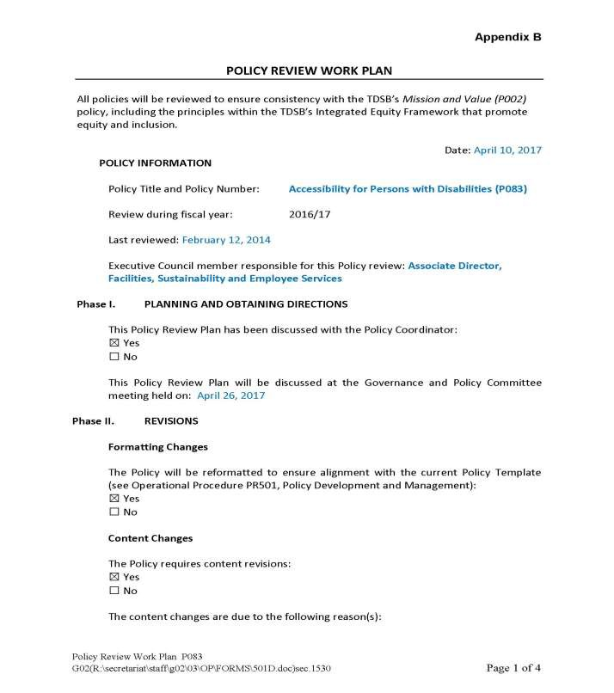

Governance and Policy Committee April 26, 2017 | Page  81 |  | Board Services Agenda Record  GPC:004A  Agenda Item 6.4

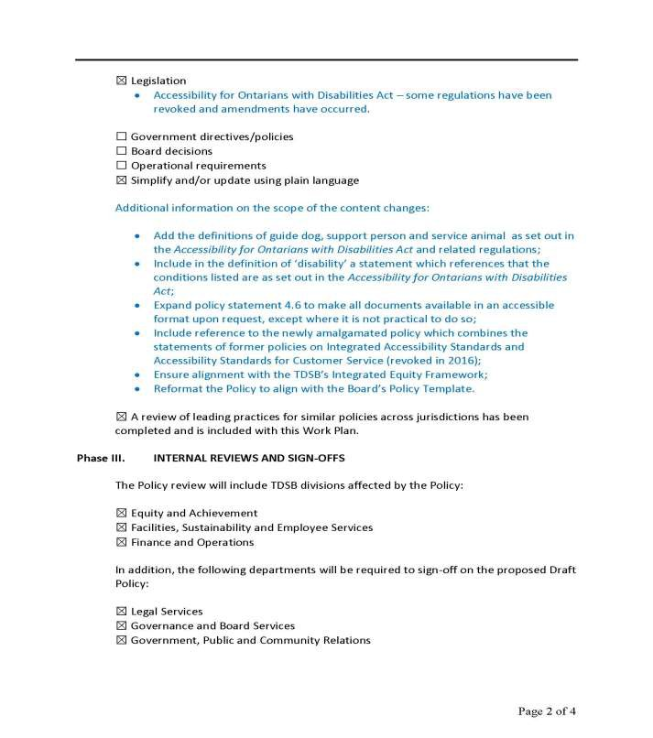

Governance and Policy Committee April 26, 2017 | Page  82 |  | Board Services Agenda Record  GPC:004A  Agenda Item 6.4

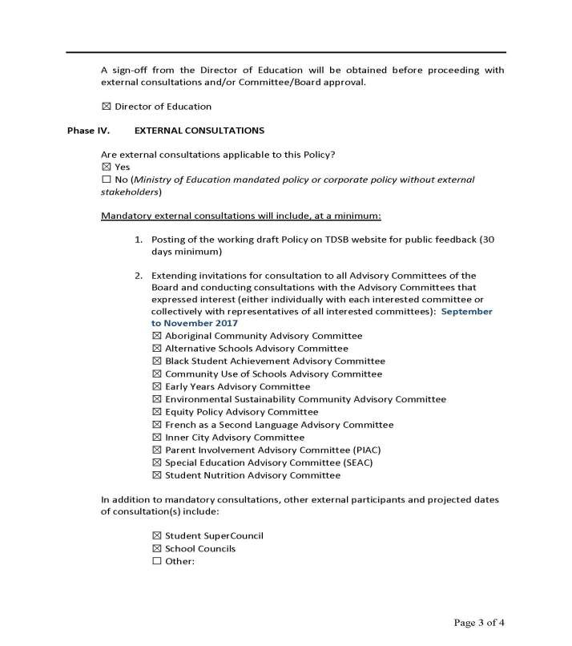

Governance and Policy Committee April 26, 2017 | Page  83 |  | Board Services Agenda Record  GPC:004A  Agenda Item 6.4

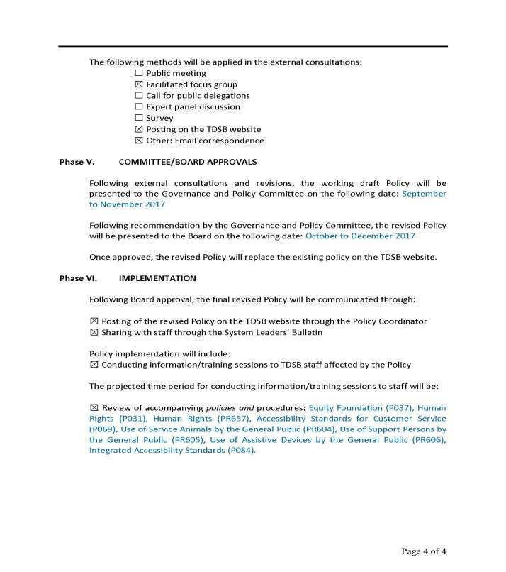

Governance and Policy Committee April 26, 2017 | Page  84 |  | Board Services Agenda Record  GPC:004A  Agenda Item 6.4

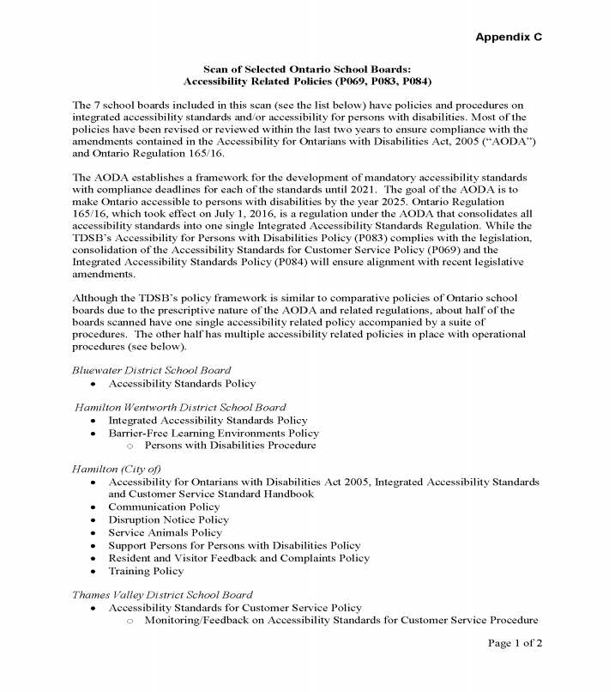

Governance and Policy Committee April 26, 2017 | Page  85 |  | Board Services Agenda Record  GPC:004A  Agenda Item 6.4

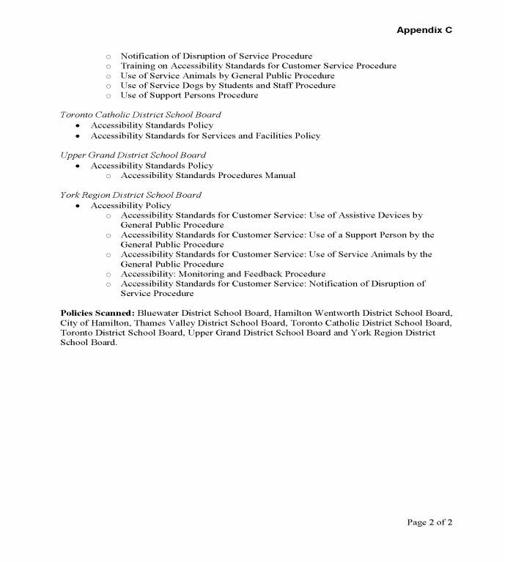

Governance and Policy Committee April 26, 2017 | Page  86 |  | Board Services Agenda Record  GPC:004A  Agenda Item 6.4

Blank Page

