OFFICE OF THE DIRECTOR OF EDUCATION
5050 Yonge Street, Toronto, Ontario M2N 5N8

January 1, 2018

Uton Robinson
Executive Superintendent
Special Education and Sections Programs
Dear Uton,
During the 2017-2018 school year, I would ask you to focus on the following key areas while fulfilling all of the duties of your position:
- Develop and implement the Special Education portion of the Integrated Equity Framework with a specific focus on remodeling the Home School Program and providing ongoing professional learning opportunities for staff so that more of our students can be better served in their community school.
- Provide opportunities to bring focus and leadership to our collective responsibility to help more students achieve in their community school by adopting a "Learning for All" stance and by developing a plan for this commitment.
- Take steps to move Special Education staff and services closer to the Learning Centres to better respond to the needs of students, parents and principals.
- Enhance communication strategies for parents and communities as it relates to Special Education by working with staff and Special Education Advisory Committee
- Increase digital accessibility for all students with special needs
- Work closely with Teaching and Learning, Professional Support Services and Section 23 administrators in support of all TDSB students.
I ask that you collaborate intentionally and strategically with the following colleagues:
Pat Rocco, Chris Usih, Jim Spyropoulos, Colleen Russell-Rawlins, Carlene Jackson, Manon Gardner, Beth Butcher, John Malloy

Thank you for your Executive leadership in TDSB.
Sincerely,
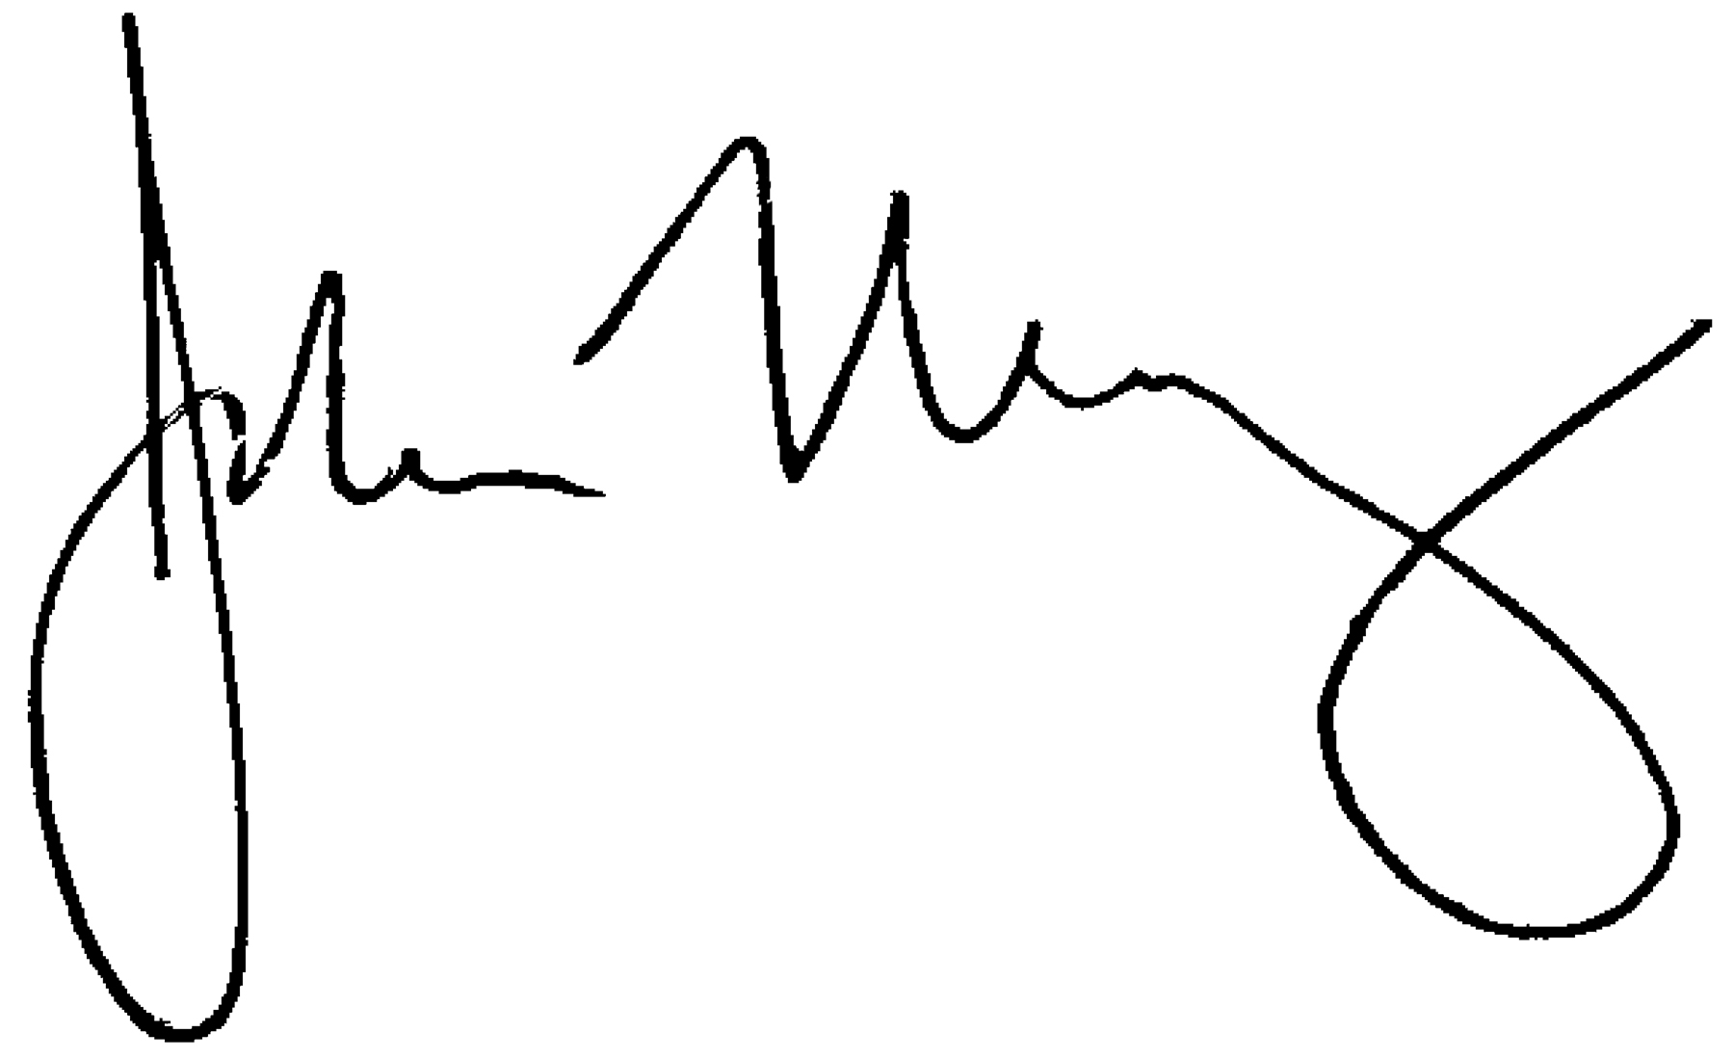
John Malloy
Director of Education

