OFFICE OF THE DIRECTOR OF EDUCATION
5050 Yonge Street, Toronto, Ontario M2N 5N8

January 1, 2018

Manon Gardner
Executive Superintendent
Teaching and Learning and
Alternative/International Education
Dear Manon,
During the 2017-2018 school year, I would ask you to focus on the following key areas while fulfilling all of the duties of your position:
- Provide leadership between TDSB and the Ministry of Education.
- Develop and implement the portion of the Integrated Equity Framework related to Secondary Programs.
- Lead our coherent TDSB Vision for deep learning supported by technology (in collaboration with Peter Singh) including providing support for our DLL’s, DLA’s, consistent with the training provided to all leaders.
- Lead the transition of the Teaching and Learning Department in order to support the Learning Centre Model.
- Lead the Leadership Capacity Steering Committee to implement a board wide plan for all employees.
- Implement the next steps in moving forward following the review of alternative schools and after careful consideration of the feedback provided through the Enhanced Equity Task Force.
- Determine our next steps as it relates to the effective implementation of our Internationalization Strategy, including how we communicate this strategy.
- Provide effective leadership of Program and School Services Committee (PSSC), French-as-a-Second-Language Advisory Committee (FSLAC) and the Alternative Schools Community Advisory Committee (ASAC).
I ask that you collaborate intentionally and strategically with the following colleagues:
Colleen Russell-Rawlins* (A)
Chris Usih, Beth Butcher, Jim Spyropoulos, Pat Rocco, Colleen Russell-Rawlins, Uton Robinson, John Malloy* (B)
Peter Singh (C) (You are the lead)
Roula Anastasakos and Peter Singh,* (D)
Chris Usih*, Jim Spyropoulos, Beth Butcher, Pat Rocco, Uton Robinson, Carlene Jackson, Lori Barnes (E)
Uton Robinson*, (F)
In order to achieve the following impacts for TDSB:
- Renewed Math Strategy.
- Developing and implementing an Integrated Learning Plan for all leaders with a focus on our Coaches.
- Deep learning supported by technology.
- Align and integrate (when appropriate) all technology, research, information and teaching and learning services.
- Action Plan – Integrated Equity Framework – Secondary Program.
- Improvement of our Learning for All stance as a Foundation for School Improvement and Leadership Capacity Plan.
Please develop an action plan with deliverables, measurements and budget and the date when various aspects of the plan will be completed.
Thank you for your Executive leadership in TDSB.
Sincerely,
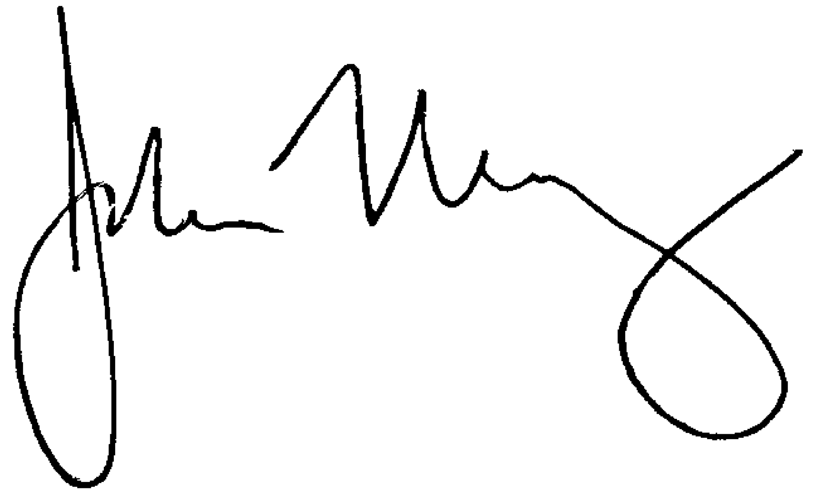
John Malloy
Director of Education

*Lead

