5050 Yonge Street, Toronto, Ontario M2N 5N8

January 1, 2018

Lori Barnes
Executive Officer
Governance and Board Services
Dear Lori:
During the 2017-2018 school year, I would ask you to focus on the following key areas while fulfilling all of the duties of your position:
- Provide leadership and support to senior staff in modelling effective governance practices, working with Trustees and Board Committee Executive Leads to ensure that optimal levels of service and information are made available to Trustees to serve the needs of all students.

- Enhance service excellence in Governance and Board Services, including the development and monitoring of work plans for all business units; Policy, Student Discipline, Trustee Shared Services, Board Services and Municipal Freedom of Information and Protection of Privacy.

- Infuse equity learning and practice into the culture of Governance and Board Services, including professional learning for staff, a review of existing hiring practices, a pilot project addressing power and privilege in the operation of the Student Discipline Committee as well as supporting the development of the Equity Policy and Equity Assessment Tool.

- Introduce and monitor software solution for the Board’s Corporate Secretariat, including ongoing staff and trustee training and continual refinement of the platform to support staff reporting and trustee decision making processes.

- Provide effective leadership for the Board Meeting, Governance and Policy Committee and House Committee by building authentic and positive working relationships with trustees and staff, as well as reviewing and addressing both challenges and best practices in a cycle of continuous improvement.

I ask that you collaborate intentionally and strategically with all Trustees and the following colleagues:
John Malloy, Carlene Jackson, Chris Usih, Ross Parry, Leola Pon, Jim Spyropoulos and Pat Rocco, as well as Executive Staff Leads for Board Committees.
Please develop an action plan with deliverables, measurements and budget and the date when various aspects of the plan will be completed.
Thank you for your Executive leadership in TDSB.
Sincerely,

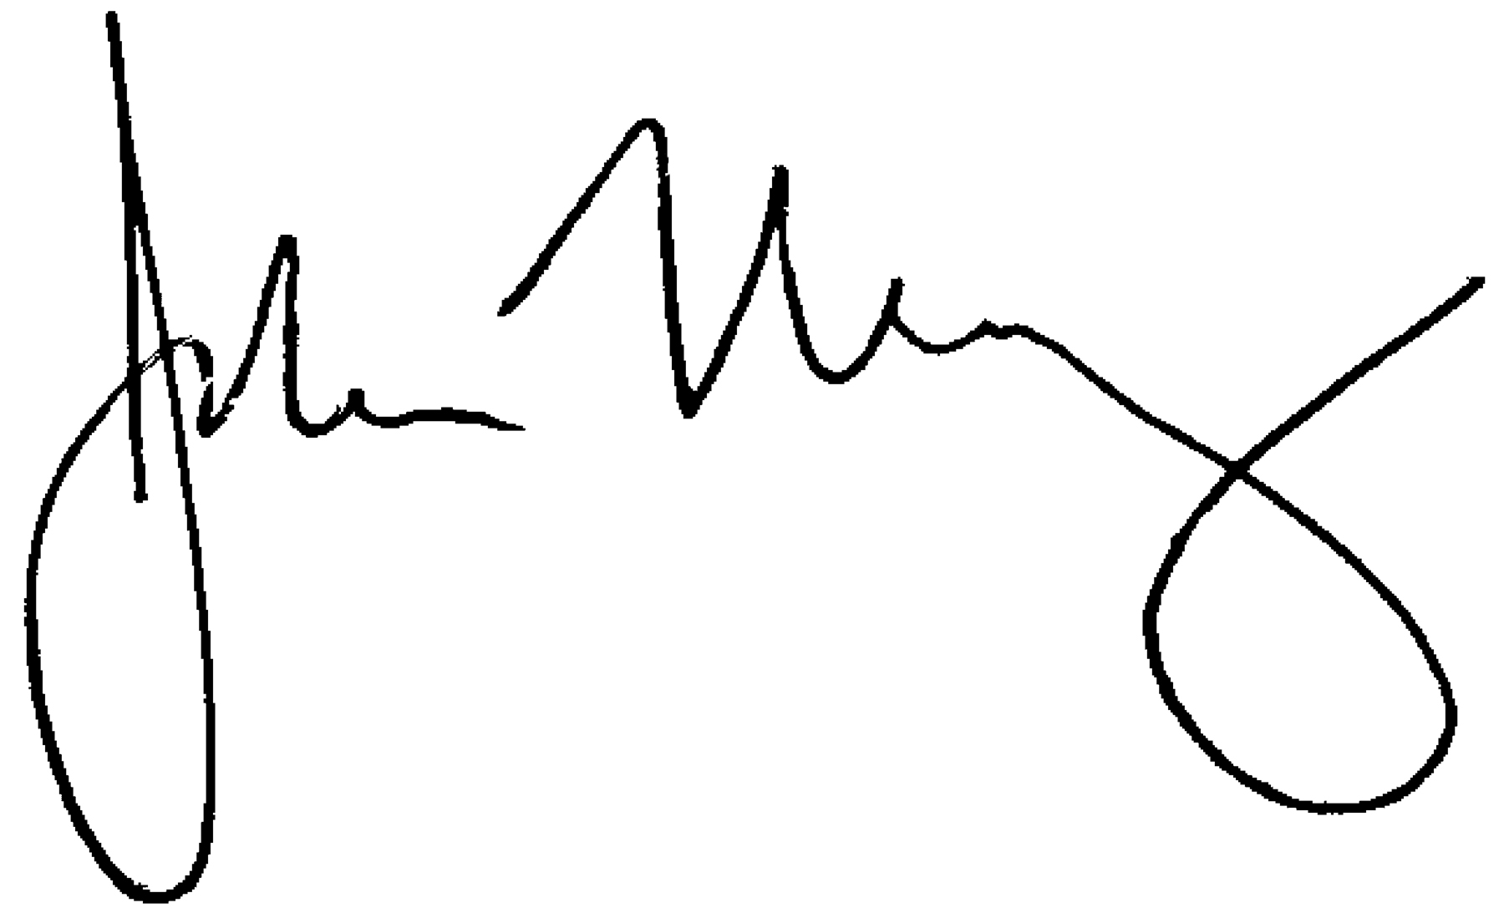
John Malloy
Director of Education

