OFFICE OF THE DIRECTOR OF EDUCATION
5050 Yonge Street, Toronto, Ontario M2N 5N8

January 1, 2018

Jim Spyropoulos
Executive Superintendent
Equity and Engagement
Dear Jim,
During the 2017-2018 school year, I would ask you to focus on the following key areas while fulfilling all of the duties of your position:
- Continue to work with Parent Engagement Office, its mandate and its impacts so as to strengthen the office’s responsiveness to our Learning Centres. Strengthen the office’s support for Parent Involvement Advisory Committee (PIAC) as well as other Advisory Committees.
- Work to effectively develop and strengthen the level of parental engagement into the School Improvement/teaching and learning process as a vehicle towards improved student achievement and well-being.
- Enhance our community engagement in intentional ways by assisting all members of Executive Council and Senior Team to build and develop relationships with our communities leading to improved students achievement and well-being.
- Lead a strong interdisciplinary team including staff from Employment Equity, Human Rights, Caring and Safe Schools, Parent and Community Engagement, in support of building the capacity of all staff to lead in more equitable and inclusive ways
- Effectively examine procedures, practices, attitudes and structures to decrease suspensions and expulsions, and to address their disproportionate number given to racialized, especially Black and Indigenous students; work effectively with existing staff so that strategies such as mediation and restorative practice are more effectively utilized to address student discipline matters.
I ask that you collaborate intentionally and strategically with the following colleagues:
Jeewan, Chanicka, Ken Jeffers (A)
Karen Falconer, Beth Butcher, Colleen Russell-Rawlins, Sandy Spyropoulos, Uton Robinson, Manon Gardner, Pat Rocco, Employment Equity Office, Human Rights Office (B)
Parent and Community Engagement Office, Model Schools staff (C)
Karen Falconer, Beth Butcher, Colleen Russell-Rawlins, Sandy Spyropoulos, Uton Robinson, Manon Gardner, Pat Rocco, Employment Equity Office, Human Rights Office (D)

In order to achieve the following impacts for TDSB:
- Build the capacity of staff to better understand and address how bias, power and privilege affect student outcomes while working through an Anti-Racism, Anti-Oppression Framework
- Support the achievement of the goals as outlined in the Integrated Equity Framework across all areas most specifically in the areas of Employment Equity and Leadership Capacity Plan
- Support Community as it related to the Advisory Committees of the Board and beyond
- Action Plan – Enhanced Equity Framework

Please develop an action plan with deliverables, measurements and budget and the date when various aspects of the plan will be completed.
Thank you for your Executive leadership in TDSB.
Sincerely,
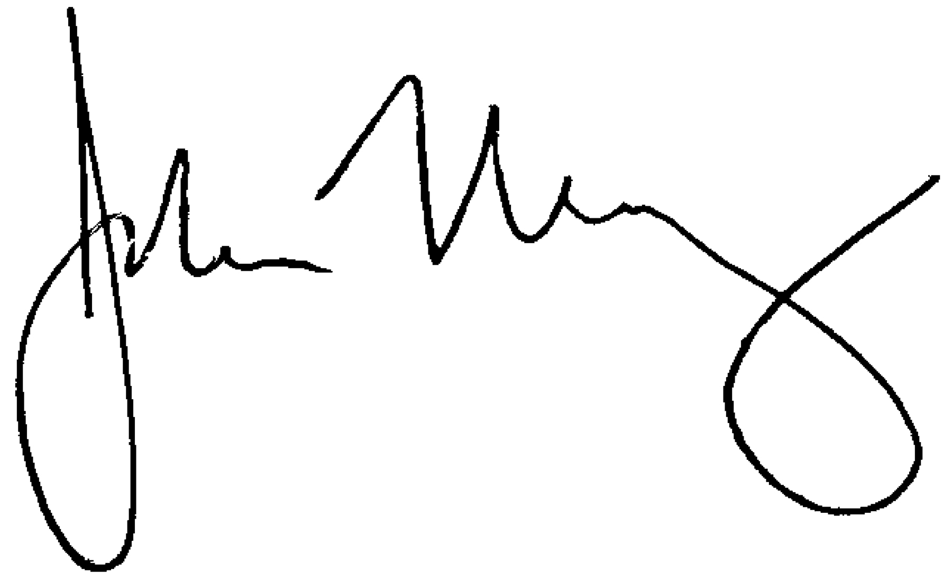
John Malloy
Director of Education

*Lead

