OFFICE OF THE DIRECTOR OF EDUCATION
5050 Yonge Street, Toronto, Ontario M2N 5N8

January 1, 2018

Carlene Jackson
Associate Director
Operations and Service Excellence

Dear Carlene,
During the 2017-2018 school year, I would ask you to focus on the following key areas while fulfilling all of the duties of your position:

- Promote a strengthened service excellence culture where responsiveness, continuous improvement, and the service mindset are at the forefront of the way business is done at TDSB;

- Provide leadership in allocating the Board’s resources using an equity perspective which maximizes student achievement and well-being for all students;

- Lead and model shared leadership through strong collaboration, integration and teamwork amongst the service and operations team as well as the learning centre teams. Facilitate enhanced communications and information sharing to eliminate silos, leverage knowledge and expertise, and create new synergies; and

- Enhance the leadership capacity of the service and operations team by encouraging and facilitating continuous learning and professional growth of all leaders and their staff.
Please develop an action plan with deliverables, measurements and budget and the date when various aspects of the plan will be completed.
Thank you for your Executive leadership in TDSB.
Sincerely,
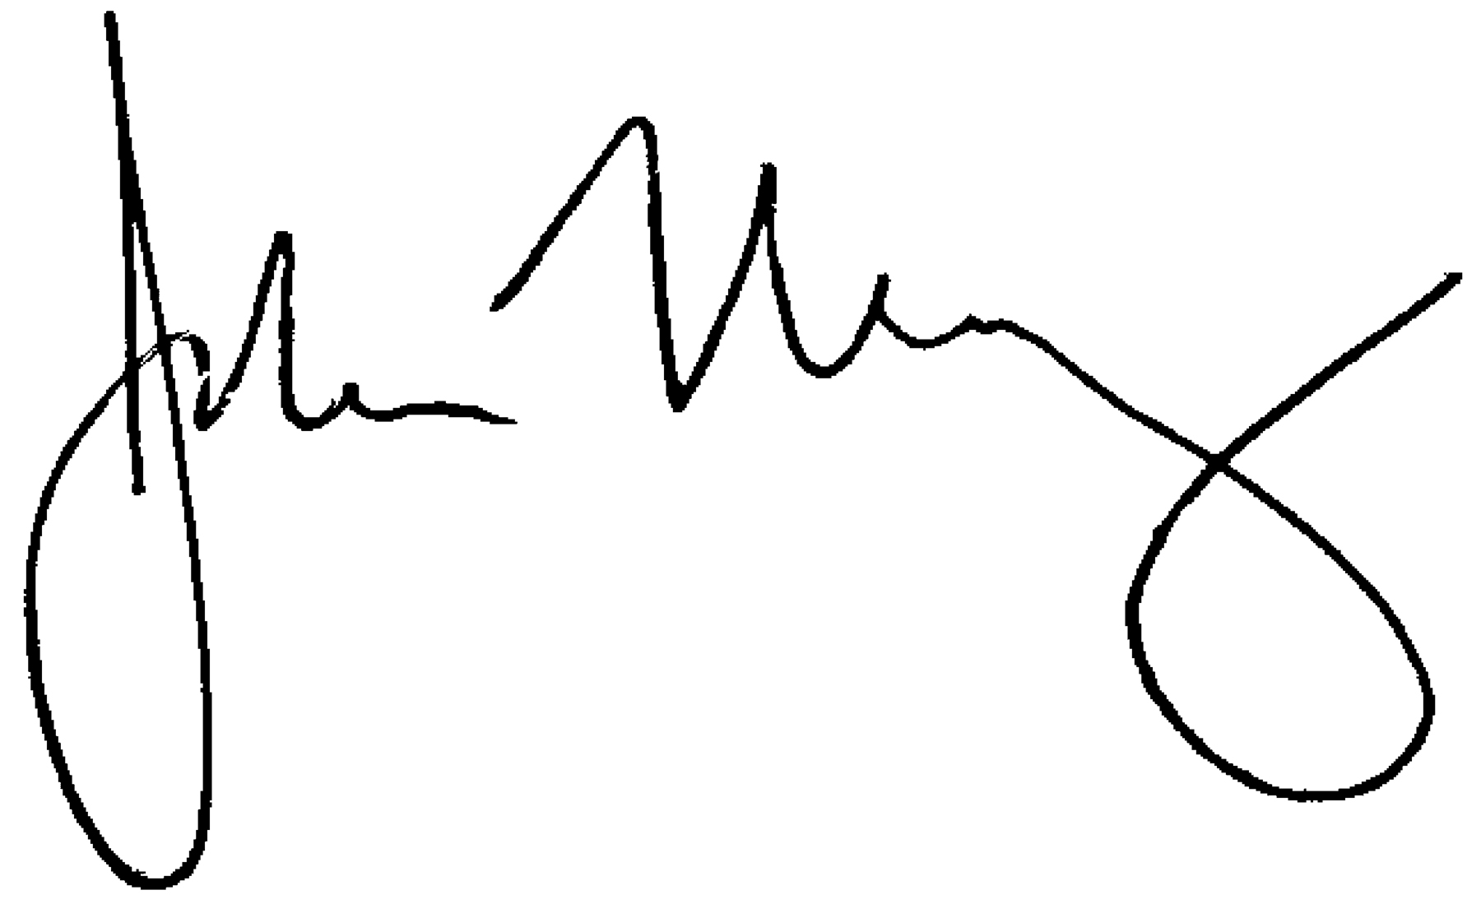
John Malloy
Director of Education

